Micropalaeontology
Micropalaeontology :- the study of microfossils properly called . Micropalaeontology. To restrict this term to studies of mineral walled microfossils (such as foraminiferal and ostracods) study of which must using the light or electron microscope.
Playnology :- which is the study of organic.
What is a fossils :- a fossil is the preserved remains a plants or animals that lived more than about 10.000 years ago , the most common fossils are shells, bones, teeth.
Fossils :- common to divided into larger macrofossil, and smaller microfossils.
Macrofauna :- animals > 1.000 microns in length.
Microfauna :- animals from 0.1 to 2 mm indiamter.
Benthic :- refers to organisms that live on the bottom, either in the ocean or in lakes.
Planktonic :- refers to organisms that live in the upper (300 ft) of the ocean or that float in open waters.
Imperforate (refers to foraminifera) :- without pores ; some tims used to porceilaneaus test b(e.g. Miliolid.
Perforate :- the term refers to wall of test pierced by numerous pores that are distinct from a perturb, Forman, canal, (e.g. calcareous hyaline).
Walled microfossils (such as pollen grains and a critarchs).
Species :- Living individual all belong to naturally isolated units called species.
Genus :- All species are placed with in a genus that contain one or more closely related species
Species :- هو مجموعة من الافراد المتشابهة في الشكل والتركيب ولها القابلية على التناسل فيما بينها وانتاج افراد قادرة بدورها على الاخصاب .
Genus :- والجنس يضم مجموعة من الانواع التي تشترك مع بعضها في صيفة او صفات متعددة ومتميزة.

القاعدة الاساسية في التسمية العلمية للكائنات سواء لعلماء البايولوجي او المتحجرات فهي التسمية الثنائية Binomial women cloture 1758 وصفها ليني 1758ومضمونها ان كل نوع من الكائنات يسمى باسمين ويكونان عادة من اصل لاتيني الاول هو اسم الجنس ويكتب بحرف كبير والاسم الثاني اسم نوعه ويكتب بحرف صغير
Kingdom
القاعدة الاساسية في التسمية العلمية وللكائنات سواء لعلماء البايولوجي او المتحجرات فهي التسمية الثنائية
Binomial Nomenolature
وصفها ليني 1758 ومضمونها ان كل نوع من الكائنات تسمى بأسمين ويكونان عادتا من اصل لاتيني الاول هو اسم الجنس ويكتب بحرف كبير والاسم الثاني اسم نونه ويكتب بحرف صغير
Phylum
Class
Order
Family
Genus
Species

The Kingdom of Live
The classification of whittaker (1969) over comes these anomalies by recognizing five kigdom ( the monera, protista, plantae, fungi and anamilia).

A- kngdommonera: -
are signal called but they lack anucleus, cell vacuoles and organelles, ( kingdom blue-greenalgas, Bacteria).
B- Kingdom Protista:-
are motile unicellular organisms with rather varied body plants, some like the dinoflagellates, or some like animalia the forminifera and radiolari.
C- Kingdom Fungi:-
Are heterotrophic, feeding by absorption of pre-formed organic matter.
D- Kingdom plantae: -
The multicellar and largely non-motile algae and the higher land plantae both belong in the kingdom plantae.
E- Kingdom Animalia:-
Comprises multicellular invertebrate animals and vertebrate animals that feed by ingestion of pre-formed organic matter. Either a live or lead

Procaryotic:-
Are single celled but they lack anucleus, cell vacuoles and organelles. (e.g. monera).

Eucaryotic:-
Are comprises unicellular organisms (e.g.protista) and multicellular organisms (e.g. Fungi, plantae, animalia).

The Structure and composition of the test wall is important to the classification of the groups of microfossils.

A- calcareous microfossils: -
1- Foraminifera, 2- Ostracods,3- Coccolithophores, 4- Calcareous algae: included to: -
a- Cyanophyta.
b- Rhodophyta.
c- Chlrophyta.
5- Caplionellid and tintinnids.
B- Siliceous microfossils: -
1- Diatoms, 2- silicoflagellates, 3- Radiolaria.
C- Phosphatic microfossils:
- Conodentopharoda.
E- Organic – wall microfossils: -
1- Spores and pollen, 2- Dinoflagellates. 3- Acritarchs, 4- chitinozoa, 5- Schizomycophyta.
What are Foraminifera?
Foraminifera are tiny single – celled organisms that construct shells. They in habitawide range of marine environment, from the intertidal zone to the deep sea all regions, after death their abundance in sediment samples can reach tens of thousand of individual per cubic.

Foraminifera :-
Are divided into major groups benth which live in sediments on the sea floor, and planktonic which live in the upper 300 ft. or so of the ocean.
Foraminiferal shells:- of both groups (benthic and planktoni) occur in avariety of shapes and typically range from (0.1 mm to 1 mm) in size. The shells of all planktonic and most benthic species are composed of calcite.
The fossils record of benthic foraminifera is ancient dating to more than (550) M.Y., while planktonic species range about (190) M.Y.

Living Foraminifera:-
General Organization: -
Forminifera are unicellular organisms (Fig.2.1) belong to the kingdom Protista. Phylum protozoa (sarcodina), class Rhizoppda, order Foraminiferida. Their protoplas differentiated into endoplasm and ectoplasm, is emitted in the form of retractile pseudopodia which are granula anastomosing filaments. There are used in catching prey, in locomotion and in the creation of the skeleton. The feature that distinguishsforminifera is the possession of mineralized intra-ectoplasm skeleton or test formed from chambers that are interconnected by openings of foramina. The interior of the test is lined with abasal organic chitinoid layer.
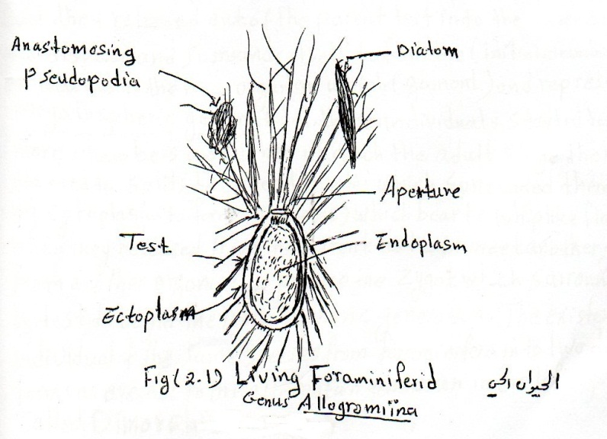

Life Cycle of Foraminifera
The life cycle of foraminifera is characterized by an alternation of generations, the first is megalospheric generation ( which it is individuals are more comman than the second generation) and the individuals of this generation are characterized by large proloculus, low number of chambers and smaller size, and they reproduce sexually. The second is microspheric generation which characterized by small proloculus, high numbers of chambers and large size, and they reproduce a sexually (Fig.1).
The life cycle of the foraminifera completed by the alternation of these generations as follow:
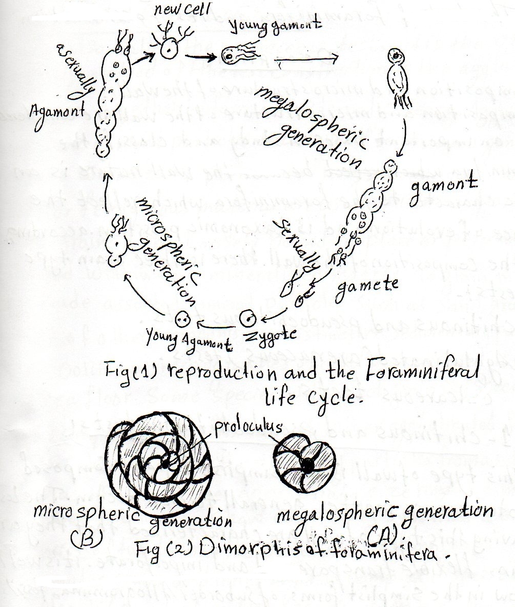
When the individuals of the microspheric generation (agament grow and be adult the cytoplasim began to splits by multiple fassion to several parts each part surround on of the nuclei after that they released out of the parent test into the water and disperse and surrounds itself to form the (initial chamber) proloculus to the new organism which (gamont) and the reperesent the megalospheric generation. These individuals started to add more chambers and when it reach the adult stage the nucleus started to splits serveral nuclei which surrounded there self to cytoplasim to form(gametes) which bear to whiplike flagella, when they released from the parent test and meet another gamete from another organism to produce the zygot which surround itself by test to begin the microlospheric generation. The existence of individual of the same species from forminifera in to two different forms as aresult to the alternation generation in the life cycle is called dimorphism Fig(9).

The test of foraminifera and it’s Fossilization
Description
1- composition and microstructure of the wall:-
Composition and microstructure of the wall are considered to be an important bases in study and classify the foraminifera because the wall nature is an basic character to the foraminifera which reflect the degree of evolution and is taxonomic position according to the composition of the wall there is three main type of tests :-
1 – chitinous and pseudochitinous tests.
2 – Agglutinated (arenaceous) tests.
3 – calcareous tests.
1 - chitinous and pseudochitinous tests :-
This type of wall is the simplist type it composed proteinaceous matter general termed tectin. The test having this type of wall are characterized that they are thin. Flexible transparented and imperforate. It is well know in the simplist forms of suborder allogromina, fossils of this type of wall are rare in due to it is low resistance to weathering factores. In few cases the foraminifera having this type of wall collect sand or mineral grain on the outer surfaces of the test. Fig(1)
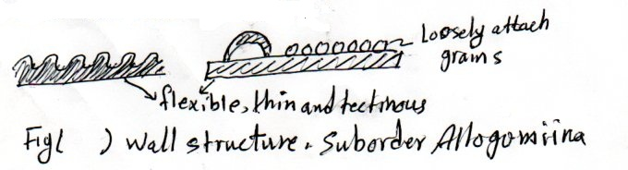

2 – Agglutinated (arenaceous) tests :-
It is also called the arenaceous tests, it is the test geologically method of the test construction is the agglutination of particles together to form an external covering. Agglutination feraminifers cement particles on to layer of tectin, an organic compound composed of protein and poly saccharides, calcites, silica, or ferruginous material are used to cement particles causing grains to be loosely bound in place or permanently cemented within this mineralized matrix. To grain involved may include assorted mineral particles such as sand grains, the test of the microganisms, distinctive sedimentary particles such as Qolite , or microgranules of calcite scavenged of the deep-sea floor. Some species will select grains of specific size and composition to affix the test, other agglutinated forms are non-selective and will employ any particles from a substrate as
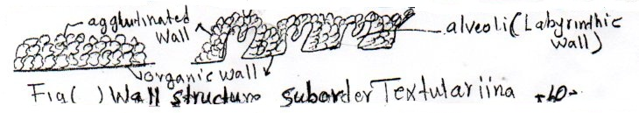
Long as it lies in the appropriate size range. Some agglutinated foraminifera show complexity by having a thick wall consist of two layers, the outer smooth consists of micro granular grains and inner layer is complex disperse through it the alveoli (singular Alveolus) appearing in cross section spongy appearance and this type of wall called Labyrinthic(Alveolar) wall, known some large foraminifera genus ex-Loftusia. The agglutinated tests may be perforate or imperforate and it represent the advanced stage to the chitinous test through the evolution of the foraminifera wall. This type is well known in suborder Texturaina, Fig(2).

3 – calcareous tests :-
This type tests are by far the most abundant and occur in all remaining suborder of forminifera, it consist from calcite or aragonite crystalls which the animal produce it, According to the arrangement of the crystalles there are three type of tests: -
3-1 microgranularcalcitic tests:
3-2 calcareous porcelaneous tests:
3-3 calcareous Hyanline tests:
3-1 Microgranularcalcitic tests:
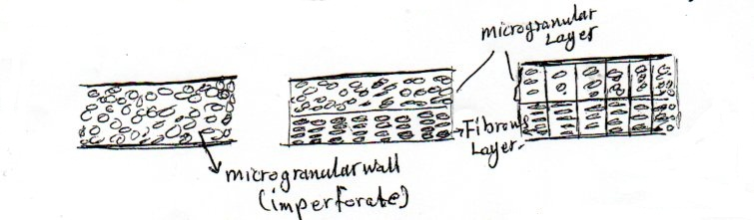
This type is well known in suborder Fusulinina the well mainly from Paleozoic. The wall is consists from microgranular particles of calcite of equal size, and well cemented by calcareous cement. The particles may distributed randomly or may organized in a uniform perpendicular rows on outer surface of the test giving it an fibrous appearance in the cross section. The wall may be consist from one layer or more and may be perforate or imperforate, Fig (3).

Fig. 13 wall structure – suborder Fusuulinina
3.2 calcareous porcelanous tests: -
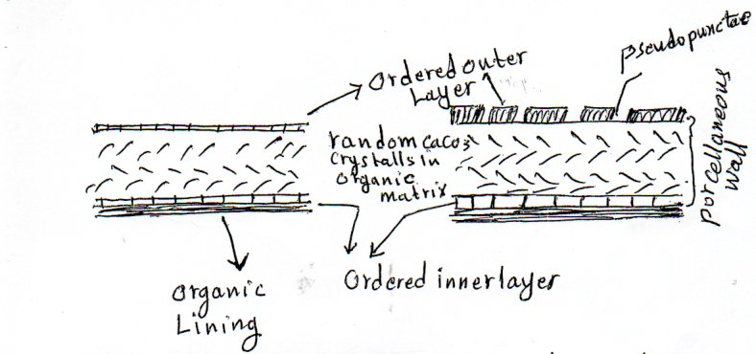
The term porcelaneous derived from the shiny, smooth appearance of the test and is the result of the orientation of submicroscopic crystals of calcite that form the chamber walls. The wall consists of microf granular calcite crystals with high proportion of (mg). porcelaneous wall generally two layers, the crystals randomly arranged except the outer layer of the wall arranged in one row. Porcelaneous tests imperforate except the family milioloporidae and some genera of family Soritidae like juvinal stage of the genus peneroplis. porcellaneous tests know in suborder miliolina.

Fig. 13.6 wall structure – suborder Miliolina.

3.3 Calcareous hyaline tests
Calcareous hyaline tests known in suborder potaliina the tests is characterized it is glassy appearance and transparent, the transparency may affected when there is inclusions in the composition of the test or due to existence of sculpture on the surface or the wall very thick. These tests composed of calcite or aragonit crystatls and perforated. When the crystatls is arranged perpendicular on the surface the type of wall structure is termed radial hyaline. When crystatls are oriented randomly the test is granular hyaline. Less common are hyaline tests composed of asingle calcite crystal is termed monocrystalline hyaline. The calcareous hyaline tests characterized in calcareous lamination or lamellae in non – lamellar forminifera, a new chamber is accelent to the preceding chamber and separated from the previous chamber only by a single thickness of septum. by distinction, lamellar groups such the Rotaliidae, newly accelerate material may form the new chamber as well as cover the entire outside of all previous chambers- thus lamellar tests are easily recognized by thicker early chambers, the thinner later chambers and the single thickness of final chambers.
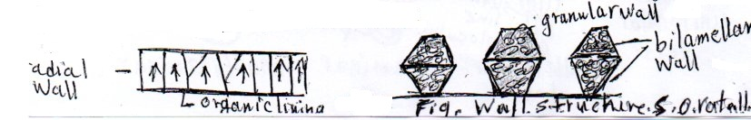

Chambers Development:
Forminiferid tests may consist of:-
1. Single chamber (unilocaular).
2. Two chamber (Bilocular).
3. More chambers (multilocular).
In unilocular forms chambers growth proceed gradually along with protoplasm growth. In multilocular forms protoplasm growth is gradual, but test growth is periodic, but there is no overlap of previous walls by the new wall, the arrangement is termed non laminar if over lap occurs, thin sections reveal the layers of successive walls (i-e multilamina) each lamina may also be composed of two distinct famellae (i-e bilamellars) different type of lamellar walls have been used in classification of the non-laminar fusuliina and multlaminar Rottalinna.
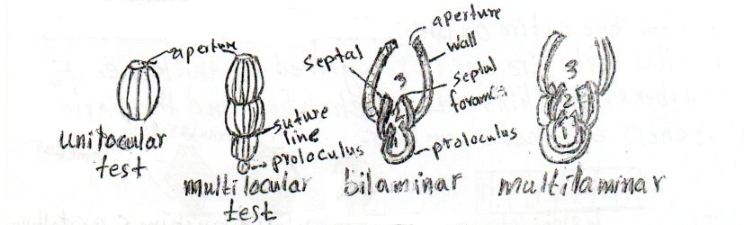

2- chambers test shape and chambers arrangement:
Shape of test:
Foraminiferal test may possess one chamber (Unilocular) or more chambers (multilocular).
Shape of chamber range from spherical, Ovate, Pyriform, Tubular, Radiate, Cyclical, conical, ….. etc.
Shape of test that are common Biconcave, Lanceolate, Conical, Fusiform, Lenticular, Discoidal, Flabelliform and Plano – Convex … etc

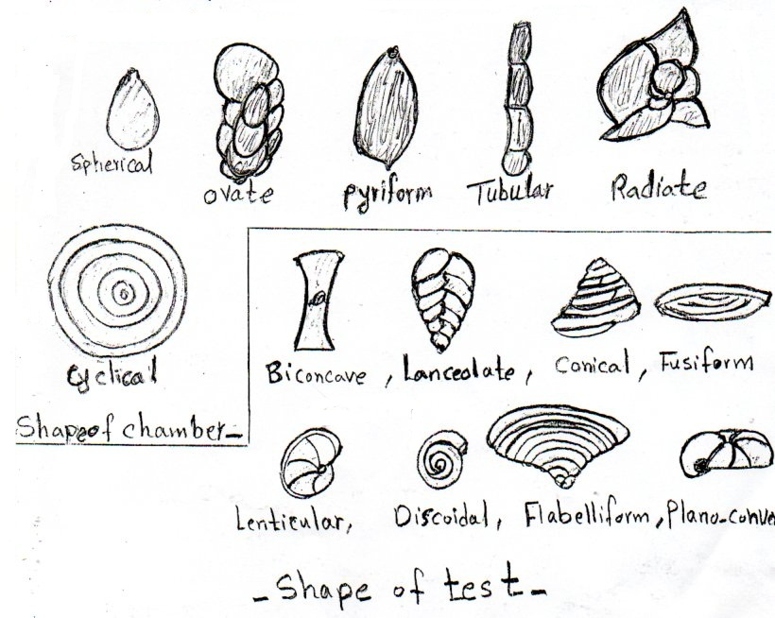
Arrangement of chambers: -
Chambers are added in a variety of patterns:
1- Uniserial manner: A single row of chambers (if it form curved row it is termed arcuate or curvilinear, if a straight row it is formed rectilinear.
2- biserial manner : two rows of chambers.
3- Triserial manner: three rows of chambers.
4- planispiral arrangement: chambers arranged spirally around an axis of eoiling and the spiral lies in one plane.
5-Trochospiral arrangement: the spiral does not lies in one plane, but progresses up to the axis of coiling, the chamber arrangement becomes helicoidal. When a series of chambers is arranged spirally or coiled about an axis, chambers involved in one complete revolution are termed a whorl, or coiled. The degree to which one whorl covers or hide a previous one is known as the degree of involution. When the majority of previous coils are hidden a species is termed Involute. while Evolute if the majority of previous coils are visible. On a coiled test the side of forminifera showing the trace of coil, or spiral is termed spiral side. The opposite side is termed the umbilical side.
5- Annular or cyclic tests:
It tests result when a spiral begins but enveloped in concentric chambers, and chambers divided to chamber lets of the separated by secondary septulo ( or septum)
6 – Annular of cyclic tests: it tests result when a spiral begins but enveloped in concentric chambers, and chambers divided to chamberlets of the separated by secondary septula (or septum)
7 - Streptospiral test: -
The miliotrdae have a streptospiral arrangement. The arched chambers tangential at their two extremities with extension axis, are arranged in cycles of five, three or two loculior one loculus.
8 - Multiform arrangement: ex. Planispiral to triserial to Biserial

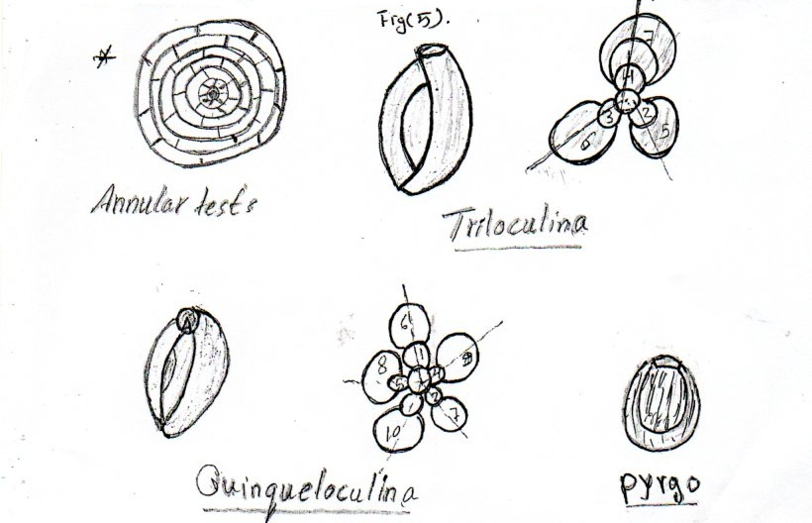

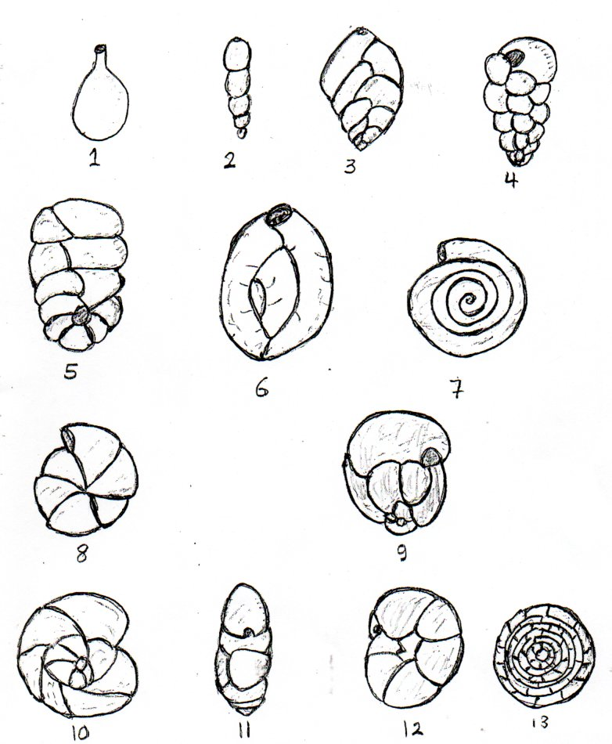
Principle types of chambers arrangement. 1. Single chambered; 2. Uniserial; 3. Biserial; 4. Triserial; 5. Planispiral to biserial; 6. Milioline; 7. Planispiralevolute; 8. Planispiral involute; 9. Strep to spiral; 10. Trochospiral (dorsal view); 11. Edge view; 12. Ventral view, Redrawn from Toebliche and Tappan 1964; 13. Cyclical coiling.
3- Apertures and opening: -
The apertures is the primary opening of the test to the outside apertures vary in size and shape (In your practical deseription apertures is described according to it’s shape, position and the additional structures ( modification) present in them. Characteristically one a perture termed the primary aperture distinguishes the apertual side of the foraminifer. If two or more apertures occur on one chamber ( as in the Eocene planktonic genus globigerinatheca), they are termed supplementary apertures. The size or shape of an aperture may vary with environment.
There are various structures that may modify the apertural opening like tooth lip, phialine lip, bulla (structure that partially or completely cover primary or secondary apertures.
A perture may be terminal, areal, basal, extraumbilical, umibilical or sutural in position. There shape varies widely e.g. rounded, bottle necked (phialine), radiate, dendritic, sieve – like (Cribrate), slit or loop shaped.
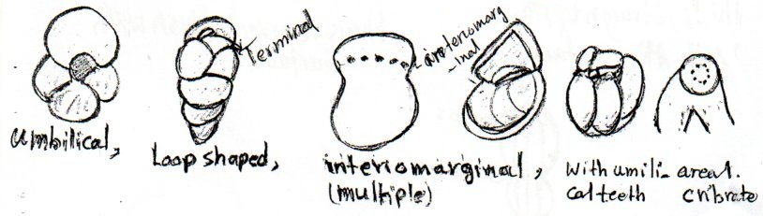

Principle types of apertures
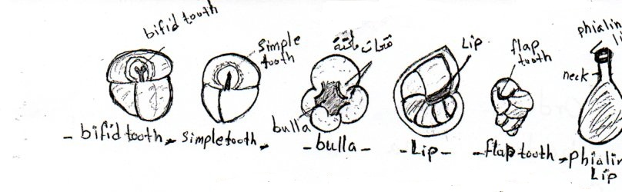

- Supplementary apertural stractures –
Suture: line of union between two chambers or between two whorls.
1. thin, Curved, depressed
2. thick, straight, flush with the surface.
3. thin, straight, flush with the surface.
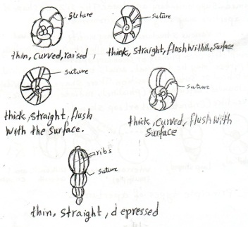
4. thin, straight, depressed.
5. thick, curved, raised.
6. thick, straight, depressed.

- Suture shape –
4- Sculpture or Ornamentation: -
The external surface of the test may bear spines (termed spinose) , keels(Carinate), rugae (rugose), fine striae (striate), coarse coastae (costate), granulas (granulate) or areticulate sculpture.
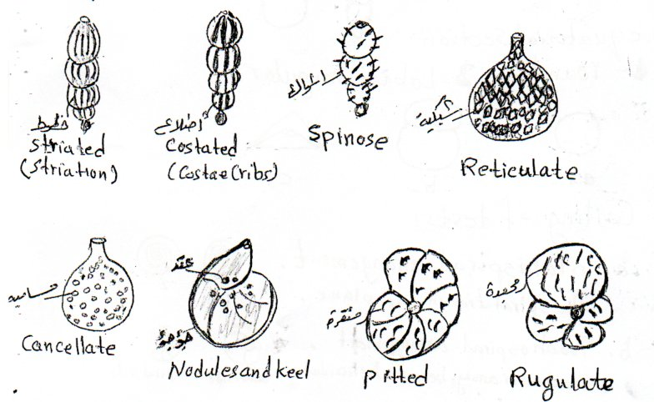

Sculpture in the test of foraminifera
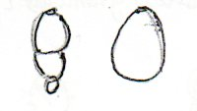
Periphery of test:-
1- serial of tests: a- axial section lobat, entire
b. equatorial section:
1. rounded, 2- Lobate, 3- angular
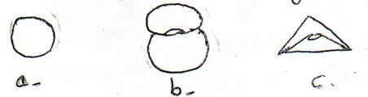
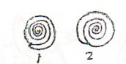
2- Coiling of tests:
a- planispiral arrangement.
The spiral lies in one plane.

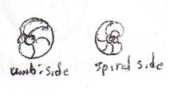
b- trochospiral arrangement
the chamber arrang becomes helicoidal.
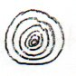
c- cyclical arrangement.
The chambers arrange concentric chamber
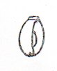
3- streptospiral test.
The miliolidaearrang.

Classification of Foraminifera:
- Kingdom Protista * Order, the end of da
- phlyum Protozoa * Suborder, the end of na
- class Rhizopoda * Super family, the end of cea
- order Faraminiferied * Family, the end of dae
The first classification system established by D Orbigny, 1826, followed by many systems, the final classification of loeplich and Tappan in 1976, the depending in their classification in the following basis.
1- Wall composition and microstructure.
2 – Shape of chambers.
3 – Arrangement of chambers.
4 – Type of aperture and modification.
5 – Life habits and environment.
Depending on this system and according to the wall composition the foraminifera cataegorized to (5) suborder which they are :-
1 – Suborder Allogromiina (U. Cambrian – Recent) .
2 – Suborder Textulariina (L. Cambrian – Recent).
3 – Suborder Fusulinina (Ordovician – Triassic)
4 – Suborder Miliolina (Carboniferous – Recent)
5 – Suborder Rolatliina (Permain – Recent)
1 – Suborder allogromiina (U. Cambrian – Recent) .
The wall of the test is chitinous or pseudochitinou thin , transparent and not perforate. The test unilocular, spherical, Sac or tube shape. The fossils of this suborder rare because of the organic nature of the test which is decay fastly. This suborder contain one superfamily Lagynacea, it individuals known now from fresh and brakish water, there fossils known from marine sediment science late Cambrian ex. Allogromia , Shepheardella.
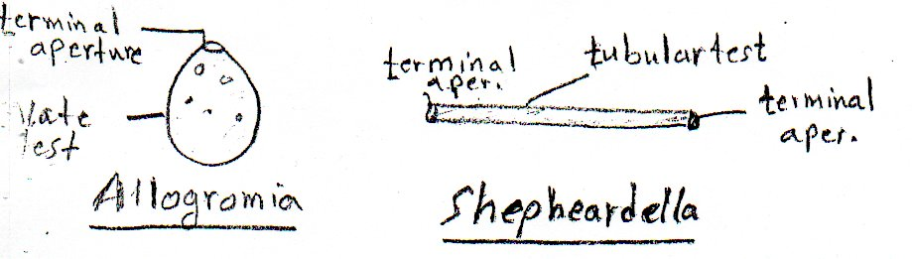

2 – Suborder Textulariina (L. Cambrian – Recent).
The test , agglutinated perforate or imperforate, it’s contain two superfamilies according to nature of chambers of the test.
2 -1 SuperfamilyAmmodiscaces (L. Cambrian – Recent)
The test often unilocularwith simple shape , spherical, ovate, tubular, branched, ununiform and the test planispiral, aperture terminal (single or multiple). From it’s common genera.
Bathysiphon :- (L. Cambrian – Recent) : tubular test opening the two ends.
Astrorhiza :- (M. ordovian – Recent) test radiating from a central point the aperture located at the end of tubular arms.
Rrhbdommina : (U. Ordovician – Recent) tubular branching test.
Ammodiscus : ( Silurian – Recent) : test discoidal consist of initial chamber followed by second tubular planishirral coiling chamber.
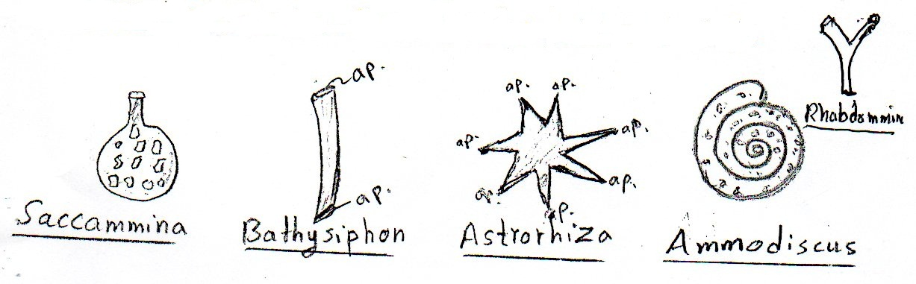
Saccammina : (Silurian – Recent) : the test spherical.

2 – 2 Superfamily Lituolacea (Up. Devonian – Recent) :
Test multilocular, uniserial, biserial , triserial , planispiral or trochospiral and some of it’s genera has multiform arrangement. a pertural terminal (single or multiple). This superfamily contain many of large genera.
This superfamily contain many of large genera.
Dorothin (L. Cretaceous – Recent) : the chambers in the early stage is trochospiral coiling then became biserial Textularia (Up. Carboniferous – Recent) chambers biserial and from the large genera there are:
Loftusia (U.cretaceous) test planspiral coiling, involute cylindrical or fusiform shape, size about (80) mm or more, wall Labyrinithic, the chamber divided to chamber tets know from Aqratm chamber tets.
Orbitolina (U.L cretaceous) test conical shape, trochospiral
Coiling in the early stage then became uniserial the chambers like saucer – shaped arrangement in one row, chambers divided to chamber lets. The chamber consist of two region, marginal zone and central zone the later divided to two zones, the radial zone with secondary radiate septa, and reticulate zone with secondary more reticulate septa. Known from Qamchuqa and sarmord formations.
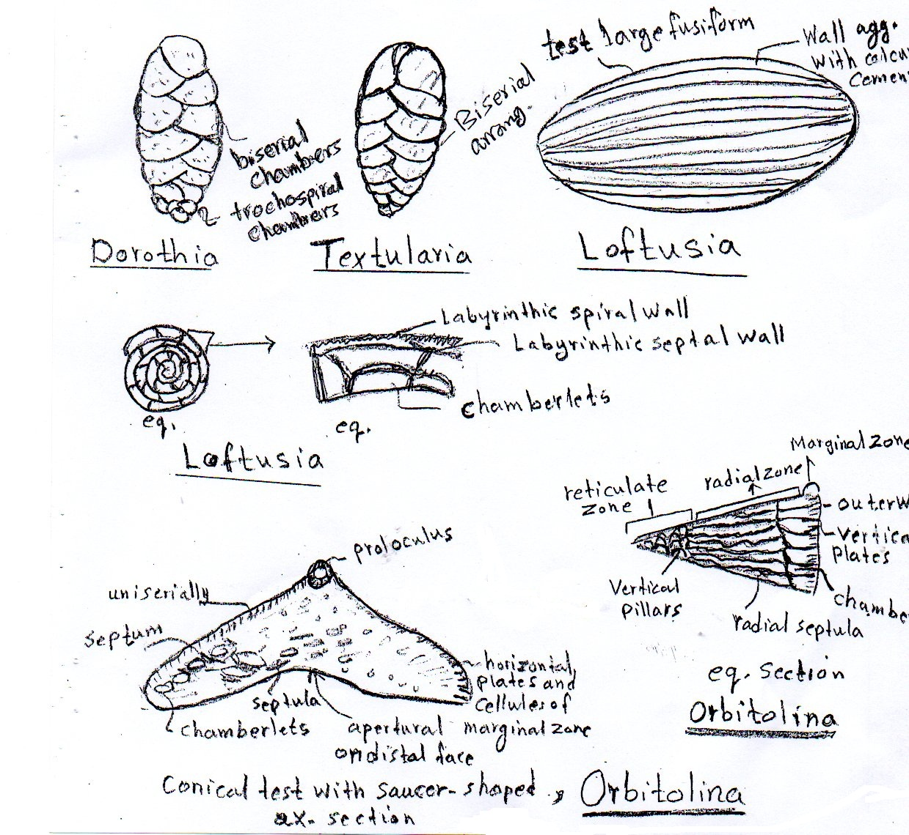

3- Suborder Fusulinina (Ordovian – Triassic).
The test is calciticmicrogranular, wall perforate or imperforate, in the primitive forms wall is of one layer but in the other forms multilayers.
This suborder divided according to wall composition and arrangement of chambers to three super families:
1- Superfamily Parathuramminacea (Ordovivan – Carb).
2- Superfamily Endothyracea (Silurin – Triassic).
3- Superfamily Fusulinacea (Carboniferous – Permion).

1. Supperfamilyparthuramminacea (Ordovision – Carb).
The wall of one layer, Imperforate, the test is unilocular, spherical, tube shape, or multiloculare with uniseral arrangement, aperture (single or multiple)
Ex: Saccamminopsis (Ordovician – Carb.) Erlandinita (Carboniferous) both are Uniserial arrangement.

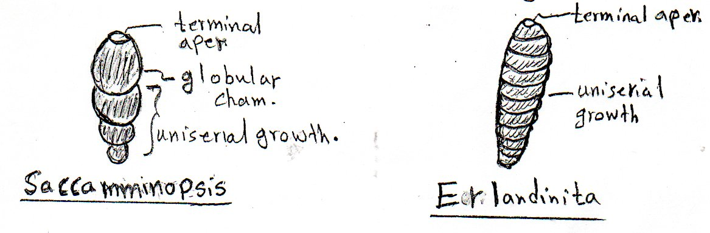
2- Superfamily Endothyracea (Silurian – Triassic)
The wall perforate consist of two layers, the outer layer is calcitic micogranularand the inner is fibrous also microgranular but of fibrous owing to the perforation test is multilocular, chambers are simple or divided to chamberlets. The chamber is of uniserial, bisserial, planispiral or trochospiral, aperture (single or multiple).
Ex: palaeotextularia (L – Carboniferous – Permain), chambers is biserial Tetrataxis. (L-Caboniferous – Triassic). Chambers is of trochospiral.

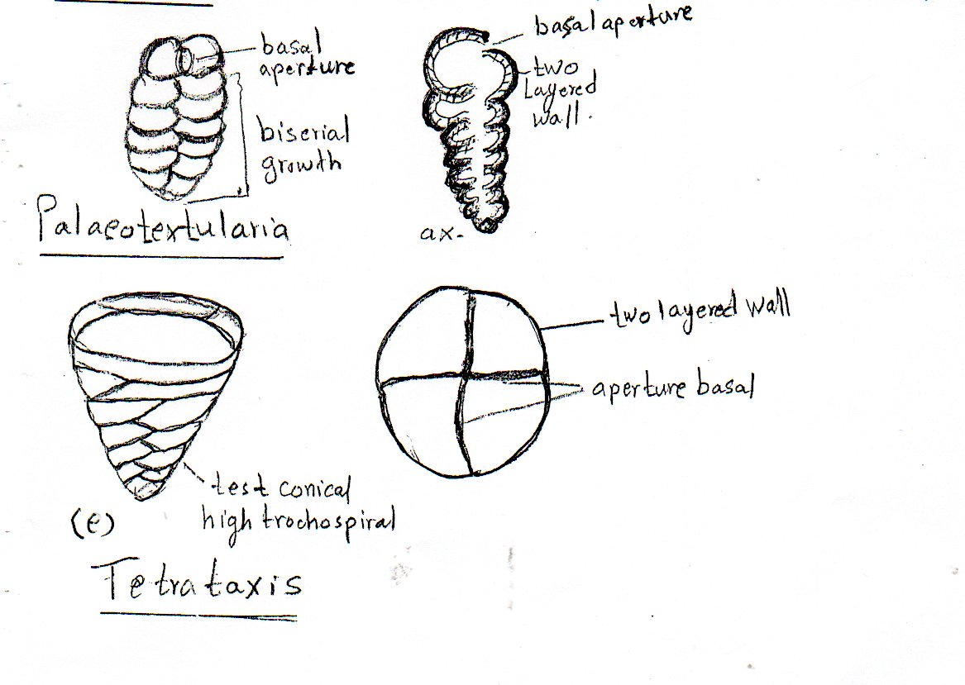
3- Superfamily Fusulinacea (Carboinferous – Permain):-
The individuals of this suborder were large forms and have a complex internal structure, test multilocular, planispiral arrangement, fusiform to semi cylindrical and in the primative forms the shape is discoidal or spherical, chambers divided to chamberlets, the wall was penetrated by mural pores, the wall consist of two to four layers, aperture at the base and multiple. This suborder contain genera characterize by rapid evolution, short geological range, so its very important in carboniferous and permain biostratigraphy. Ex Fusulina (Up.Carb) and Schwagerina (Permian).
The wall types in Fusulinacea: -
In the primative forms the spirotheca consist from central dark layer termed tectum surrounded from upper and lower which is more light and more thickness the upper layer termed upper tectorium and the lower termed lower tetorium. This type of wall termed the wall of three layers its known in genus Profusulinella
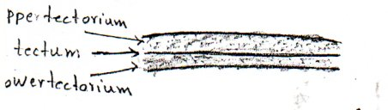

In the other genera there is fourth thick and transparent layer below the tectum layer termed diaphanotheca and the wall is termed the wall of four layers and this type known in genus fusulina.
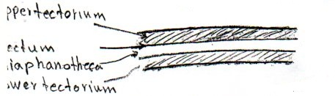

In orther forms such as Triticites and Schwagenna the wall consist from two layers, the outer layer tectum and the innel layer termed keriotheca with alveolar structure.
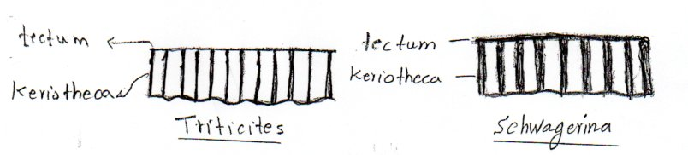
The evolutionary trends of Fusulinid:
1- The change in the shape of the test from discoidal to spherical to fusiform or semicylindrical.
2- The complexity of the wall and increasing in thichness.
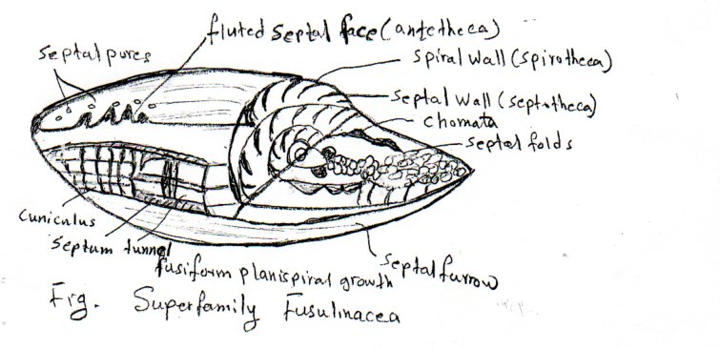
3- Modification from the septa from flat to regulate pattern.
4- Suborder Miliolina : (Carboniferous – Recent).
The Miliolina have imperfoate calcareous test of porcelaneos appearance. Test uniserial or multlocular, simple or divided to chamberlets, aperture, single or multiple (terminal, oreal, basal) is some genera it has modifications.
Superfamily Miliolacea involved to: -
1- Family Miliolidae (Jurassic – Recent).
Chambers is of an tubular shape, simple sometims divided, with milioline (streptospiral) arrangement, aperture terminal, single or cribrate modified by single tooth or bifid tooth.
Chambers arranged in different planes along the growth axis if the chambers are added at angle of 144° degree with the proceeding chambers so in this pattern the last five chambers will be visible from outside of the test pattern termed (Quinqueloculine arrangement) as in genus (Quinqueloculina [Jur – Re])
If the chambers are added at angle of 120° degree with the proceeding chambers so in this pattern the last three chambers will be visible from outside of the test and this pattern termed (Triloculine arrangement) as in genus Triloculina (J-Re).
This family encompasses genera which they are good indicaters to paleoecological studies they exist in shallow, warm, lagoonal environment and in back reef with hortmal to hypersaline salinity.
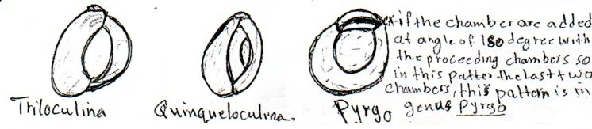

2- Family Soritidae (U.Triassic – Jurassic): -
In the early stage the test is planispiraly coiling then become cyclical as in Orbitolites (Up.PaleacenetoEocene), or it may be change to uniserial as in Spirolina (Eocene – Recent). Chambers may be divided as in Orbitolites. Aperture single or multiple.
The genera of this family exist in carbonate and reef environment of warm water. ex. Dammam and Avanah Fm.
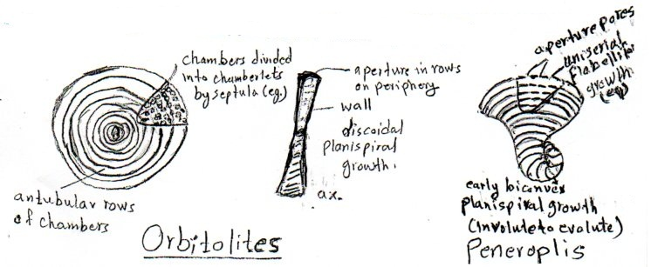

3- Family alveolinidae (Cretaceous – Recent).
Test imperforate, planispiral coiling involute, large sized with fusiform, semicylindrical, discoidal, Ovate or Spherical shape, chambers divided by septululae into numerous tubular chamberlets arranged into one row or more. Aperture multiple arranged in one row or more. This group exhibits remarkable convergence with Superfamily Fusulinacea (L . Paleozois), this convergence has no any evolutionary relationship between these two families. The Alveolinides are well known from shallow and reef environments. Modern genera are found in shallow tropical environments. Due to its large size and abundancy of tests it considered to be sedimentary rock (building) forming. ex. Fasciolotes (Pa.Eo).
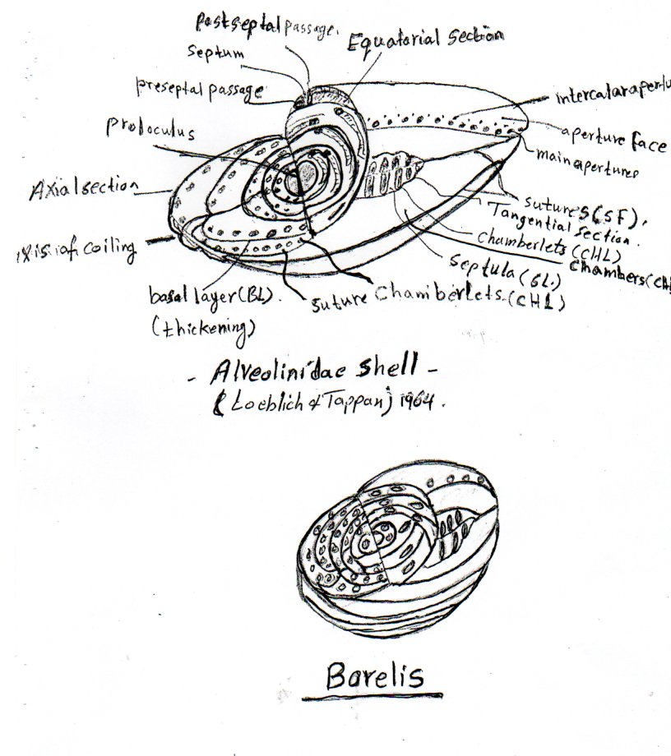
Borelis (Up.Eo-Rec)

4 – Suborder Rotaliina (Permian – Recent).
Test calcareous hyaline, perforate, wall lamellar it forma large and more evolutionary suborder of foraminifera.
- it classified to 12 superfamilies according :-
1 – composition and microstructure of the wall.
2 – microstructure of the wall.
3 – arrangement of the chambers.
4 – nature of aperture.
These superfamilies are :-
1 – Superfamily Nodosariacea (Permian – Recent)
Wall radial hyaline, test unilocular, ex. Lagena (Jurassic – Recent), uniserial as Nodasaria (Permian - Recent) or planispiral as Lenticulina (Triassic – Recent).
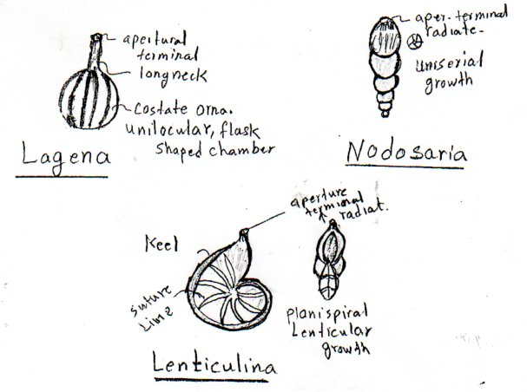

2 – Superfamily Buliminacea (Jurassic – Recent).
Wall radial hyaline, test perforate, chamber of biserial arrangement Bolivina (Up. Cret – Recent), triserial arrangement Bulimina (Palea – Recent). Aperture basal or terminal, may be situated on a short neck, chambers of multiform arrangement.
Rectobolivina (M. Eocene – R).
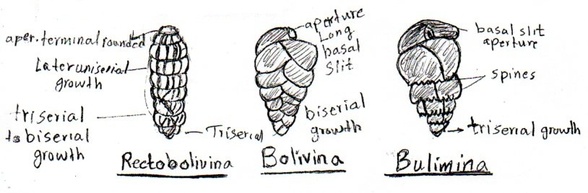

3 – Superfamily Discorbacea (Cretaceous – Recent).
Wall radial hyaline, trochospiral coiling, aperture always situated on the innermargine of the last chamber.
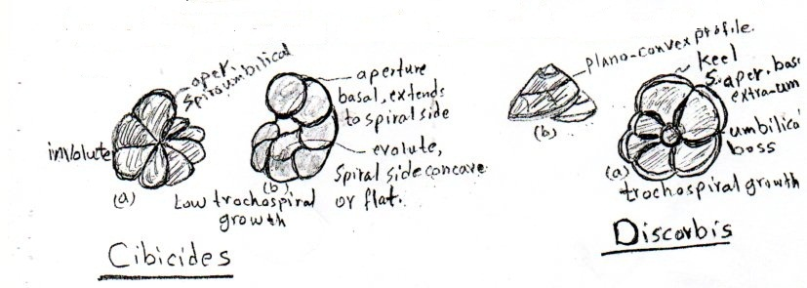
Cibicides (Cret – Rec) is distinguished by spiroumbilcal aperture, Discorbis (Eocene – Rec) is distinguished by secondary aperture on the Suture line and umbilical boss.

4 – Superfamily Spirillinacea (Trriassic – Recent).
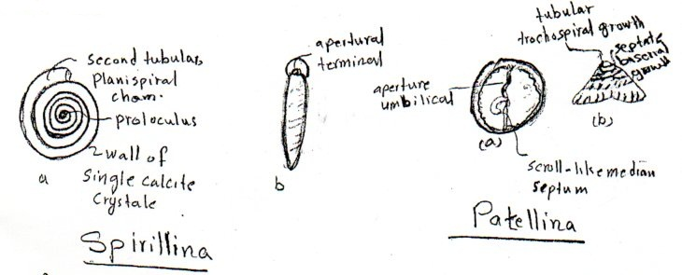
Wall radial hyaline, mino crystalline or consist of from many calcite crystals. It consist of proloculus (initial chamber) and second tubular chamber with planispiral coiling as spirillina or trochospiral then became biserial as in patellina (Cretaceous – Recent).

5- Suerfamily Duostominacea (Triassic – Jurassic)
This considered to be an transitional group between foraminifera of microgranularcalcitic tests and those of radial hyaline, so it’s is consist of both types of component. trochospiral coiling, aperture singular or multiple.
ex: Duostomina (M.Triassic).

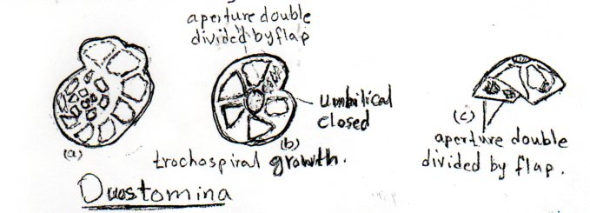
6- Superfamily Rotaliacea (Up.cretaceous – Recent).
Wall radial hyaline, test of planispiral or trochospiral coiling. In large genera chambers divided to chamberlets.
This group characterized by the existence of canal system in the thickening parts of the test ( in the suture line and the umbical region) a perture single or multiple.
ex: Rotalia (Up.cretaceous – Recent) is characterized by it’s great onamentation on the Umbilical side. Ammonia known from brakish water environment. Elphidium (Eocene – Recent) is characterized by short lines between suture line separated by fossettes and the chambers characterized by retral processes.
This group encompasses many of the large genera which most of them is in the family Nummulitidae (Up.cr – Rec).
ex. Nummulites (Paleocene – Recent) of discoidalplansipiral involute coiling. Which of a great importance in the correlation of lower Tertiary, due to their wide distribution and high abundancy so it’s arock forming which is called Nummulitic limestone. The lower Tertiary (Paleogene) is called also the Nummulitic period. Nummulites is found in reef, shallow water environment. ex.ratga. Avanah, shekalas and Dammam Fm.
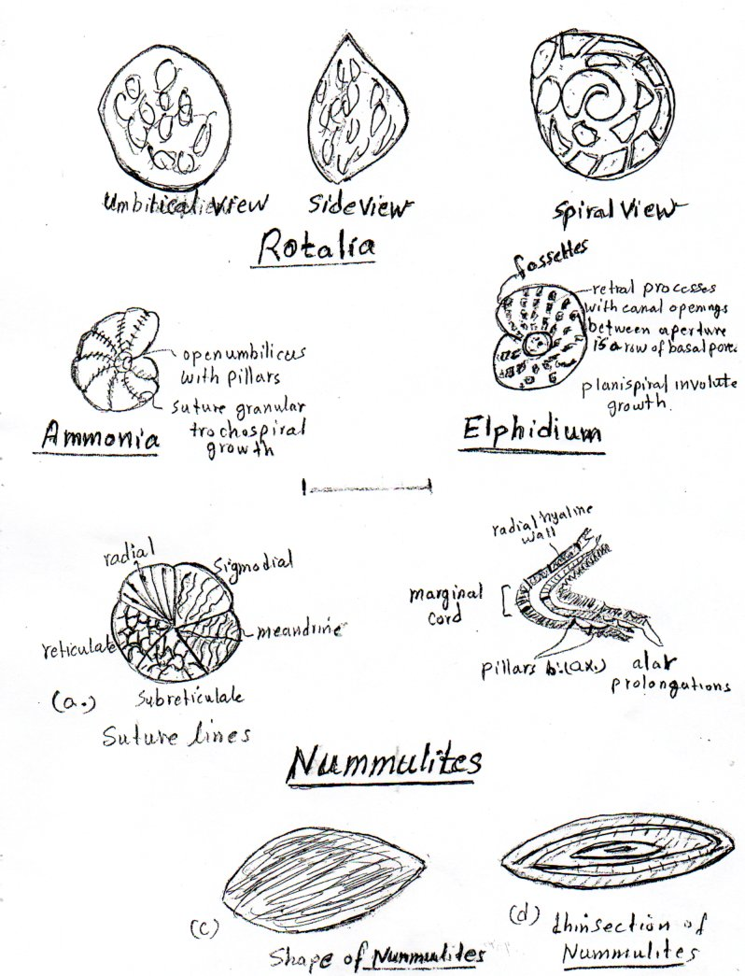

7- Superfamily Globigerinacea (Jurassic – recent)
Wall radial hyaline, test of planispiral or trochospirl coiling or arranged in rows.
This group is characterized by it’s planktonic habits, it’s globular or semiglobular chambers aid it to float in water as well as having wide pores and the surface covered by fine spines. Aperture always single, basal or interiomarginal, many of it’s genera have secondary a pertures and modification such as bulla and lip.
Superfamily Globigerenacea consider to be very important in biostratigraphical studies because it have: -
1- planktonic habits.
2- wide geographical distribution.
3- short geological range.
Example: -
Globotruncana (Up.-Cret) characterized by it’s truncated chambers and single and double keel.
Globigenia (Paleocene – Recent) test of trochospiral coiling.
Globorotalia (Paleocene – Recent) test of trochospiral coiling.
Globigerinoides (Late Oligocone-Recent) has secondary apertures.

8- Superfamily Orbitoidacea (Up.-Cretaceous – Miocene)
This group contain many of large which considered to be an index fossils to Up.-cretaceous – Miocene sediments.
It’s well known from tropical and semitropical marine and reef environment structure. Chambers with cyclical arrangement or in one plane. Two groups of chambers can be distinguished:
1- Equatorial chambers which lies in a median layer surrounded the juvenarium.
2- Lateral chambers kies in many layers around the equatorial chambers. Aperture absent, chambers connected by stolons.
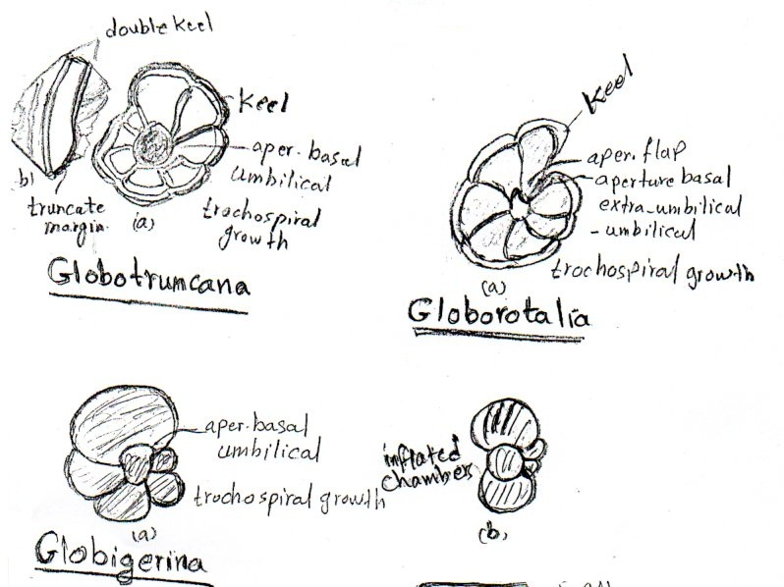
Example:-
Orbitoides (Up.cretaceous) juvenal chambers (2-4)
Surrounded with thick walls.
Discocyclina (Paleocene – Eocene) juvenal chambers (2), wall penetrated by calcareous pillars, chambers connected by stolones.
Miogypsina (Up.oligocene – L – Miocene) Juvenal chambers (2) near the margine of the test, test has canal system.
Lepidocyclina (Eocene – M.Miocene) Juvenal chambers (2) chambers connected by stolones.
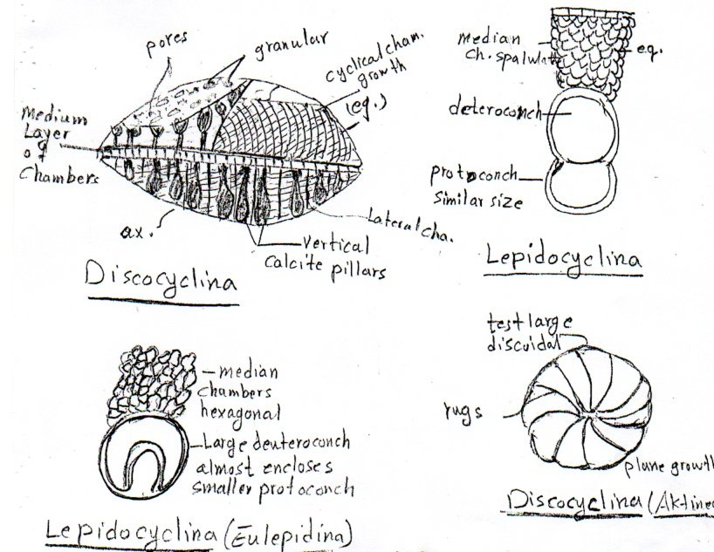

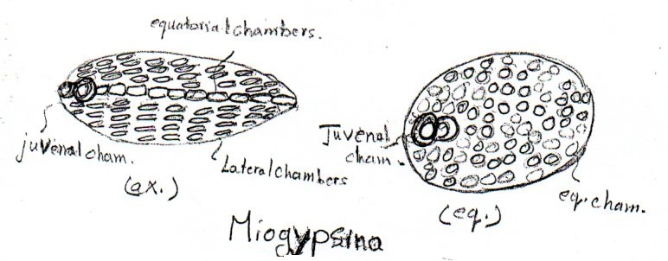

9- Superfamily Cassidulinacea (Cretaceous – Recent).
Test granular hyaline, planispiral or trochospiral coiling or arranged in serial Aperture slit like, some has secondary apertures. ex. Loxostomum (Up.eret – Paleocene).
10- Superfamily Nonionacea (Jurassic – Recent).
Test granular hyaline, Aperture slit like basal.
ex: Nonion (planspiral-recent) , planispiral coiling test.
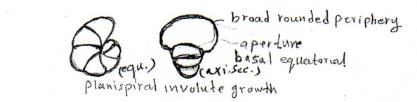
11- Superfamily carterineccea (recent)
The wall consist of calcareous spines, monocrystalline parallel each to other. Chambers are trochosipral coiling divided chamberlets. Ex Carterina (rec.)
12- Superfamily Robertinacea (Tertiary – Recent).
Test radial hyaline composed of aragonite, chambers trochospiral coiling simple or divided to chamberlets and may have secondary apertures.
ex: Ceratobulimina (up.Cret-Rec). the test low trochaspiral ?????

Geological history foraminifera:
1- Lower Paleozoic:
In the geological record the oldest foraminiferal fossils are of simple, unilocular forms of agglutinated tests.
ex: Bathysiphon (Lower Cambrian).
Although there is no dating to foraminiferal fossils in the Precambrian interval so this agglutinated foraminifera considered to be the ancestral to simple form of Allogromiida family of which it may has or has not an organic wall in Precambrian to leave fossils in this interval.
Chitinodendron from Up.cambrian represent the oldest form of the chitinous foraminifera.
In Ordovician appear the first calcitic microgranular tests as Saccamminopsis.
In the early Paleozic (Cambrian – Ordovician – Silurian) the forms still with limited distribution and represented by simple unilocular and form of tubular coiling appear in Silurian such as Ammodiscus.
2- Late Paleozoic (Devonian – Carboniferous – Permian).
At the begining from Devonian the foraminifera assemblages show the first wide distribution accombined with some basic evolutionary trends which they are:
1- calcareous wall from the cells of the animal and formation of multilocular tests (due to the formation of septa in Late Devonian.
2- Through Carboniferous the porcellaneous tests appear as well as the trochospiral coiling.
3- Through Permian the calcitic hyaline tests appear.
This distribution remain to the Late Paleozoic, reaching, it’s acme zone (Limite) in late Carboniferous and Permian when Superfamilies Endothyracea and Fusulinacea flourished and Fusulinacea flourished and reached their acme limiteindistribution and evolution. Then all the fusulinids extinct at the end of Fermain.
3- Mesozoic (Triassic, Jurassic, Cretaceous).
1. In Triassic the foraminifera show distribution and limited diversity.
2. In Early Jurassic the foraminifera entered the second stage of it’s wide distribution and evolution contined through Cretaceous and Tertiary (with some exception in K/T boundary and the end of paleogene.
3. In the Jurassic appear the first planktonic forms as (Gubkinella). The benthic characterized by the dominance of Miliolids, Codosarids and Textutarids, which characterized by complex wall and internal structure.
4- The above assemblage continue through the Cretaceous with the appereance and distribution of new large genera like (Loftusia, Orbitolina, Orbitoides) and other Alvoolinids genera.
5 - The planktonic foraminifera reached the top of it’s distribution in Late Cretaceous, such as the wide distribution of the Family Globotruncanidae of the distinctive importance in biostratigraphical studies in UP. Cretaceous and disappeared in late Cretaceous.
4- Tertiary:
In the Early Tertiary the forminifera began to distributed again by occurance of a new groups recognize foraminifera such as Rotaliids, Lituolids, Miliolids, Discorrbids, nonionids and from the planktonic foraminifera the familes Globigerinidae, Globorotalidae which they show a distinctive distribution in Eocene – Miocene.
In Tertiary appear new groups of large and important biostratigraphical genera
like Nummulites, Discocyclina, Miogypsina, Lepidocyclina and Fasciolites.
In the end of paleogene all the large foraminiferal forms disappeared and now it’s well know in a few genera from tropical environment, while the small benthic forms still wide distribution.
The evolutionary trends offoraminifera in Jurassic period are:
1- Completely finished the evolution of calcareous hyaline wall and distinguished, it to granular hyaline and radial hyaline.
2- The adaption successfully to planktonic habits.
3- Evolution of new group of large forms genera with complex internal structure.
4- Modification in a perture like (teeth, lip, and bulla).
Ecology of foraminifera
Foraminifera is a quatic most lived in oceans and seas it comprise an important part to the main ecological system foraminifera are benthic and planktonic:
1- physical factores (Temperature, Depth, Light, current, substrata, Turbidity).
2- chemical factores (salinity and dissolved gases).
3- biological factoes (food supply).

1- physical factores:
Temperature: -
It is important factores that affect the distribution of foraminifera lateraly (geographically) and verticaly (water depth).
The foraminifera known from temperature ranged between (1-40) degree but the best degree for distribution anddiversity is between (19-29) dagrees Temperature a Heeten on foraminifera as well as it play an important role on the building and construction of tests (especially calcareous tests) some of foraminiferal species change its depth position when it change it’s geographical position (Laterally or latitudinally) because they are adapted to certain temperature. Each species is adapted to acertain range of temperature condition.

Depth:
The physical factores (temperature, light, food supply and Oxygen gas) are affected and changed through the change of foraminiferal depth in water column.
Foraminifera know from shallow water to the deeper environment which reach 5000 meters, but it’s great distribution in the continental shelf margin which not exceed (200 meters) in depth because this region is of typical ecological condition. The benthic foraminifera distribution will decrease with the increasing of depth and it will disappeared in the great depths the dominace will be to the agglutinated in depth exceed (3000 meteers).
Planpv,t tonic foraminifera great distribution take place between the surface to (200) meters in the off shore margin.

Stenotherm: - describes an organism unable to lerateawide range of temperature.
Eurytherm: describes an organism that can to lerateawide range of temperature.
The stenotherm species can change there position in the water column when it changed there geographical location to reach it’s favourite temperature.
The light: -
The light affect the distribution of foraminifera through the affect of light on the phytoplankton which made the food of foraminifera.
Currents: -
Currents affect is abvous on the empty tests by transporting the tests from it’s original position and a sorted it according to size.
Substrate: -
Till now the affect is not clear. The substrate when change some ecological factors will change too like (food).
Foraminifera are found in great amounts in the substrate composed of fine sand, silt and clay because this substrate is rich in food.
2- Chemical factores:
Salinity and dissolved gases…...
Salinity:
It is important factores. Most of foraminifera species are adapted to salinity range between 33% - 37%, this mean that the higher diversification is all in the normal saline water and this diversification will decrese in brakish and hypersaline water.
In brakish water the foraminifera is characterized by
1- low diverdity.
2- small size of test.
3- thin wall of test.
the brackish lagoon env. The foraminifera assemblage is from the agglutinated, the hypersaline lagoon are characterized by distribution of miliolid. The suborder Rotaliina will be in high percentage in the shallow water with normal salinity. The fresh water there is no foraminifera aaccept individual suborder allogromina such as Allogromia.

Dissolved gases: -
1- CO2:
CO2 has high concentration in great depths so it’s affect appear in the great depths in showing calcium carbonate deposition which is very important in test construction, and this explain why in great depths the dominance is to the foraminifera having agglutinated tests.

2- Oxygen:
The decrease in oxygen gas ratio down the ordinary limite causes to decrease in foraminifera diversity.
3- the Biological factores:
The food is the biological factores affecting the distribution of foraminifera, it’s important is to determine the variation in foraminiferal diversity in different ecological environments – so more foraminiferal diversity indicate more food supply in the environment.

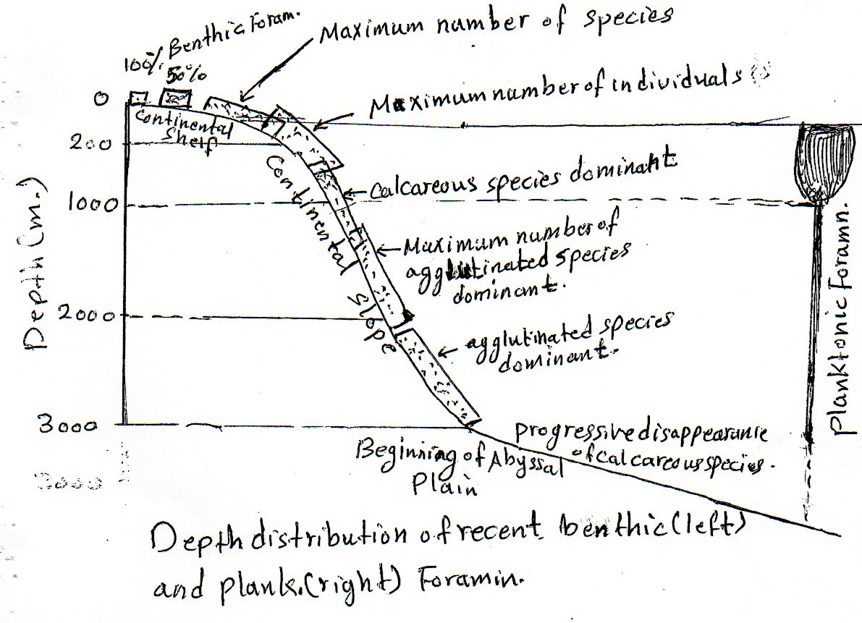

Application of Foraminifera:
Foraminifera application in geological studies is in two fields:
1- The biostratigraphical studies.
2- The paleoecological and paleogeographical studies.

1- the biostratigraphical studies.
Because the foraminifera has (wide geographical distribution, fast evolution, short geological range) so it has been used to divide and correlate the upper cretaceous and Cenozoic rocks all over the world.
2- The paleoecological and paleogeographical studies.
The foraminiferal fossils has been used in interpretation of different ecological factores such as:
1- Climate.
2- The depth of sedimentary basins.
3- Salinity.
4- Continental drift.

1- climate:
The narrower thermal adaption to planktonic speacies is consider to be a good indicater to the interpretation of paleoclimate.
1. The uses to change in the ratio of cold water foraminifera assemblage to warm water asemblages through Quaternary sequences.
2. The uses to change in the direction of coiling in the planktonic foraminifera of trochospiral coiling as well known in Globorotalia truncatulinoides and Globoquadrana pachyderma, the ratio of the sinistral coiling in crease in cold water while the dextral coiling ratio increase in the warmwater.

2- the depth of sedimentary basins:-
In determination to the paleobathymetry the studies depending on:
a- The ratio of planktonic / Benthonic foraminifera(P/B ratio), Tese indicaters will be increased with increased depth.
b- Numner and diversity of the foraminifera. These indicaters will be increased with increase of depth, and depth increasing distance from the shoreline.
3 - Salinity:
To determin the salinity of water and the geography of the sedimentary basin Murray, 1973 depend on the Triangular plot diagram which reflect the relative distribution of foraminifera groups (Benthic):-
Textulariina, Miliolina, and Rotaliina, the percentage to these three groups together indicates to certain environment from it’s salinity and geography.
In Triangle (1) the fresh water there is no foraminifera accept individual of Suborder Allogrominia such as the genus Allogromia.
In Triangle (2) the Rotaliina will be in high percentage in the shallow water with normal salinity, in this environment there will be high diversity of foraminifera.
In Triangle (3) the brackish lagoon environment and estua ries, the foraminifera assemblages from the agglutinated which has no calcareous cement material as genus Reophax in addition to some Rotaliina as Ammonia. The diversity of foraminifera in this environment is low.
In Triangle (4) of normal marine Lagoon and carbonate platforms and Triangle(5) of hypersaline lagoon are characterized by the distribution of miliolid as Triloculina and Guinqueloculina, as well as some distinctive Rotaliids as Cibicides – some of foraminifera.

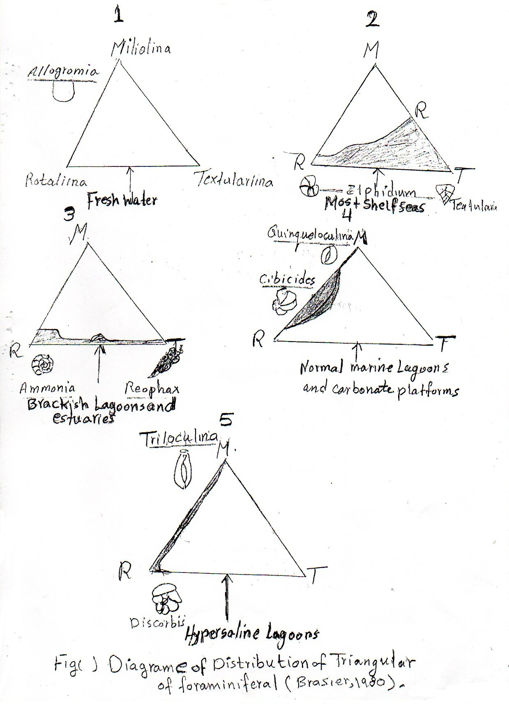

Taxa are stenotherm can also help in determine the salinity of water as Elphidiumexcavatum, Noniondepressulus, Ammonia beccarii.
4- Continental drift: -
The appearance and distributed of the two species Globorotalia multieamerata and Globorotalia miocenica to determine the time of collosion between north and south America and then the disconnection between pacifiocean from one side and the Atlantic, Carrbbian sea.
Before 4.5 My. The species Globorotalia multicamerata apper in two (pacific and atlantic ocean) and this indicate that they are connected. After that and before 3.5 My. The species Globorotalia miocenica appear and be well known only from the Atlantic, Carbbian sea giving an interpretation that made as abarrier to the species Globorotalia miocenica to migrate to pacific ocean.

