Finite Automata
- Finite automata are used to recognize patterns.
- It takes the string of symbol as input and changes its state accordingly. When the desired symbol is found, then the transition occurs.
- At the time of transition, the automata can either move to the next state or stay in the same state.
- Finite automata have two states, Accept state or Reject state. When the input string is processed successfully, and the automata reached its final state, then it will accept.

Formal Definition of FA
A finite automaton is a collection of 5-tuple (Q, ∑, δ, q0, F), where:
- Q: finite set of states
- ∑: finite set of the input symbol
- q0: initial state
- F: final state
- δ: Transition function

Finite Automata Model:
Finite automata can be represented by input tape and finite control.
Input tape: It is a linear tape having some number of cells. Each input symbol is placed in each cell.
Finite control: The finite control decides the next state on receiving particular input from input tape. The tape reader reads the cells one by one from left to right, and at a time only one input symbol is read.
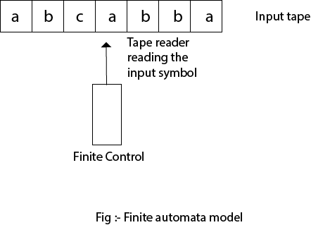

Types of Automata:
There are two types of finite automata:
- DFA(deterministic finite automata)
- NFA(non-deterministic finite automata)
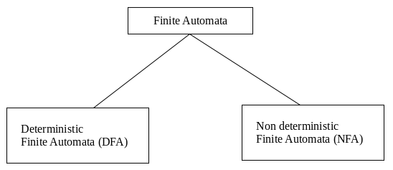
1. DFA
DFA refers to deterministic finite automata. Deterministic refers to the uniqueness of the computation. In the DFA, the machine goes to one state only for a particular input character. DFA does not accept the null move.
2. NFA
NFA stands for non-deterministic finite automata. It is used to transmit any number of states for a particular input. It can accept the null move.
Some important points about DFA and NFA:
- Every DFA is NFA, but NFA is not DFA.
- There can be multiple final states in both NFA and DFA.
- DFA is used in Lexical Analysis in Compiler.
- NFA is more of a theoretical concept.

Transition Diagram
A transition diagram or state transition diagram is a directed graph which can be constructed as follows:
- There is a node for each state in Q, which is represented by the circle.
- There is a directed edge from node q to node p labeled a if δ(q, a) = p.
- In the start state, there is an arrow with no source.
- Accepting states or final states are indicating by a double circle.
Some Notations that are used in the transition diagram:
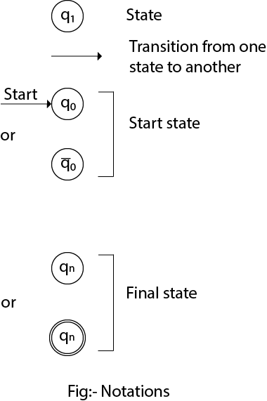1. In DFA, the input to the automata can be any string. Now, put a pointer to the start state q and read the input string w from left to right and move the pointer according to the transition function, δ. We can read one symbol at a time. If the next symbol of string w is a and the pointer is on state p, move the pointer to δ(p, a). When the end of the input string w is encountered, then the pointer is on some state F.
2. The string w is said to be accepted by the DFA if r ∈ F that means the input string w is processed successfully and the automata reached its final state. The string is said to be rejected by DFA if r ∉ F.

Example 1:
DFA with ∑ = {0, 1} accepts all strings starting with 1.
Solution:
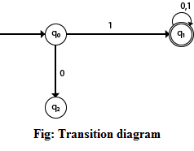
The finite automata can be represented using a transition graph. In the above diagram, the machine initially is in start state q0 then on receiving input 1 the machine changes its state to q1. From q0 on receiving 0, the machine changes its state to q2, which is the dead state. From q1 on receiving input 0, 1 the machine changes its state to q1, which is the final state. The possible input strings that can be generated are 10, 11, 110, 101, 111......., that means all string starts with 1.

Example 2:
NFA with ∑ = {0, 1} accepts all strings starting with 1.
Solution:
The NFA can be represented using a transition graph. In the above diagram, the machine initially is in start state q0 then on receiving input 1 the machine changes its state to q1. From q1 on receiving input 0, 1 the machine changes its state to q1. The possible input string that can be generated is 10, 11, 110, 101, 111......, that means all string starts with 1.

Transition Table
The transition table is basically a tabular representation of the transition function. It takes two arguments (a state and a symbol) and returns a state (the "next state").
A transition table is represented by the following things:
- Columns correspond to input symbols.
- Rows correspond to states.
- Entries correspond to the next state.
- The start state is denoted by an arrow with no source.
- The accept state is denoted by a star.

Example 1:
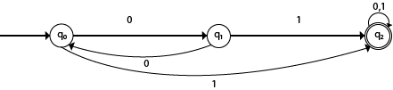Transition table of given DFA is as follows:
Present State | Next state for Input 0 | Next State of Input 1
→q0 | q1 | q2
q1 | q0 | q2
*q2 | q2 | q2
Explanation:
- In the above table, the first column indicates all the current states. Under column 0 and 1, the next states are shown.
- The first row of the transition table can be read as, when the current state is q0, on input 0 the next state will be q1 and on input 1 the next state will be q2.
- In the second row, when the current state is q1, on input 0, the next state will be q0, and on 1 input the next state will be q2.
- In the third row, when the current state is q2 on input 0, the next state will be q2, and on 1 input the next state will be q2.
- The arrow marked to q0 indicates that it is a start state and circle marked to q2 indicates that it is a final state.

Example 2:
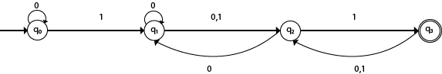
Solution:
Transition table of given NFA is as follows:
Present State | Next state for Input 0 | Next State of Input 1
→q0 | q0 | q1
q1 | q1, q2 | q2
q2 | q1 | q3
*q3 | q2 | q2
Explanation:
- The first row of the transition table can be read as, when the current state is q0, on input 0 the next state will be q0 and on input 1 the next state will be q1.
- In the second row, when the current state is q1, on input 0 the next state will be either q1 or q2, and on 1 input the next state will be q2.
- In the third row, when the current state is q2 on input 0, the next state will be q1, and on 1 input the next state will be q3.
- In the fourth row, when the current state is q3 on input 0, the next state will be q2, and on 1 input the next state will be q2.

DFA (Deterministic finite automata)
- DFA refers to deterministic finite automata. Deterministic refers to the uniqueness of the computation. The finite automata are called deterministic finite automata if the machine is read an input string one symbol at a time.
- In DFA, there is only one path for specific input from the current state to the next state.
- DFA does not accept the null move, i.e., the DFA cannot change state without any input character.
- DFA can contain multiple final states. It is used in Lexical Analysis in Compiler.
In the following diagram, we can see that from state q0 for input a, there is only one path which is going to q1. Similarly, from q0, there is only one path for input b going to q2.
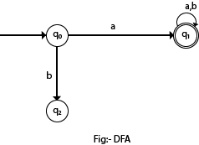

Formal Definition of DFA
A DFA is a collection of 5-tuples same as we described in the definition of FA.
- Q: finite set of states
- ∑: finite set of the input symbol
- q0: initial state
- F: final state
- δ: Transition function
Transition function can be defined as:
- δ: Q x ∑→Q

Graphical Representation of DFA
A DFA can be represented by digraphs called state diagram. In which:
- The state is represented by vertices.
- The arc labeled with an input character show the transitions.
- The initial state is marked with an arrow.
- The final state is denoted by a double circle.

Example 1:
- Q = {q0, q1, q2}
- ∑ = {0, 1}
- q0 = {q0}
- F = {q2}
Solution:
Transition Diagram:
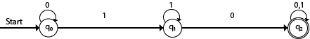
Transition Table:
Present State | Next state for Input 0 | Next State of Input 1
→q0 | q0 | q1
q1 | q2 | q1
*q2 | q2 | q2

Example 2:
DFA with ∑ = {0, 1} accepts all starting with 0.
Solution:
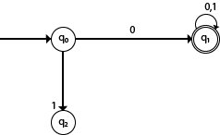
Explanation:
- In the above diagram, we can see that on given 0 as input to DFA in state q0 the DFA changes state to q1 and always go to final state q1 on starting input 0. It can accept 00, 01, 000, 001....etc. It can't accept any string which starts with 1, because it will never go to final state on a string starting with 1.

Example 3:
DFA with ∑ = {0, 1} accepts all ending with 0.
Solution:
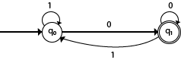
Explanation:
In the above diagram, we can see that on given 0 as input to DFA in state q0, the DFA changes state to q1. It can accept any string which ends with 0 like 00, 10, 110, 100....etc. It can't accept any string which ends with 1, because it will never go to the final state q1 on 1 input, so the string ending with 1, will not be accepted or will be rejected.

Examples of DFA

Example 1:
Design a FA with ∑ = {0, 1} accepts those string which starts with 1 and ends with 0.
Solution:
The FA will have a start state q0 from which only the edge with input 1 will go to the next state.
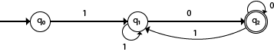
In state q1, if we read 1, we will be in state q1, but if we read 0 at state q1, we will reach to state q2 which is the final state. In state q2, if we read either 0 or 1, we will go to q2 state or q1 state respectively. Note that if the input ends with 0, it will be in the final state.

Example 2:
Design a FA with ∑ = {0, 1} accepts the only input 101.
Solution:
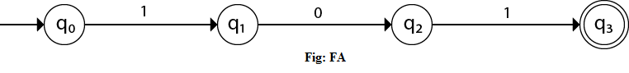
In the given solution, we can see that only input 101 will be accepted. Hence, for input 101, there is no other path shown for other input.

Example 3:
Design FA with ∑ = {0, 1} accepts even number of 0's and even number of 1's.
Solution:
This FA will consider four different stages for input 0 and input 1. The stages could be:
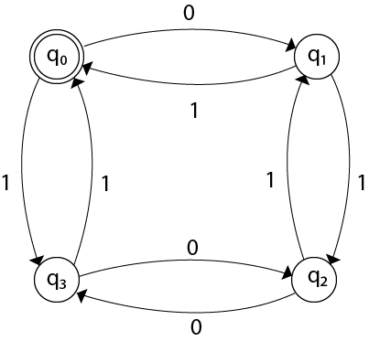
Here q0 is a start state and the final state also. Note carefully that a symmetry of 0's and 1's is maintained. We can associate meanings to each state as:
q0: state of even number of 0's and even number of 1's.
q1: state of odd number of 0's and even number of 1's.
q2: state of odd number of 0's and odd number of 1's.
q3: state of even number of 0's and odd number of 1's.

Example 4:
Design FA with ∑ = {0, 1} accepts the set of all strings with three consecutive 0's.
Solution:
The strings that will be generated for this particular languages are 000, 0001, 1000, 10001, .... in which 0 always appears in a clump of 3. The transition graph is as follows:
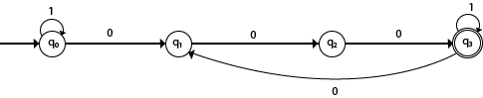

Note that the sequence of triple zeros is maintained to reach the final state.

Example 5:
Design a DFA L(M) = {w | w ε {0, 1}*} and W is a string that does not contain consecutive 1's.
Solution:
When three consecutive 1's occur the DFA will be:

NFA (Non-Deterministic finite automata)
- NFA stands for non-deterministic finite automata. It is easy to construct an NFA than DFA for a given regular language.
- The finite automata are called NFA when there exist many paths for specific input from the current state to the next state.
- Every NFA is not DFA, but each NFA can be translated into DFA.
- NFA is defined in the same way as DFA but with the following two exceptions, it contains multiple next states, and it contains ε transition.
In the following image, we can see that from state q0 for input a, there are two next states q1 and q2, similarly, from q0 for input b, the next states are q0 and q1. Thus it is not fixed or determined that with a particular input where to go next. Hence this FA is called non-deterministic finite automata.
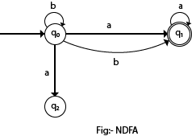

Formal definition of NFA:
NFA also has five states same as DFA, but with different transition function, as shown follows:
δ: Q x ∑ →2^{Q}
where,
- Q: finite set of states
- ∑: finite set of the input symbol
- q0: initial state
- F: final state
- δ: Transition function

Graphical Representation of an NFA
An NFA can be represented by digraphs called state diagram. In which:
- The state is represented by vertices.
- The arc labeled with an input character show the transitions.
- The initial state is marked with an arrow.
- The final state is denoted by the double circle.

Example 1:
- Q = {q0, q1, q2}
- ∑ = {0, 1}
- q0 = {q0}
- F = {q2}
Solution:
Transition diagram:
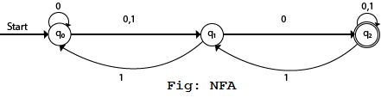
Transition Table:
Present State | Next state for Input 0 | Next State of Input 1
→q0 | q0, q1 | q1
q1 | q2 | q0
*q2 | q2 | q1, q2
In the above diagram, we can see that when the current state is q0, on input 0, the next state will be q0 or q1, and on 1 input the next state will be q1. When the current state is q1, on input 0 the next state will be q2 and on 1 input, the next state will be q0. When the current state is q2, on 0 input the next state is q2, and on 1 input the next state will be q1 or q2.

Example 2:
NFA with ∑ = {0, 1} accepts all strings with 01.
Solution:
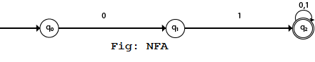
Transition Table:
Present State | Next state for Input 0 | Next State of Input 1
→q0 | q1 | ε
q1 | ε | q2
*q2 | q2 | q2

Example 3:
NFA with ∑ = {0, 1} and accept all string of length atleast 2.
Solution:
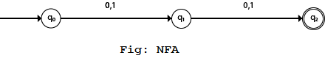
Transition Table:
Present State | Next state for Input 0 | Next State of Input 1
→q0 | q1 | q1
q1 | q2 | q2
*q2 | ε | ε
Here two consecutive 1's or single 1 is acceptable, hence
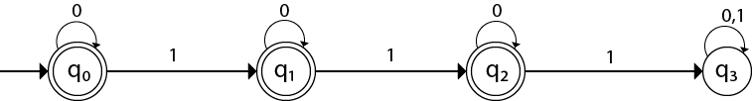
The stages q0, q1, q2 are the final states. The DFA will generate the strings that do not contain consecutive 1's like 10, 110, 101,..... etc.

Example 6:
Design a FA with ∑ = {0, 1} accepts the strings with an even number of 0's followed by single 1.
Solution:
The DFA can be shown by a transition diagram as:

Examples of NFA

Example 1:
Design a NFA for the transition table as given below:
Present State | 0 | 1
→q0 | q0, q1 | q0, q2
q1 | q3 | ε
q2 | q2, q3 | q3
→q3 | q3 | q3
Solution:
The transition diagram can be drawn by using the mapping function as given in the table.
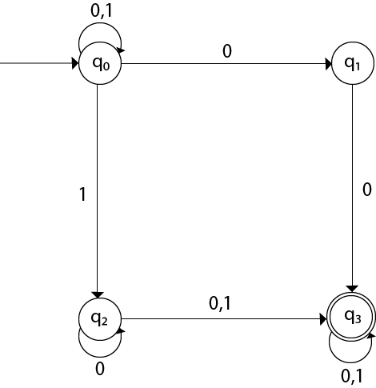
Here,
- δ(q0, 0) = {q0, q1}
- δ(q0, 1) = {q0, q2}
- Then, δ(q1, 0) = {q3}
- Then, δ(q2, 0) = {q2, q3}
- δ(q2, 1) = {q3}
- Then, δ(q3, 0) = {q3}
- δ(q3, 1) = {q3}

Example 2:
Design an NFA with ∑ = {0, 1} accepts all string ending with 01.
Solution:
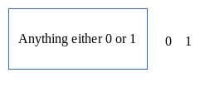
Hence, NFA would be:
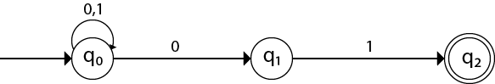

Example 3:
Design an NFA with ∑ = {0, 1} in which double '1' is followed by double '0'.
Solution:
The FA with double 1 is as follows:
It should be immediately followed by double 0.
Then,
Now before double 1, there can be any string of 0 and 1. Similarly, after double 0, there can be any string of 0 and 1.
Hence the NFA becomes:
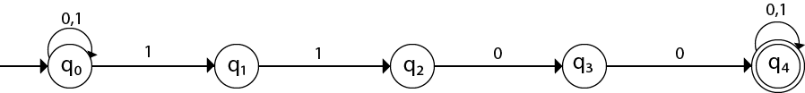
Now considering the string 01100011
- q0 → q1 → q2 → q3 → q4 → q4 → q4 → q4

Example 4:
Design an NFA in which all the string contain a substring 1110.
Solution:
The language consists of all the string containing substring 1010. The partial transition diagram can be:
Now as 1010 could be the substring. Hence we will add the inputs 0's and 1's so that the substring 1010 of the language can be maintained. Hence the NFA becomes:
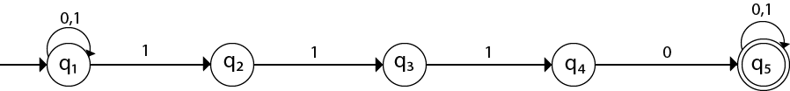
Transition table for the above transition diagram can be given below:
Present State | 0 | 1
→q1 | q1 | q1, q2
q2 |  | q3
q3 |  | q4
q4 | q5
*q5 | q5 | q5
Consider a string 111010,
- δ(q1, 111010) = δ(q1, 1100)
- = δ(q1, 100)
- = δ(q2, 00)
Got stuck! As there is no path from q2 for input symbol 0. We can process string 111010 in another way.
- δ(q1, 111010) = δ(q2, 1100)
- = δ(q3, 100)
- = δ(q4, 00)
- = δ(q5, 0)
- = δ(q5, ε)
As state q5 is the accept state. We get the complete scanned, and we reached to the final state.

Example 5:
Design an NFA with ∑ = {0, 1} accepts all string in which the third symbol from the right end is always 0.
Solution:
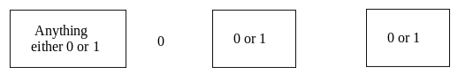
Thus we get the third symbol from the right end as '0' always. The NFA can be:
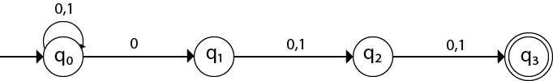
The above image is an NFA because in state q0 with input 0, we can either go to state q0 or q1.

