Curriculum vitae

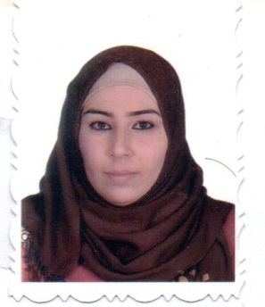 | Dr. Azhar Ibrahim Shukur
 | Department of food science, College of Agriculture and Forestry, University of Mosul, Mosul 41002, Ninawa, Iraq
Azharibrahim333@gmail.com
Scopus ID or ORCID ID or Research ID or Publons ID

Education
University | Graduationyear | Specialization | Certificate
Mosul University /College of Agriculture and Forests/ Iraq | 2009 | food science | B. Sc.
Mosul University /College of Agriculture and Forests/ Iraq | 2012 | food science | M.Sc.
Mosul University /College of Agriculture and Forests/ Iraq | 2020 | Food science(Dairy science) | Ph.D.

Areas of Interest
1.

Professional Qualification/ Membership/ Affiliation
1. Registered as membership of Agricultural Engineers since 1999.

Appointment
1. Appoint as Faculty membership 2001.
2. Appoint as Lecturer since 2011.

Publications
Journals
1-

Conference Proceedings

Supervisor for Students of M.Sc. and Ph.D.
1- Effect of fortifying by whey protein and probiotic bacteria on properties of soft cheese during cold storage
2- Fortification of milk and yoghurt with flax and sesame oil and probiotic bacteria and study its effect on product characteristics.
Certificates of Appreciation
1-
Other Acti

