Curriculum Vitae  Name ( Ahmad Hassan Jarjisse )  French Department, College of Arts  University of Mosul |  |  |  |  |  |  |  | 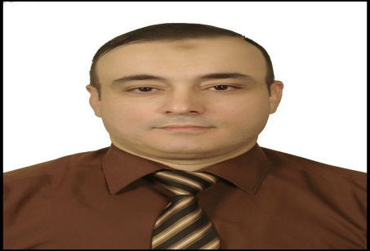
Personal Information
- Name |  |  | Ahmad Hassan Jarjisse
- Dare of Birth |  |  | 19/11/1979
- Place of Birth |  |  | Mosul
- Gender |  |  | Male
- Nationality |  |  | Iraqi
- Marital Status |  |  | Married
- No. of Children |  |  | 4
- Cell phone No. |  |  | -----
Academic Information
- Scientific Title |  |  |  | Assistant Prof
- Scientific Dept. |  |  |  | French department
- General specialty |  |  |  | French language and literature
- Specific specialty |  |  |  | literature
- Email |  |  |  | Ahmad.h.j@uomosul.edu.iq
- Research Gate |  |  |  | https://www.researchgate.net/profile/Ahmad-Jarjisse
- Google Scholar |  |  |  | https://scholar.google.com/citations?view_op=list_updates&hl=ar&user=m-thwfwAAAAJ&citsig=ACseELKFBakZcs-t83kWQaCYtuEe
- ORCID |  |  |  | https://orcid.org/my-orcid?orcid=0000-0001-8632-9111
Education
Degree
- PhD
- MSc | 2005 |  |  |  | French language and literature | University of Mosul
- Bachelor | 2002 |  |  |  | French language and literature | University of Mosul
Scientific titles
- Professor
- Assistant Prof. |  | Assistant Prof.
- Lecturer
- Assistant Lect.
Scientific and Administrative Experiences
Head of the French department  Member of Graduate Studies  Head of the scientific committee  Exam Committee Chairman  Member of the Ministerial Curriculum Update Committee |  |  |  |  |  |  | 2017-2021  2019-2020  2017-2022
Teaching Activities
Teaching various subjects to undergraduate students
Teaching research methods, theater and novel to master's students
Postgraduate Supervision
- Master |  | Durra Manhal Omer  Maha Amar Yousef  Raoua Masman  Heneen Majed Abd AlRahem  Maram SalahAldeen  Jassam Raka
- PhD
Peer-reviewed Publications
- https://radab.mosuljournals.com/article_163391_032582c122932abf803260164f2a5b36.pdf.
- chrome-extension://efaidnbmnnnibpcajpcglclefindmkaj/https://www.iasj.net/iasj/download/df387ab2d68e0819.
- chrome-extension://efaidnbmnnnibpcajpcglclefindmkaj/https://iasj.net/iasj/download/19398356723b236e.
- chrome-extension://efaidnbmnnnibpcajpcglclefindmkaj/https://radab.mosuljournals.com/article_83229_06c181a2d771b4998f1ba41c2d62b18b.pdf.
- chrome-extension://efaidnbmnnnibpcajpcglclefindmkaj/https://www.iasj.net/iasj/download/43ed4144494e6626.
- chrome-extension://efaidnbmnnnibpcajpcglclefindmkaj/https://www.iasj.net/iasj/download/6c1592ef05ada990.
The pathos in Bernardin of Saint-Pierre's Paul et Virginie
The concept of freedom in J.P. Sartre's "Les Flies”
The tragedy through the figure of the king in "The King is dying" by Ionesco
The use of vaudeville in Musset's Lorenzaccio , Cocteau's Les Parents terribles and Anouilh's Antigone
The monologue between silence and solitude in Bernard-Marie Koltès' Roberto Zucco
the concept of death in Jean Anouilh's Antigone

Books and Chapters
Scientific Conferences and Symposiums
Other Scientific activities
Annual participation in the management of the Francophone novels reading competition
Associations
Director of the Francophone Fajr Al-Hadba Foundation for Culture and Education
Member of the Iraqi Translators Association

