Curriculum Vitae  Name (Baraa Ibrahim Mahmood)  French Department, College of Arts, University of Mosul |  |  |  |  |  |  |  | 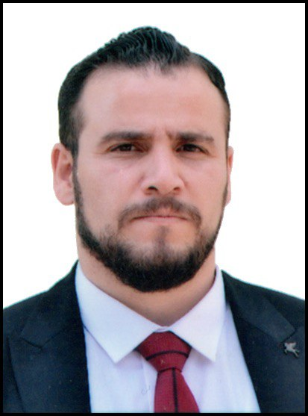
Personal Information
- Name |  |  | Baraa Ibrahim Mahmood
- Date of Birth |  |  | 1986
- Place of Birth |  |  | Baghdad
- Gender |  |  | Male
- Nationality |  |  | Iraqi
- Marital Status |  |  | Married
- No. of Children |  |  | 3
- Cell phone No. |  |  | 07701870592
Academic Information
- Scientific Title |  |  |  | Assistant Lect.
- Scientific Dept.
- General specialty |  |  |  | French language
- Specific specialty |  |  |  | French language/ linguistic
- Email |  |  |  | Baraa.ibrahim@uomosul.edu.iq
- Research Gate |  |  |  | https://www.researchgate.net/profile/Baraa-Ibrahim-Mahmood?ev=hdr_xprf
- Google Scholar |  |  |  | https://scholar.google.com/citations?user=4t4Y_RsAAAAJ&hl=ar&authuser=1
- ORCID |  |  |  | 0000-0003-0015-3448
Education
Degree
- PhD
- MSc | 2013 |  |  |  | French language |  | University of Mosul
- Bachelor | 2008 |  |  |  | French language |  | University of Mosul
Scientific titles
- Professor
- Assistant Prof.
- Lecturer
- Assistant Lect. |  | 7-3-2023
Scientific and Administrative Experiences
Teaching Activities
Postgraduate Supervision
- Master
- PhD
Peer-reviewed Publications
تسلسل البحوث من الأحدث فالأقدم بالنسبة لسنة النشر
Books and Chapters
تسلسل الكتب من الأحدث فالأقدم بالنسبة لسنة النشر
Scientific Conferences and Symposiums
1. A digital learning course in French at the French Association in Paris 2019
2. A training course on digital education in Lebanon 2021
3. A training course on digital education in Baghdad 2022
4. A training course on digital education in Erbil 2023
Other Scientific activities
Associations
Thanks wrote
A letter of thanks from the Minister of Higher Education and Scientific Research 2023

