Curriculum Vitae  Saad Sajid FATTAH  Master's degree in French language and literature  French Department, College of Arts, University of Mosul |  |  |  |  |  |  |  | 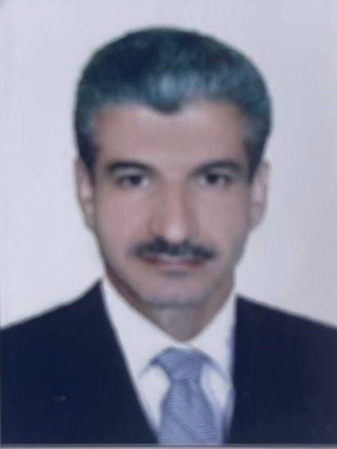
Personal Information
- Name |  |  | Saad Sajid FATTAH
- Date of Birth |  |  | 22.04.1975
- Place of Birth |  |  | Mosul
- Gender |  |  | Male
- Nationality |  |  | Iraqi
- Marital Status |  |  | Married
- No. of Children |  |  | 3
- Cell phone No. |  |  | ----
Academic Information
- Scientific Title |  |  |  | Assistant lecturer
- Scientific Dept. |  |  |  | French department
- General specialty |  |  |  | French language and literature
- Specific specialty |  |  |  | French language
- Email |  |  |  | saad.s@uomosul.edu.iq
- Research Gate |  |  |  | https://www.researchgate.net/profile/Saad-Sajid-Fattah
- Google Scholar |  |  |  | https://scholar.google.com/citations?view_op=new_profile&hl=fr
- ORCID |  |  |  | 0000-0002-5074-9883
Education
Degree
- PhD
- MSc | 2003 |  |  |  | French language and literature |  | University of Mosul
- Bachelor | 2000 |  |  |  | French language and literature |  | University of Mosul
Scientific titles
- Professor
- Assistant Prof.
- Lecturer
- Assistant Lect. |  | Assistant Lect.
Scientific and Administrative Experiences
Teaching Activities
Teaching various subjects to undergraduate students
Postgraduate Supervision
- Master
- PhD
Peer-reviewed Publications
A study of the syntactic structure of the simple sentence in "Les Impatientes" by Amadou Amal Djaïli
https://radab.mosuljournals.com/article_178449.html
Love in ‘‘Paul and Virginie’’ by Bernardin de Saint-Pierre
https://radab.mosuljournals.com/article_164640.html

Books and Chapters
تسلسل الكتب من الأحدث فالأقدم بالنسبة لسنة النشر
Scientific Conferences and Symposiums
Other Scientific activities
French language lecturer at the French-Iraqi Cultural Institute in Mosul
Annual participation in the Francophone novel reading competition
Associations
Member of Fajr Al Hadbaa Francophone Foundation for Culture and Education N.G.O.

