Curriculum Vitae  Name ( Durra Manhal Omer)  Department of French language, College of Arts  University of Mosul |  |  |  |  |  |  |  | 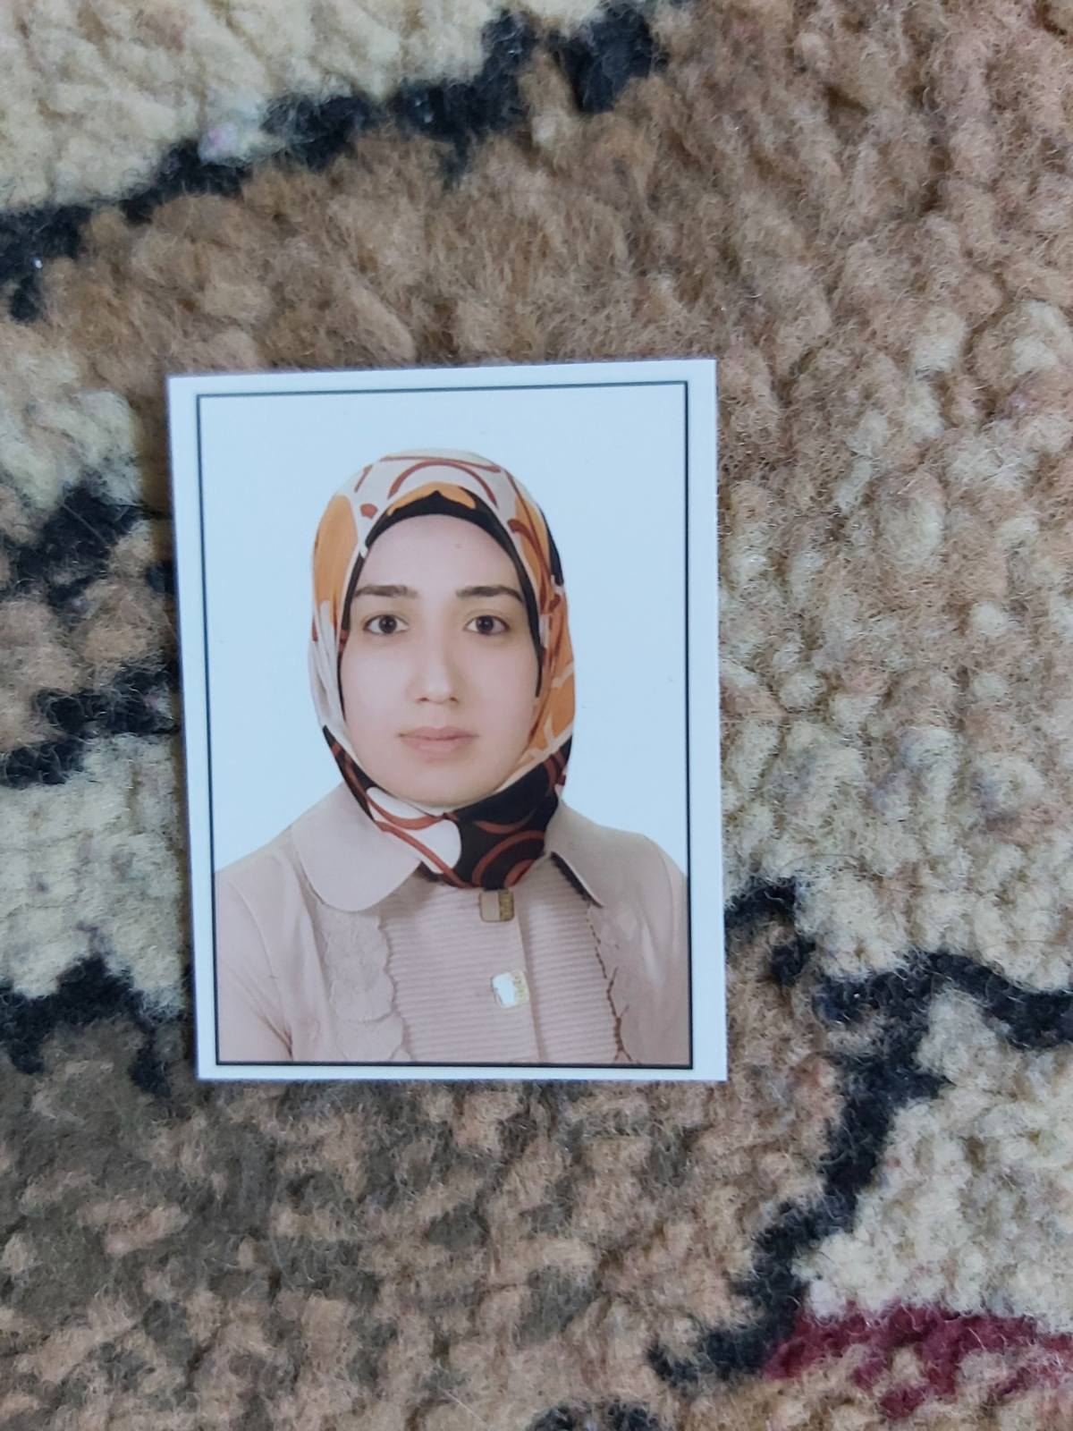
Personal Information
- Name |  |  | Durra Manhal Omer
- Dare of Birth |  |  | 20 July 1988
- Place of Birth |  |  | Mosul-Iraq
- Gender |  |  | Female
- Nationality |  |  | Iraqi
- Marital Status |  |  | Married
- No. of Children |  |  | 2
- Cell phone No.
Academic Information
- Scientific Title |  |  |  | Assistant Lect.
- Scientific Dept. |  |  |  | French language
- General specialty |  |  |  | Language and literature French
- Specific specialty |  |  |  | Modern French literature
- Email |  |  |  | durra.m@uomosul.edu.iq
- Research Gate |  |  |  | https://www.researchgate.net/profile/Durah-Omer
- Google Scholar |  |  |  | https://scholar.google.com/citations?user=lEIwgAQAAAAJ&hl=ar
- ORCID |  |  |  | 0000-0002-9248-406X
Education
Degree
- PhD
- MSc | 2019 |  |  |  | Modern French literature |  | University of Mosul
- Bachelor | 2010 |  |  |  | Language and literature French |  | University of Mosul
Scientific titles
- Professor
- Assistant Prof.
- Lecturer
- Assistant Lect. |  | Assistant Lect.
Scientific and Administrative Experiences
Since 2019 |  | Assistant Lect. |  |  |  | Dept. of French
Teaching Activities
- Phonetics and dictation - first year.
- Reading and vocabulary - second year
- Oral and written comprehension - third year
- French for specific purposes – third year
- French for specific purposes – fourth year.
- Theater - fourth year
Supervising several B.A. research papers in French language.
Postgraduate Supervision
- Master
- PhD
Peer-reviewed Publications
Books and Chapters
Scientific Conferences and Symposiums
Other Scientific activities
Courses
- Intensive training course on digital education in Erbil 2019.
- A training course on teaching the French language after 2020.
- A distance training course in French on Informatics and the Internet 2021.
- A training workshop entitled (Designing a classroom for teaching a foreign language) organized by teachers in the French Language Department at the University of Mosul 2021.
- A distance training course on teaching French as a foreign language and pedagogy at the university 2021-2022.
Associations

