Curriculum Vitae  Name ( Haneen Majid Abdulraheem )  Department of French, College of Arts  University of Mosul |  |  |  |  |  |  | 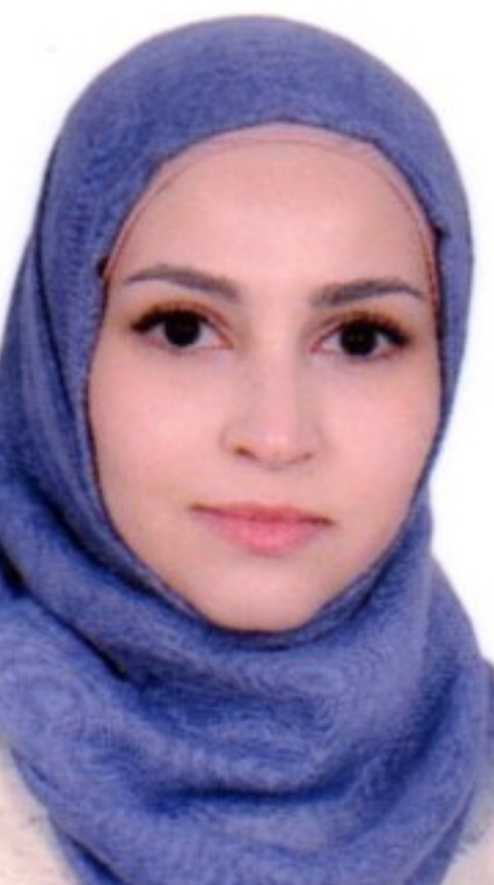
Personal Information
- Name |  |  | Haneen Majid Abdulraheem
- Dare of Birth |  |  | 06/07/1992
- Place of Birth |  |  | Mosul/ Iraq
- Gender |  |  | Female
- Nationality |  |  | Iraqi
- Marital Status |  |  | Single
- No. of Children
- Cell phone No. |  |  | 009647703076773
Academic Information
- Scientific Title |  |  |  | Assistant Lecturer
- Scientific Dept. |  |  |  | French language
- General specialty |  |  |  | French language and literature
- Specific specialty
- Email
- Research Gate |  |  |  | رابط صفحة profile من الResearch Gate
- Google Scholar |  |  |  | رابط صفحة profile من الGoogle Scholar
- ORCID |  |  |  | رقم ORCID يتكون من 16 رقماً: ????-????-????-????
Education
Degree
- PhD
- MSc | 2023 |  |  |  | French language and literature |  |  | University of Mosul/ Iraq
- Bachelor | 2014 |  |  |  | French language and literature |  |  | University of Mosul/ Iraq
Scientific titles
- Professor
- Assistant Prof.
- Lecturer
- Assistant Lect.
Scientific and Administrative Experiences
Teaching Activities
Postgraduate Supervision
- Master
- PhD
Peer-reviewed Publications
تسلسل البحوث من الأحدث فالأقدم بالنسبة لسنة النشر
Books and Chapters
تسلسل الكتب من الأحدث فالأقدم بالنسبة لسنة النشر
Scientific Conferences and Symposiums
Other Scientific activities
Associations

