Curriculum Vitae  Name (Marwa Ghassan Younis)  Translation Department, College of Arts  University of Mosul |  |  |  |  |  | 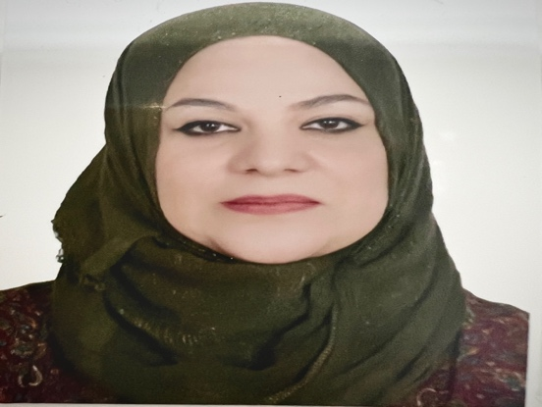
Personal Information
- Name |  |  | Marwa Ghassan Younis
- Dare of Birth |  |  | 29/1/1985
- Place of Birth |  |  | Mosul
- Gender |  |  | female
- Nationality |  |  | Iraqi
- Marital Status |  |  | married
- No. of Children |  |  | 3
- Cell phone No.
Academic Information
- Scientific Title |  |  |  | Translation
- Scientific Dept. |  |  |  | French language
- General specialty |  |  |  | Translation
- Specific specialty |  |  |  | Translation
- Email |  |  |  | marwa.younis@uomosul.edu.iq
- Research Gate
- Google Scholar |  |  |  | https://scholar.google.com/citations?hl=ar&user=iCT-pKsAA
- ORCID
Education
Degree
- PhD
- MSc | 2021 |  |  |  | Translation |  |  | College of Arts
- Bachelor | 2006 |  |  |  | Translation |  |  | College of Arts
Scientific titles
- Professor
- Assistant Prof.
- Lecturer
- Assistant Lect. |  | yes
Scientific and Administrative Experiences
Responsibility for retirement unit in the college of Arts |  | 2022-2023
Teaching Activities
Teaching English language in the department of Mathematics/ College of Computer Science and Mathematics
2021-2022
Teaching English language in the (philosophy/ Arabic and French) departments /
College of Arts 2022-2023
Postgraduate Supervision
- Master
- PhD
Peer-reviewed Publications
https://radab.mosuljournals.com
Evaluativeness in Argumentative texts

Books and Chapters
Scientific Conferences and Symposiums
Other Scientific activities
Associations

