Curriculum Vitae  Name ( Qatran Bashar Ali )  Department:Freanch language, College: of Arts  University of Mosul |  |  |  |  | صورة شخصية  ()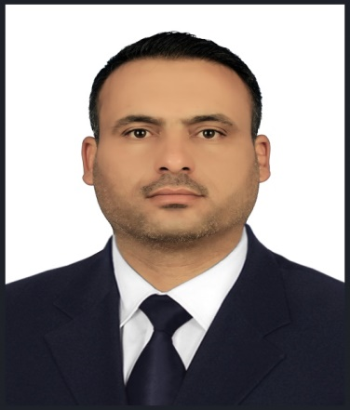
Personal Information
- Name |  |  | Qatran Bashar Ali Hamad
- Dare of Birth |  |  | 1/3/1983
- Place of Birth |  |  | Shirquat / Ninhve
- Gender |  |  | Melle
- Nationality |  |  | Iraqi
- Marital Status |  |  | marred
- No. of Children |  |  | 6
- Cell phone No. |  |  | 07716848297
Academic Information
- Scientific Title |  |  |  | Assistant Lect
- Scientific Dept. |  |  |  | French language
- General specialty |  |  |  | French language and literature
- Specific specialty |  |  |  | Linguistics
- Email |  |  |  | Qatran.b@uomosul.edu.iq
- Research Gate |  |  |  | https://www.researchgate.net/profile/Qatran-Bashar
- Google Scholar |  |  |  | https://scholar.google.com/citations?user=--h-ACQAAAAJ&hl=ar
- ORCID |  |  |  | https://orcid.org/0000-0002-6403-140X
Education
Degree
- PhD
- MSc | Msc
- Bachelor
Scientific titles
- Professor
- Assistant Prof.
- Lecturer
- Assistant Lect. |  | Assistant Lect
Scientific and Administrative Experiences
Teaching Activities
- French Grammar (First year)
- History of French literature (Fourth year)
- Novel (Third year)
- French poetry (Third year)
- Writing expression (Third year)
- Reading and Conversation (second year)
- Comprehension and written expression (First year)
- Supervising Fourth year students research projects

Postgraduate Supervision
- Master
- PhD
Peer-reviewed Publications
- La focalisation interne dans Un amour de Swann de Marcel Proust https://www.iasj.net/iasj/article/235065
- Les rapports entre le style et le vocabulaire dans quelques contes de Guy de Maupassant
Iraqi Academic Scientific Journals - IASJ
- L’usage des séquences vidéo dans un cours de compréhension orale (cas des étudiants de 4e année/Département du français/ Université de Mossoul/Irak
https://radab.mosuljournals.com/article_176054.html
Books and Chapters
تسلسل الكتب من الأحدث فالأقدم بالنسبة لسنة النشر
Scientific Conferences and Symposiums
Other Scientific activities
Associations

