Curriculum Vitae  Zahraa Muayed Abbas  Department of French language, College of Art  University of Mosul |  |  |  | 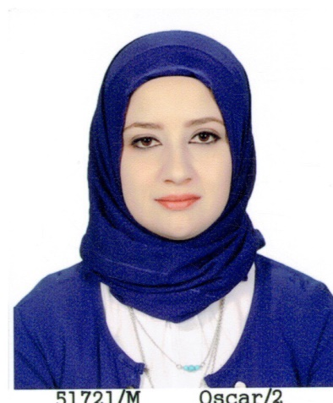
Personal Information
- Name | Zahraa Muayed Abbas
- Dare of Birth | 1987
- Place of Birth | Mosul
- Gender | female
- Nationality | Iraqi
- Marital Status | Married
- No. of Children | 1
- Cell phone No.
Academic Information
- Scientific Title | Lecturer
- Scientific Dept. | French language department
- General specialty | French language and literature
- Specific specialty | Linguistic
- Email | zahraa.m@uomosul.edu.iq
- Research Gate | https://www.researchgate.net/profile/Zahraa-Abbas-4
- Google Scholar | https://scholar.google.com/citations?user=v-xadIwAAAAJ&hl=ar
- ORCID | 0009-0009-3045-2300
Education
Degree
- PhD
- MSc | 2014 |  | French language and literature | University of Mosul
- Bachelor | 2009 |  | French language and literature | University of Mosul
Scientific titles
- Professor
- Assistant Prof.
- Lecturer |  | 2021
- Assistant Lect. |  | 2014
Scientific and Administrative Experiences
2021 |  | C2i | Computer and Internet Certificate (C2i) Level 1
2019 |  | Dalf | Diploma in French Language Studies B1
Teaching Activities
Teaching grammar, comprehension, oral and written expression, reading and conversation
Postgraduate Supervision
- Master
- PhD
Peer-reviewed Publications
- L'usage d'un poème non-ponctué dans l'enseignement du FLE
https://www.researchgate.net/publication/339473108_L'usage_d'un_poeme_non-ponctue_dans_l'enseignement_du_FLE
- Les usages linguistiques et sociaux dans Les Précieuses ridicules de Molière
https://www.researchgate.net/publication/339473223_Les_usages_linguistiques_et_sociaux_dans_Les_Precieuses_ridicules_de_Moliere
- Le néoclassicisme et le romantisme à travers L’expression picturale française
https://www.researchgate.net/publication/339486777_Le_neoclassicisme_et_le_romantisme_a_travers_L'expression_picturale_francaise

Books and Chapters
تسلسل الكتب من الأحدث فالأقدم بالنسبة لسنة النشر
Scientific Conferences and Symposiums
- Distance tutoring, July 12-16, 2021 The University Agency of La Francophonie in Beirut.
- Online training entitled "professional French", from October 24 to 30, 2020. The trainer Stefan HAFEZ.
- Teaching French at a distance in 2020: review of teaching practices in Iraq (December 5, 2020 Institut français d'Irak)
- Culture and innovation in FLE classes, devices to motivate learning (23-27 September 2019 Allinance Française - Paris)

Other Scientific activities
Associations

