Curriculum Vitae  Name (Abdulrahim abdulrahman Mohamed Amin)  Department of French, College of Arts  University of Mosul |  |  |  |  |  |  |  | 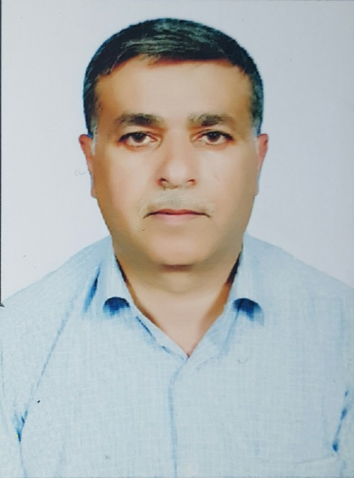
Personal Information
- Name |  |  | Abdulrahim Abdulrahman Mohamed Amin
- Dare of Birth |  |  | 1/7/1967
- Place of Birth |  |  | Akra-ninevah
- Gender |  |  | male
- Nationality |  |  | Iraqi
- Marital Status |  |  | Married
- No. of Children |  |  | 4
- Cell phone No. |  |  | 07508416054
Academic Information
- Scientific Title |  |  |  | Assistant-lecture
- Scientific Dept. |  |  |  | Dept- of French
- General specialty |  |  |  | French language and literature
- Specific specialty |  |  |  | French language
- Email |  |  |  | abdulrahim.a@uomosul.edu.iq
- Research Gate |  |  |  | https://www.researchgate.net/profile/Abdulrahim-Abdulrahman-Mohamed-Amin
- Google Scholar |  |  |  | https://scholar.google.com/citations?hl=en&view_op=list_works&gmla=AJsN-F4Xg5BHgRlIJ8zfqMzW4154aL1c39ypdoJofa_YSW-8fm3efcG9FvL3wXIuwPu5OeJbnMTnUwGyeYe8wYmY6yJc9oZpHQ&user=jaH5H1YAAAAJ
- ORCID |  |  |  | 0000-0001-9779-9741
Education
Degree
- PhD
- MSc | 2012 |  |  |  | University of Mosul |  | master in French language and literature
- Bachelor | 1992 |  |  |  | University of Mosul |  | Bachelor in French language and literature
Scientific titles
- Professor
- Assistant Prof.
- Lecturer
- Assistant Lect. |  | Assistant lecturer
Scientific and Administrative Experiences
Guidance, exam and audit committees, oral exam committees
Experience in the field of e-learning platforms
Teaching Activities
Teaching in the department of French language- Teaching French in English and translation department- supervising the graduation researches of the fourth stage students
Postgraduate Supervision
- Master
- PhD
Peer-reviewed Publications
The main themes in the human condition of André Malraux
https://www.iasj.net/iasj/download/2780c5c0b990c2c3
The pathos in Paul and Virginie of Bernardin de Saint- Pierre
https://radab.mosuljournals.com/article_83229_06c181a2d771b4998f1ba41c2d62b18b.pdf
Audiovisual programs as a strategy to develop written production skills in a French as a foreign language class
https://www.iasj.net/iasj/download/baaa89196c986b0a

Books and Chapters
Scientific Conferences and Symposiums
- Computer and internet course at the university of Mosul 2010
- Methodological and pedagogical modalities course at the pedagogical center of university of Mosul in 2009 and 2012
- Arabic language training at the faculty of letters 2018
- FOS training in France at the University of Artois at the center of continuing education 2015.
- Training in education technologies in Baghdad organized by the French embassy in Iraq and AUF 2018.
- Training of the CEFR, a common European frame work of reference organized by the AUF at the French institute in Erbil 2014.
- Training in the teaching of translation and interpreting in a FLE class organized by the AUF at formation institute French in Erbil 2015.
- Training in construct and integrating FOS course organized by the AUF at the institute French in Erbil 2016.
Online training: teaching French at a distance in 2020: review of teaching practices in Iraq, from 25 to 30 November, 2020 at the institute French in Iraq.
- distance training at the center for applied linguistics of the university of Franche-Comte: teaching literature in the FLE class from 01/09 to 07/O9/2021
-Distance training at the center for applied linguistics of the university of the Franche-Comte: teach grammar differently from 09/15 to 09/21/2021.
-training in the teaching of French as a foreign language at the institute French in Erbil from 12 to 16 February 2023
Other Scientific activities
Participation in activities and seminars in the French language department- level certificate B2 in French language
Associations
Member of francophone university syndicate.

