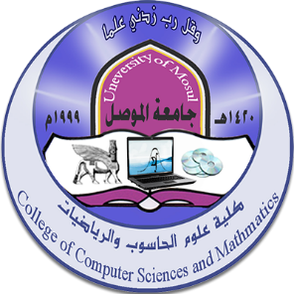
College of Computer Science and Mathematics - University of Mosul
Future activities for February 2024

First: Discussions
ت | Discussion title | student's name | the study | Section | Supervisor name | Date
1 | Develop a tool to support use cases for identifying software requirements | Maha Salah El-Din Ahmed Hamdy | Master’s | البرمجيات | .د. نكتل مؤيد عيدان | 1/2/2024
2 | Numerical solution of the Kuramoto-Sivashinsky equation using wavelet methods | Hudhayfah Haitham Ahmed Hassan | Master’s | Math | Dr. Ekhlas Saadallah Ahmed | 4/2/2024
3 | In strong damaged pure rings of type -3 | Zubaida Walid Abdullah Hassan | Master’s | Math | Dr . Nizar Hamdoun | 14/2/2024

Second: Workshops
تاريخ الورشة | عنوان الورشة | ت
13 / 2/ 2024 | Enterprise cybersecurity: Building walls of trust in a connected world

Third: Courses
Date | Section | Name of the lecturer | Course title | ت
4 - 8/2/2024 | Math | D. Ahmed Amer Mohamed Fawzi  Nesma Jamil Hamid | Use Math Mix to edit equations

Fourth: - Seminars
التاريخ | القسم | Name of the lecturer | Seminar address | ت
15 /2 / 2024 | Operations research and intelligence technologies | Dr. Manal Salem Hamdi | Fractal geometry | 1
19 / 2 / 2024 | Statistics and informatics | Dr. Lama Akram Abdullah | The risks of electronic blackmail and maintaining the security and integrity of personal data | 2
29 /2 / 2024 | Operations research and intelligence technologies | Dr. Hudhayfah Hazem Taha | Using the exponential beam network and its features | 3

Fifth: Seminars
Date | Symposium title | ت
7 / 2 / 2024 | The Artificial Intelligence Revolution (Vision and Horizons)

