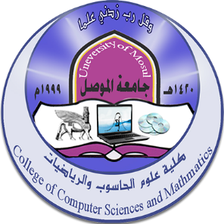
College of Computer Science and Mathematics - University of Mosul
Future activities for January 2024

First: Discussions
ت | Discussion title | student's name | the study | Section | Supervisor name | Date
1 | Classification of categorical time series using statistical methods and deep neural networks | Omar Akram Muhammad Saeed Bakr | Master's | Master’sStatistics and informatics | D. Osama Bashir Shukr | 4/1/2024
2 | Estimating the reliability of a Lomax distribution using ordered set sampling with the application | Musa Muhammad Musa Farhan | Master’s | Master’sStatistics and informatics | Dr. Ban Ghanem Omar | 14/1/2024
3 | Improving cryptanalysis using artificial intelligence (blowfish algorithm as a case study) | Raghad Laith Mal Allah Aziz | Master’s | Computer | Dr . Uday Hashem Saeed | 28/1/2024

Second: Workshops:
Workshop date | Workshop title | ت
30/1/2024 | Achieving cybersecurity: challenges of technological developments and pillars of protection

Third: Seminars:
Symposium date | Symposium title
9/1/2024 | Together for a drug-free university community
23/1/2024 | Our culture is about conserving water and enhancing community awareness to preserve water sources

