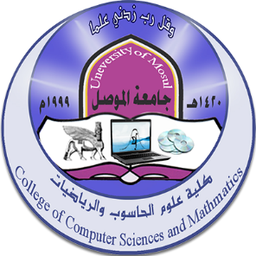
College of Computer Science and Math - University of Mosul
Future activities for November 2023

First: - Seminars:
اسم المحاضر | Section | Date | Title | ت
Dr.Neam Abdel Moneim Abdel Majeed | Operations research and intelligence technologies | 9/11/2023 | Stochastic programming
Dr.. Ghazwan Hani Mahmoud | Operations research and intelligence technologies | 23/11/2023 | Multi-objective Optimization
M. Farah Hazem Muhammad | math | 1/11/2023 | Minimum size template set$\left(\left[\frac{3}{2}\left(q+1\right)+1\right]\right)$ $PG\left(2,19\right)$
Dr.Baraa Mahmoud Suleiman | math | 1/11/2023 | Semi-open aggregates of type H and their continuity in topological spaces
Dr.. Muhammad Omar Shaaban Al-Amr | math | 5/11/203 | Different dynamics of wave solutions of the fifth-order generalized Korteweg-de Vries equation of the Fermi-Pasta-Ulam problem with geometric descriptions
Dr.. Elaf Suleiman Khalil | math | 13/11/2023 | Development of a search line method in nonlinear programming
Dr.. Elaf Suleiman Khalil  Dr.. Hamsa Tharwat Saeed | math | 13/11/2023 | A new measure of search direction for solving miniaturization problems
Dr.. Raghad Abdel Aziz Mustafa  Dr.. Ahmed Mohammed Ali | math | 20/11/2023 | Hosoya polynomials and Wiener's proofs for the almost complete statement of some special data

Second: Postgraduate students’ discussions:
Date | Section | the study | student's name | Discussion title
1/11/2023 | math | Master’s | Nour Bassam Taha Ali | Solve integral equations using the modified Adomaine analysis method with the Bee algorithm
1/11/2023 | math | Ph.D | Yahya Abdel Fattah Hamoudi | Improving chaotic numerical optimization algorithms for optimal information hiding
6/11/2023 | math | Master’s | Alaa Abdul Razzaq Mahdi Saleh | Predicting protein secondary structure by combining a hidden Markov model and an artificial neural network
2/11/2023 | math | Ph.D | Nibal Sabah Abdul Rahman | Local linear approximation of some nonlinear stochastic differential equations with application
9/11/2023 | math | Ph.D | Lamia Qader Ismail Khalil | Applications to scalar-extended Banach algebras

