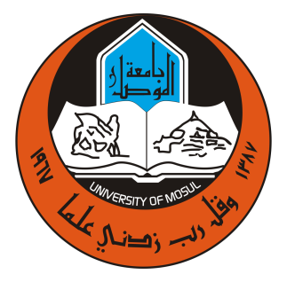
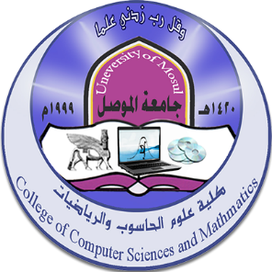
College of Computer Science and Mathematics - University of Mosul
Future activities for October 2023

First: - Seminars:
اسم المحاضر | القسم | التاريخ | العنوان | ت
Shaima Hatem Ahmed  Dr.. Raeda Daoud Mahmoud | Math | 4/10/2023 | Some Results on AWN - injective Rings
Dr.Baraa Mahmoud Suleiman | Math | 4/10/2023 | On IO - Open Sets in Topological Spaces
Asma Salah Aziz | Math | 8/10/2023 | d - Index of Graphs
Dr.. Neam Hazem Ahmed | Operations Research | 12/10/2023 | Calculating course units according to the Bologna system
Dr.. Zahraa Abdel Aziz Taha | Operations Research | 26/10/2023 | Positives of the Bologna path

Second: Postgraduate students’ discussions:
Date | Section | the study | student's name | Discussion title
1/10/2023 | Math | Ph.D | Ali Abdul Qader Mustafa | Solving partial differential equations by using Vibrational iteration
4/10/2023 | Math | Ph.D | Zaidoun Shamil Hashem | Design of high-dimensional systems with multiple attractors and its applications
12/10/2023 | Math | Ph.D | Rasha Fahd Ahmed | Solving system of integral equations by using homotopy analysis methods with genetic algorithm
15/10/2023 | Math | Ph.D | Nour Muhammad Nouri Abdel Mohsen | A hybrid model using nature inspired meta-heuristic algorithms as a deep feature selection method

