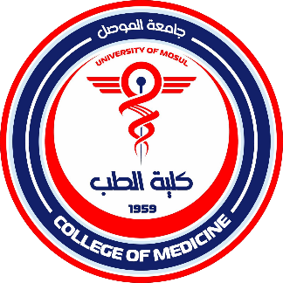
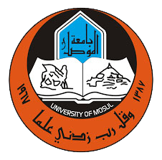
College of Medicine
Studies and Planning Division

The tasks performed by the division:

1. Organizing statistics: Preparing and organizing statistics for faculty members of the College of Medicine according to academic branch, gender, academic title, job title, year of appointment, general and specific specialization, and university of graduation.

2. Operational movement system: Monitoring the operational movement system for faculty and permanent staff through the electronic portal of the Department of Studies, Planning, and Follow-up.

3. Annual university statistics: Organizing university statistics for each academic year for undergraduate and postgraduate students.

4. Preparing the annual report: Preparing the comprehensive annual report for the College of Medicine, documenting activities and achievements.

5. Graduation statistics: Organizing statistics for graduating students annually, specifying the number and specializations.

6. Parallel education statistics form: Preparing and organizing the parallel education, professional training, and development statistics form for each academic year.

7. Quarterly report: Preparing the quarterly report on the College of Medicine's activities, documenting activities and achievements every three months.

8. Updating the Ministry's System: Updating data in the Ministry's human resources system (faculty and staff) on the electronic portal of the Department of Studies, Planning, and Follow-up.

9. Administrative Order Submission System: Submitting administrative orders related to the medical and health group through the electronic portal of the Department of Studies, Planning, and Follow-up.

10. Answering the needed Statistics: Answering the various inquiries and statistics sent by the university.

11. Graduate Student Database: Organizing a database of graduate students on the electronic portal of the Department of Studies, Planning, and Follow-up.

12. Electronic Archiving: Implementing electronic archiving of all official documents and correspondence.

13. Student Training: Organizing training programs for students from various colleges and institutes according to their specializations within the summer training program.

14. Monitoring the appointment and extension of department heads, department coordinators, division heads, and unit heads.

15. Monitoring the college's activities related to the Sustainable Development Goals and submitting monthly and quarterly reports to the university.
Studies and Planning Division

