
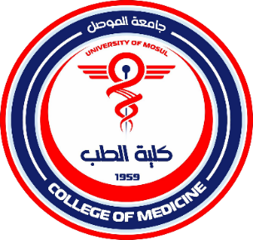
College of Medicine
Studies and Planning Division

Division Name: Studies and Planning Division
Vision:
To be a key source of accurate information for the college's database of all its members.
Mission:
The Studies and Planning Division strives to enhance the efficiency of the educational process at the college by implementing and monitoring the college's strategic plan in academic fields.
Objectives:
To raise the levels of team work by preparing reports, including university statistics and annual and quarterly reports, to ensure the success of the educational process.
Studies and Planning Division

