Peer Review Process
Journal of Petroleum and Mining uses a double-blind peer review system to assure the high quality of the reviewing process. All manuscripts should be submitted through our online manuscript submission system. For a manuscript with minimal JPM requirements and within the journal's aims and scope, the Editor-in-Chief sends the manuscript to three external scientific reviewers who are not from the same institute as the authors and not on the editorial board of the JPM. Authenticate uses to check similarities before starting reviewing. A notifying email will be sent to corresponding authors within two months, informing them about the weather acceptance or rejection of their manuscripts through our online system. JPM depends on external reviewers in reviewing the submitted manuscript and asks authors to suggest the reviewers; in addition, the editorial board members did not share in the reviewing process as reviewers, but they have a major role in choosing the manuscript's reviewers depending upon their specialty and academic reputation.
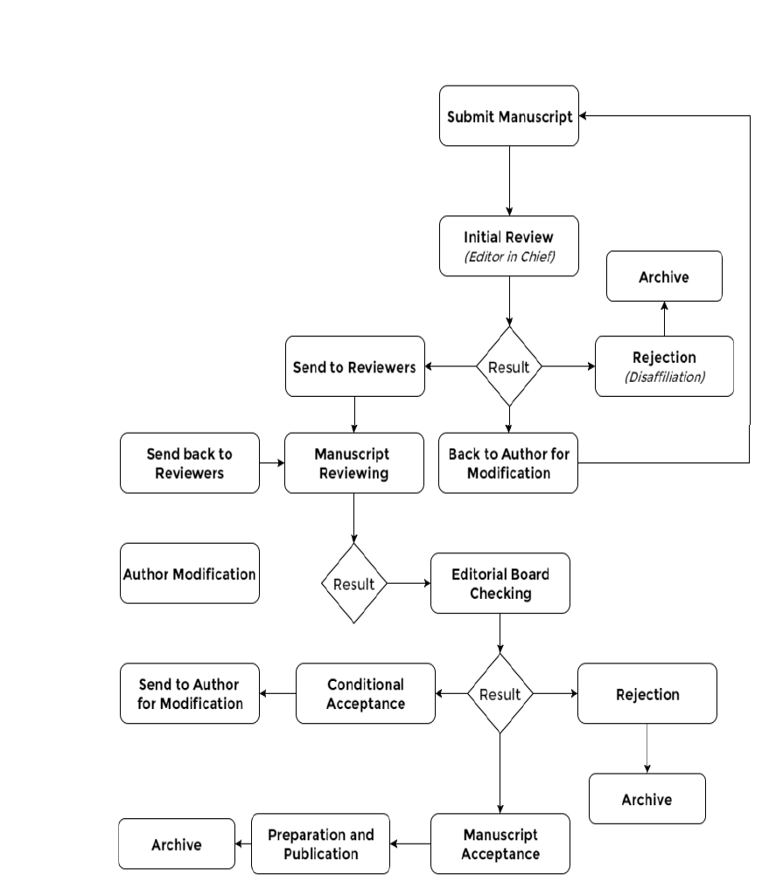

Submission of Article: The corresponding or submitting author submits the article to the JPM. This is usually via an online system.
Structural Assessment: The Exudative Director checks the article's composition and arrangement against the journal's Author Guidelines to make sure it includes the required sections and stylizations. The quality of the article is not assessed at this point.
Editor-in-Chief Assessment and Processing: The Editor-in-Chief checks that the article is appropriate for the journal and is sufficiently original and interesting. If not, the article may be rejected without being reviewed any further.
Plagiarism Checkup: The article at this step is tested by Authenticate for similarity results, if it is less than 20%, the article is considered for reviewer assigning; else, the article is rejected due to similarity results.
Invitation to Reviewers: The Editor-in-Chief sends invitations to individuals he or she believes would be appropriate reviewers. As responses are received, further invitations are issued, if necessary, until the required number of acceptances is obtained (two accepted reviewer decisions).
Response to Invitations: Potential reviewers consider the invitation against their expertise, conflicts of interest, and availability. They then accept or decline.
Review is conducted: The reviewer sets time aside to read the article several times. The first read is used to form an initial impression of the work. If major problems are found at this stage, the reviewer may feel comfortable rejecting the article without further work. Otherwise, they will read the article several more times, taking notes to build a detailed point-by-point review. The review is then submitted to the journal, with a recommendation to accept or reject it – or else with a revision request (usually flagged as either major or minor) before it is reconsidered.
Journal Evaluates the Reviews: The Editor-in-Chief considers all the returned reviews before making an overall decision. If the reviews differ widely, the editor may invite an additional reviewer to get an extra opinion before making a decision.
Primarily Decision: The Editor-in-Chief sends a decision email to the author including any relevant reviewer comments. The reviewer's name is anonymous to the author (s).
Author Send Revised Manuscript: The author should do the changes asked by the reviewer to do, and should highlight these changes in red or yellow shadow.
Final Decision: If accepted, the author should pay the publication fee, and the article should be sent to the page designer and then to the publisher.

