# **Probability (P) Discrete probability distribution Continuous probability distribution**

**Assist. Prof. Dr. Humam G. Zubeer**

Family &Community Med. Depart.

College of Medicine-University of Mosul

October – 2020

# **Discrete probability distribution**

## Suppose an event (E) can happened in (r) ways out of total of (n) possible equally likely ways. e.g: S = {1,2,3,4,5,6} (sample space of a die) Then

## The prob. of occurrence of the event **“called it’s success”.**

## **Is defined by (p) where:**

## 

## **Example of coin:**

# 

## Where :

## **p :** Probability of an event (success).

## **n :** Sample space (success & failure events)

## **r :** Success events only.

## **N – r :** Failure events only.

## 

## **0 ≤ p ≤ 1**

## **If p = 1** called the Certain prob.

## **If p = 0** called the Impossible prob.

# **Probability Distribution of a Continuous Variable**

# “The Normal Distribution” **OR** GAUSSIAN Distribution

# 

# Suppose that we increase the no. of children to 50 000 and decrease the width of interval to 0.01 lb.

# The term normal curve, in fact, refers not to one curve but to a family of curves, each characterized by a mean **μ** and a variance **σ2**. In the special case where **μ** = 0 and **σ2** = 1, we have the ***standard normal curve***. The curve is bell-shaped with the tails dipping down to the baseline.

# In theory, the tails get closer and closer to the baseline but never touch it, proceeding to infinity in either direction. In practice, we ignore that and work within practical limits.

# **Gaussian or normal Distribution.**

## **Why used it?**

## **The normal distribution is important because the distribution of many medical measurements in population approximate the normal in shape.**

## 

**e.g: Serum uric acid level, cholesterol level, blood pressure, glucose level, age, height, weight… Etc.**



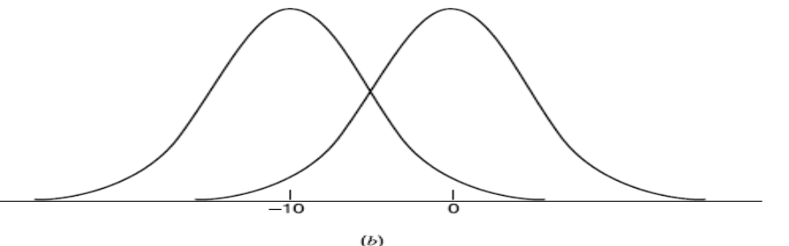

# Family of normal curves: (a) two normal distributions with the same mean but different variances; (b) two normal distributions with the same variance but different means.

# 

# Sometimes the bell is tall and narrow, and sometimes it is more flattened, but whatever the dispersion of the data, approximately 95% of measurements lay within two standard deviations either side of the mean.



**µ**



68%



95%

99%



**Shape of Normal Distribution**

## **Characteristics of the normal distribution:**

## **1-** The general form of the normal distribution is:

## 

## 

## 2- The normal distribution is determined by two quantities the mean μ & variance σ2 (2 parameters which define a normal curve).

## 3- The normal distribution is Uni-Model (only one peak).

## 4- The (Mean = Median = Mode).

## 5- Bell shaped, symmetrical about the mean (μ) and the mean (μ) divided the whole area into two parts (50%) below it & (50%) above it.

## 6- The intervals spanning the mean ( μ ) by σ , 2 σ , 3 σ on the both sides of ( μ ) is respectively: (68.27%), (95.45%), (99.73%) of the total area.

## **Lower and upper limits of the data follow normal distribution:**

## 

## 

## 