Communication Skills in Nursing
Definition of communication
- Communication is a complex, ongoing, dynamic process in which the participants in the same time create shared meaning in an interaction.
- A process through which individuals exchange their ideas, values, thoughts, feeling & actions with one or more people.
- The transfer of information from the sender to the receiver so that it is understood in the right context
Communication process
- Communication process is an interactive that occurs when a person (the sender) sends a verbal or nonverbal message to another person (the receiver) and receives feedback.
- The communication process is influenced by emotions, needs, perceptions, values, education, culture, goals, literacy, cognitive ability, the communication mode, and Noise.
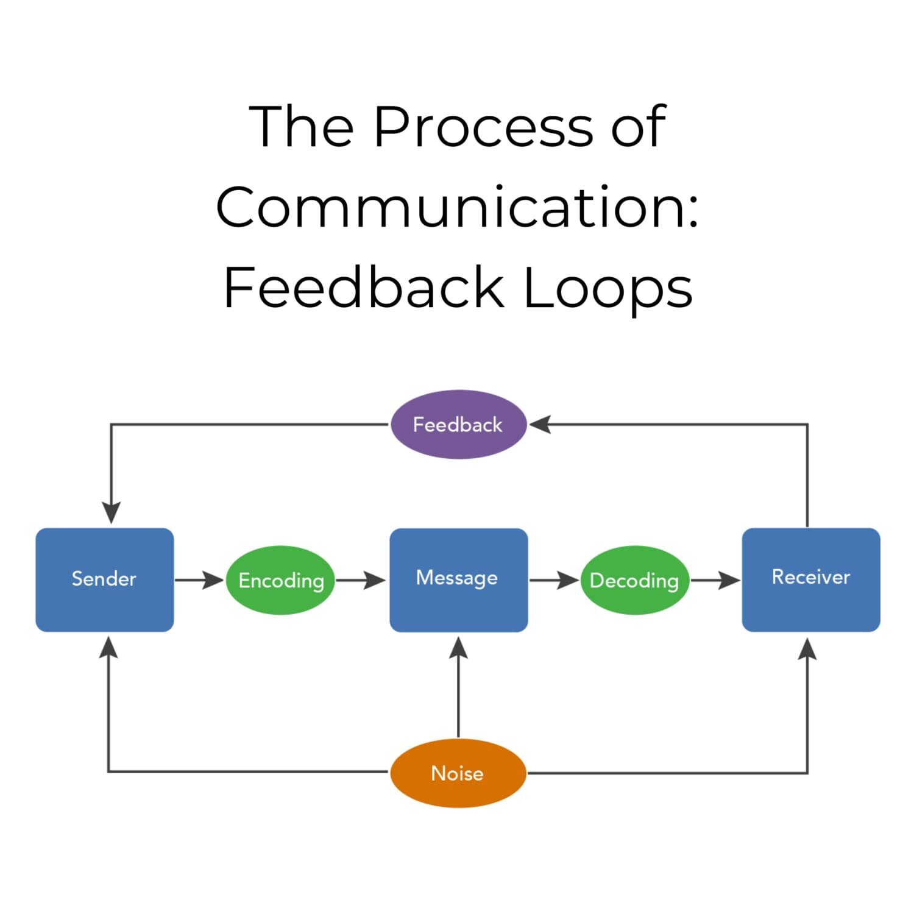

Elements of the communication
Sender:
- A sender is a person who encodes & sends the message to the expected receiver through an appropriate channel.
Message:
- The message is the content of communication and may contain verbal, nonverbal or symbolic language.
Channel:
- A channel is a medium through which a message is sent or received between two or more people.
- Several channels can be used to send or receive the message, i.e., seeing, hearing.
Receiver:
- A receiver (decoder)is an individual or a group of individuals intended to receive, decode & interpret the message sent by the sender/source of message.
Feedback:
- It is a return message sent by the receiver to the sender.
- A successful communication must be a two-way process where the sender sends the message & receives feedback from the receiver as intended.

Confounding elements:
- These elements are not a direct part of the communication process but have significantly influence on communication process.
Characteristics of Communication
5‘C’ of communication:
- Completeness.
- Conciseness.
- Correctness.
- Clarity.
- Courtesy (the showing of kindness toward others).
Types of communication
- Based on the means of delivering the message
- Verbal communication:
- It occurs through the medium of spoken or written.
- Some important elements of verbal communication are language, meaning, clarity, brevity, consciousness, timing, relevance…. etc.
- Nonverbal communication
- This communication occurs without words; where the five senses & whole range of body movements, posture, gesture, facial expressions & silence are used for sending & receiving the message.
- Based on the purpose of communication
- Formal communication
Formal communication follows line of authority & is generally used in organization to achieve organizational objectives
- Informal communication
Informal communication does not follow line of authority.
- Therapeutic communication:
Therapeutic communication takes place between a health care personnel & a patient, with the purpose of modifying the patient behavior.
Communication and the therapeutic relationship
- Nurses are expected to use communications with clients in a manner designed to promote health.
- The interaction with clients should be therapeutic relationships. It requires the use of verbal and nonverbal techniques that are focused on client needs.
- Based on the levels of communication
  - Intrapersonal communication
It takes place within an individual; we may also say it is self-talk.
  - Interpersonal communication
It takes place whenever two or more people interact & exchange messages or ideas.
  - Transpersonal communication
It takes place within a person’s spiritual domain.
- Based on the levels of communication
  - Small-group communication
- An example of a small-group communication is when nurse interact with two or more individuals face-to-face or use a medium (like a conference call).
  - Public communication
- Public is generally defined as a large group of people.
  - Organizational communication
- It takes place when individuals & groups within an organization communicate with each other to achieve established organizational goals.
- Based on the pattern of communication
  - One-way communication
It takes place when message is delivered to the audience from the communicator only without constant feedback.
  - Two-way communication
It takes place when both the communicator & audience take part in the process.
  - One-to-one communication
Communication between one sender & one recipient at one time.
  - One-to-many communication
Where one person communicates with many people at the same time.
  - Many-to-one communication
Many-to-one communication takes place when several people communicate with one person at the same time.
Nurse characteristics that promote effective communication
- Showing unconditional positive regard for your client: means accepting and respecting the client as a human being, without imposing any conditions for that acceptance.
- Empathy: identifying closely with a client because a nurse can imagine herself in the client's situation.
- Authenticity: being real, it requires openness and sharing of true feelings.
- Caring: means paying attention for a client.
- Active listening: is the act of perceiving what is communicated verbally as well as nonverbally.
Benefits of communication
- Communication is a source of information to the organizational members for decision-making process as it helps identifying and assessing alternative course of actions.
- Communication also plays a crucial role in altering individual’s attitudes, i.e., a well-informed individual will have better attitude than a less-informed individual.
- Communication also helps in socializing. It is also said that one cannot survive without communication.
- Communication assists in controlling process. It helps controlling organizational member’s behavior in various ways.
Common Barriers to Effective Communication:
- The use of jargon. Over-complicated, unfamiliar and technical terms.
- Emotional barriers. Some people may find it difficult to express their emotions and some topics may be completely taboo.
- Lack of attention, interest, distractions, or irrelevance to the receiver.
- Differences in perception and viewpoint.
- Physical disabilities such as hearing problems or speech difficulties.

