Risk Management
Learning Objectives for the Lecture:
At the end of the lecture, the student is going to be able to:
- Define the meaning of risk management.
- Identify the importance of change management.
- What are the basic methods of risk management?
Risk management is the process of identifying, assessing, and controlling threats to an organization's capital and earnings. These risks stem from a variety of sources including financial uncertainties, legal liabilities, technology issues, strategic management errors, accidents, and natural disasters.
What is the purpose of risk management?
The purpose of risk management is to identify and deal with problems before they occur in order to avoid surprises and losses. Most large companies have professional risk management on staff.

Risk Management Process

One of the best-known sources is the ISO 31000 standard, Risk Management -- Guidelines, developed by the International Organization for Standardization, a standards body commonly known as ISO.
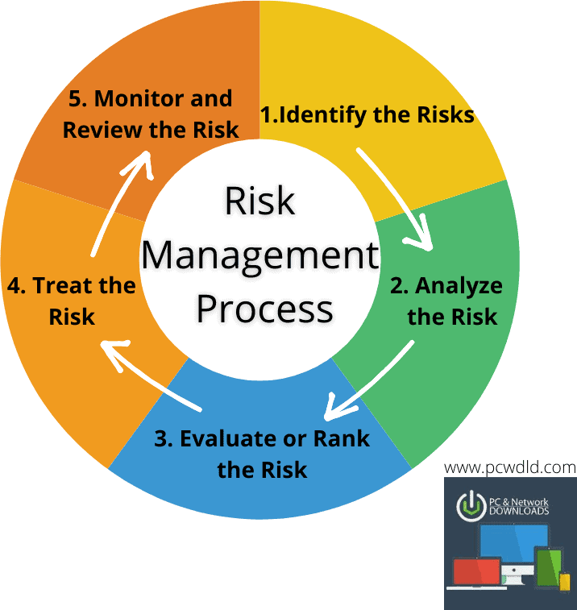
ISO's five-step risk management process comprises the following and can be used by any type of entity:

- Identify the risks.
- Analyze the likelihood and impact of each one.
- Prioritize risks based on business objectives.
- Treat (or respond to) the risk conditions.
- Monitor results and adjust as necessary.

Importance of Risk Management
Risk management is an important process because it empowers a business with the necessary tools so that it can adequately identify and deal with potential risks.
Once a risk has been identified, it is then easy to mitigate it. In addition, risk management provides a business with a basis upon which it can undertake sound decision-making.
For a business, assessment, and management of risks is the best way to prepare for eventualities that may come in the way of progress and growth. When a business evaluates its plan for handling potential threats and then develops structures to address them, it improves its odds of becoming a successful entity.
In addition, progressive risk management ensures risks of high priority are dealt with as aggressively as possible. Moreover, the management will have the necessary information that they can use to make informed decisions and ensure that the business remains profitable.
Four Basic Methods for Risk Management
The basic methods for risk management—avoidance, retention, sharing, transferring, and loss prevention and reduction—can apply to all facets of an individual's life and can pay off in the long run.

