Pneumothorax
- Partial or complete collapse of the lung due to positive pressure in the pleural space
- A pneumothorax occurs when free air accumulates in the pleural cavity between the visceral and parietal areas, and causes a portion or the complete lung to collapse.
- Pressure in the pleural space is normally less than that of atmospheric pressure but following a penetration injury, air can enter the cavity from the outside changing the pressure within the lung cavity and causing it to collapse.
- Air can also migrate to the area when the esophagus is perforated or a bronchus ruptures, leaking air into the mediastinum
(pneumomediastinum).
- Barotrauma related to mechanical ventilatory support using high levels of PEEP leads to alveoli rupture and collapse.
- Gas formation from gas forming organisms can also result in
pneumothorax.
- Pneumothorax may occur spontaneously in cases where a sub-pleural bleb or emphysematous bulla ruptures due to chronic obstructive pulmonary disease, tuberculosis, cancer, or infection and this
is the most common reason in otherwise healthy individuals.
- A tension pneumothorax is a life-threatening emergency and occurs when air is permitted into the pleural cavity but not allowed to escape, resulting in increased intrathoracic pressure and complete collapse of the lung.

Types of Pneumothorax
  - Simple Pneumothorax
- A simple, or spontaneous, pneumothorax occurs when air enters the pleural space through a breach of either the parietal or visceral pleura.
- Most commonly this occurs as air enters the pleural space through the rupture of a bleb or a bronchopleural fistula.
  - Traumatic Pneumothorax
- A traumatic pneumothorax occurs when air escapes from a laceration in the lung itself and enters the pleural space or enters the pleural space through a wound in the chest wall.
- It may result from:
      - blunt trauma (e.g., rib fractures).
      - penetrating chest or abdominal trauma (e.g., stab wounds or gunshot wounds).or,
      - diaphragmatic tears.
      - It may occur during invasive thoracic procedures (i.e., thoracentesis, trans bronchial lung biopsy, insertion of a subclavian line) in which the pleura is inadvertently punctured, or with barotrauma from mechanical ventilation.
  - Open pneumothorax
- Is one form of traumatic pneumothorax. It occurs when a wound in the chest wall is large enough to allow air to pass freely in and out of the thoracic cavity with each attempted respiration.
- Pneumothorax in which the pleural cavity is exposed to the atmosphere through an open wound in the chest wall.

  - Tension Pneumothorax
- A tension pneumothorax occurs when air is drawn into the pleural space from a lacerated lung or through a small opening or wound in the chest wall.
- It may be a complication of other types of pneumothorax.
- In contrast to open pneumothorax, the air that enters the chest cavity with each inspiration is trapped; it cannot be expelled during expiration through the air passages or the opening in the chest wall.
  - Artificial pneumothorax

an pneumothorax induced intentionally by artificial means.
  - Catamenial pneumothorax

This type occurring in young women during menstruation usually on the right side .
  - Iatrogenic pneumothorax

This type occur as a complication of some medical procedures ,such as:
- Central venous catheter insertion
- Thoracentesis
- Transbronchial and transthoracic lung biopsy .
- Extra-pleural pneumothorax

The formation of a pneumothorax by introducing air into the space between the pleura and the inside of the rib cage.

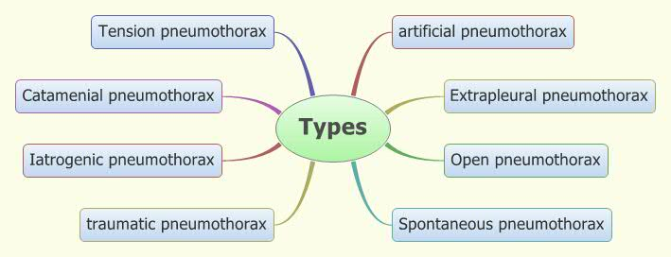

Treatment

Varies according to type and amount of lung collapse

A: traumatic
- iatrogenic .
- Chest tube to closed water seal .
- chest drainage for lung expansion .
- surgery .
- bed rest

B: Spontaneous

If no sign of increased pleural pressure ,less than 15% lung collapse , and no dyspnea or other indication of physiological compromise.

Thoracostomy tube
- If no fluid present (Second intercostal space) .
- If fluid present(Fourth, fifth or sixth intercostal space )

MEDICAL CARE
A: Laboratory: hemoglobin and hematocrit may be decreased with
blood loss.
B: Chest x-ray: used to evaluate air or fluid accumulations, collapse of
lungs, or mediastinal shifts; a visceral pleural line may be visualized.
C: Arterial blood gases: vary depending on the severity of the
pneumothorax; oxygen saturation usually decreases, Pa02 is usually
normal or decreased, and PaCO2 is occasionally increased.
D: Chest tube: placement required to facilitate re-expansion of the
collapsed lung and to permit drainage of fluid from lung.
E: Thoracentesis: needle thoracentesis is required for removing the
accumulation air in the pleural cavity.

Patient Care

Vital signs

chest expansion

Pulse Oxemetry

blood gasses

Purpose for placing a chest tube explained to the pt.

Nursing Diagnosis
- Acute Pain related to recent injury ,coughing .and deep breathing .
- Fear Related to threat to own well-being and difficulty breathing
- Impaired Gas exchange related to ventilation perfusion imbalance.
- Risk for injury related to possible complications associated with closed chest drainage system .

Nursing Interventions
  - Reduce anxiety.
  - foster cooperation with the procedure.
  - Semi Fowlers position
  - Encourage deep coughing exercise.
  - Incentive spirometry .
  - Encourage early ambulation.
  - Administered analgesics as order.
  - if chest tube is accidentally dislodged , occlusive dressing *(petroleum gauze) , to prevent lung collapse .

