Wellsite Activities:-
Coring high-quality core material is absolutely crucial to the success of a rock characterization study. The coring pro¬gram must minimize damage to the rock and maximize recovery. Equally important are core handling and pres¬ervation procedures used prior to the arrival of the core at the laboratory. Mishandling core can invalidate even the most carefully designed laboratory test. Several recent innovations in coring technology con¬tribute to acquisition of more reservoir-representative rock. A shift toward the coring of unconsolidated sediments, as the case in Niger Delta, has accelerated the use of disposable inner barrels and liners. Fiberglass, aluminum, and plastic inner barrels have effectively replaced rubber-sleeve methods for coring complex lithologies. Specialized core catchers permit complete clo¬sure of the inner barrel before surfacing the bottom-hole coring assembly and are highly effective in recovering unconsolidated rocks .The invasion of drilling fluid into highly permeable rock is damaging and reduces the volume of uncontaminated rock available for analysis. Sidetrack coring is an emerging technology that will have a great impact on the way coring is performed in soft sediments . This system allows for the acquisition of a full-diameter continuous sidewall core where it is difficult for the geologist to pre¬dict the formation top of a potential pay zone and drilling rates are high. The benefit of such a system becomes clear when one considers the economics of coring offshore.

The increase in horizontal drilling activity and the need to understand more about lateral reservoir characteristics have led to the development of reliable horizontal (medium-radius) coring systems.
Elec¬tronic multi-shot instruments (EMI) are available for the accurate orientation of core using a standard three-point scribing system. In fractured formations, the EMI can provide a high density of shot points, unlike previous methods that relied on photo-mechanical tech¬nology. Oriented core is useful in examining fracture strike, in situ stresses, and directional reservoir properties, e.g., permeability and depositional patterns. The paleomagnetic orientation of core is an alternative to the EMI method when operational and geological conditions are favorable. Another method to evaluate reservoirs target¬ed for exploratory horizontal drilling involves the use of vertical pilot-hole coring. A combination of field and laboratory rock characterization technologies is used to assess borehole stability, reservoir fracture po¬tential, and basic reservoir properties to optimize hori¬zontal wellbore placement and azimuth.
The slim-hole, high-speed, wireline-retrieved, contin¬uous core-drilling method is an innovative, cost-effective means to explore for hydrocarbons (Walker and Mill-heim, 1990). This technology, adapted from the mining industry, presents a new opportunity to rock-character¬ization generalists. In an economic environment in which it is often difficult to obtain budget approval for any coring program, the slim-hole method provides continuous core from the surface through the zone of interest (to 12,000 ft). Real-time well-site processing and evaluation methods have been developed to take advantage of the wealth of detailed information available to define rock properties on a continuous basis. Conceptually, this technology may replace traditional drilling technology in remote, difficult, and environmentally sensitive areas.

A developing technology with a high potential is coiled-tubing-conveyed CTC coring. Coiled tubing is a continuous string of pipe spooled onto a reel and mounted on a portable drilling rig. The main advantages of CTC coring are the savings in trip time since coiled tubing is run continuously with no connections, and circulation can be maintained during tripping to help remove cuttings and cool down-hole tools. This technology is now used to drill directional and horizontal wells and may be capable of coring vertical wells to depths of 50,000 ft with down-hole mud motors.
The pressure-retained coring method, widely used dur¬ing the early 1980's to recover in situ fluid saturations, is rarely used because of its high cost. Alternatively, many operators have resorted to sponge-coring systems to accurately measure reservoir fluid saturations. Significant effort has been spent refining sponge-core an¬alytical procedures have developed proton nuclear-magnetic-resonance (NMR) spectroscopy methods to determine oil saturation in sponge core. In general, the sponge-coring method can provide additional reservoir data at a cost no more than twice that of a conventional core.
Wireline-conveyed percussion sidewall coring and me¬chanically drilled sidewall-coring methods can be an in¬valuable supplement to log interpretation when conven¬tional core is unavailable. In soft rocks where percussion methods are used, advances in the measurement of particle size distribution using laser optics has added a new perspective to petro-physical interpretation and well completion strategies. The mechanically or rotary-drilled sidewall coring technique continues to be an excellent means to obtain undamaged plug samples suitable for special core testing. Recent innovations in rotary sidewall coring include greater sample capacity, improved reliability, and better tool performance.

Core Handling and Preservation:-
The main objective of a coring and core preservation program is to obtain the rock that is representative of the formation and deliver it to the core analysis laboratory as unaltered as possible. Although a variety of techniques have been developed, there is unfortunately no single
best method for handling and preserving core samples. Different rock types may require additional precautions. The most appropriate core handling techniques may depend on the length of time for transportation, storage and the nature of the specific tests to be conducted.
Conventional core handling involves breaking lengths of core into 1m (~3 ft) sections as the core is retrieved from the inner barrel on the drill floor or on the catwalk. These pieces are then loaded in sequential order into transit core boxes and taken to the place designated for core layout and description. The core should be laid-out, cleaned, fitted, marked and described, and then packed into the final transport boxes for shipment to the core storage/analysis facilities
Unconsolidated core normally requires some form of stabilization inside the core barrels prior to transport. Two stabilization methods are in general use in the industry, freezing of the core and injection of fast hardening epoxy resin/plastics in the core/core barrel annulus. Often combination of both methods i used.

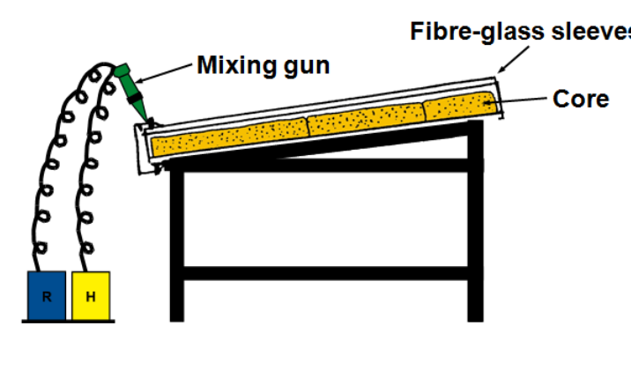
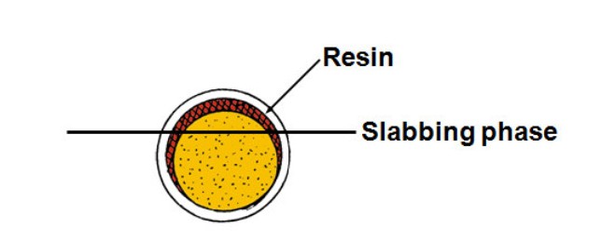
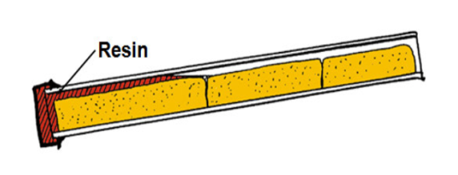

Core Analysis Preparation:-
After the core has been cut and preserved at the well site, it is transported to the core analysis laboratory where it is subject to a wide variety of measurements. These measurements are divided into two main categories: (1) basic (or routine) core analysis laboratory (RCAL) and (2) special core analysis laboratory (SCAL) measurements. They include grain density, porosity,
permeability, fluid saturation, electrical resistivity, capillary pressure and relative permeability
measurements. However, several steps should be taken before these measurements take place.
These are imaging, sample selection, core plugging and plug preparation. The flow diagram for conducting basic core analysis measurements is shown in

Recommended flow diagram for basic core analysis
