Capacitors
1- Capacitance : We previously showed that the electric potential of an insulated spherical conductor in a vacuum is:
$$V=\frac{1}{4πε_{0}}\frac{q}{R }$$
Where ( q ) represents the charge placed on a spherical body of radius ( R ) . This can be written the equation is as follows
$$q=\left(4πε_{0}R \right) V$$
It is clear that the charge carried by a spherical conductor is directly proportional to its electrical potential. This has been proven experiments show that this result applies to all charged conductors, whatever their shapes.
From this it is clear that the charge placed on any conductor can be increased, thereby increasing its voltage. But if this increase continues, it will lead to an increase in voltage to the point where an electrical discharge occurs .
By definition, its unit according to the International System (SI) is C/V (Farad) .known scientist Michael Farad, who contributed to developing the idea of ​​electrical capacity. So
$$1F=\frac{1C}{1V}$$
( $1μF$ = ${10}^{-6 }$ Farad ) ( $1PF$ = ${10}^{-12 }$ Farad )
This means that the capacitance is equal to one farad if the capacitance requires one coulomb of charge to raise a difference
The voltage between its two ends is one volt.

2- Capacitors :If we place a number of charged and Insulated conductors near each other, mutual effects occur between them, which makes the voltage of each conductor depend not only on the charge carried by that conductor, but also on the charges of the other conductors adjacent to it, as well as on their shapes, dimensions, and locations .
The figure shows a general case of two conductors adjacent to each other, isolated from each other, and carrying equal and opposite charges in sign. A structure like this is called an electrolytic capacitor. The two conductors are called plates, and they are made in different geometric shapes, as will be seen later.
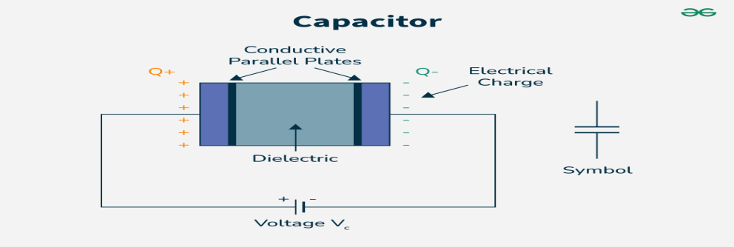
Capacitors are among the basic elements in electrical circuits and are of great importance in modern technology ,They are used to rectify alternating current ripples, and to generate or detect electromagnetic waves and in storing electromagnetic energy and discharging it when needed, and for other used many components of electronic devices . In general general , it can be said that the electronic age ,We are witnessing that it cannot remain without Capacitors .
Capacitors used for scientific purposes:
A) capacitance ( Vastus ) foliar.
(b) capacitance ( Expansive ) mica.
C) Electrolytic capacitance.
D) variable capacitance( vastus ).

3- How to calculate capacity :
The capacitance ( C ) of any capacitor is the ratio between the charge of the capacitor ( q ) and the potential difference ( V ) between the two conductors that make up it. This is because the quantum sum of the capacitive charge in both plates is zero.The capacitance depends on the geometry of the two plates, the distance between them, and the dielectric medium . The special case in which the medium separating the two plates is vacuum (or air), so we go beyond it to insulating materials. We will now rely on the definition (C=q/V ) to calculate the capacitance of a number of capacitors whose conductive plates are of different geometric shapes.
A) The amplitude of the amplitude with two parallel waves:
The parallel plate capacitor , It consists of two parallel conductive plates separated by a thin layer of insulating material(or vacuum). The capacitor is charged by connecting the two plates to the poles of an electric battery, so that the plate connected to the pole gains power The positive is a positive charge. The other plate acquires a negative charge equal in amount to the positive charge .
The magnitude of the electric field strength between two parallel plates : $E=\frac{σ}{ε_{0}} ≫≫ E =\frac{q}{ε_{0 }}$
Since the field between the two plates is uniform, the potential difference between them is equal
$$V=Ed ≫≫ V=\frac{q}{ε_{0}}\frac{d}{A}$$
So, the capacity of the parallel-plate expansion becomes:
$$C=\frac{σ}{V} ≫≫ C=ε_{0}\frac{A}{d }$$
From this equation, we see that the capacitance is a fixed quantity for a particular capacitor that does not depend on the charge of the capacitor, but rather is directly proportional to the area of ​​the two plates and inversely proportional to the distance between them.
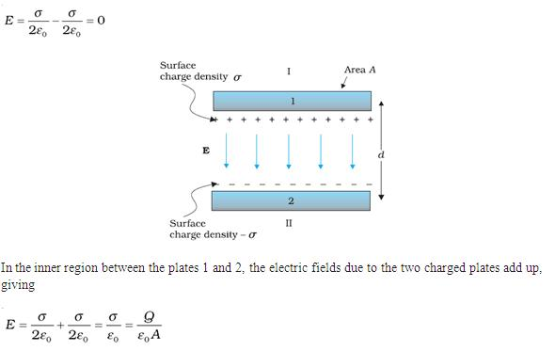

B - The amplitude of the cylindrical capacitor :
The cylindrical capacitor consists of two coaxial cylinders
Their length L is the radius of the inner cylinder (a) and the radius of the inner surface of the outer cylinder (b). The length of the expander is assumed to be large so that the distortion occurring in the radial field at the two ends of the expander can be neglected when calculating the capacity.

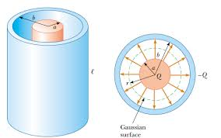
$$E\left(2πrL\right)=\frac{q}{ε_{0}} ≫≫ E=\frac{q}{2πε_{0}rl}$$
We obtain the potential difference, after which the capacitance can be calculated by dividing the charge by the potential difference. any
$$C=\frac{q}{V}=\frac{2πε_{0 }l}{ln({\frac{b}{a }) }}$$
The capacity depends on the geometric shape of the expander and on its geometric dimensions represented by a, b, and L. It also depends on the nature of the insulating material Separate one of the two plates connecting the expander from the other.

C - The amplitude of the spherical capacitor:
The spherical capacitor consists of two spherical surfaces connected concentrically, the radius of the entering sphere ( a ) and the radius of the outer sphere ( b ) . Let us assume that
Vacuum (or air) separates one surface from the other, as is the case in the two spaces we mentioned above .
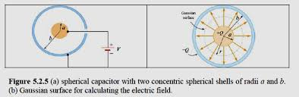
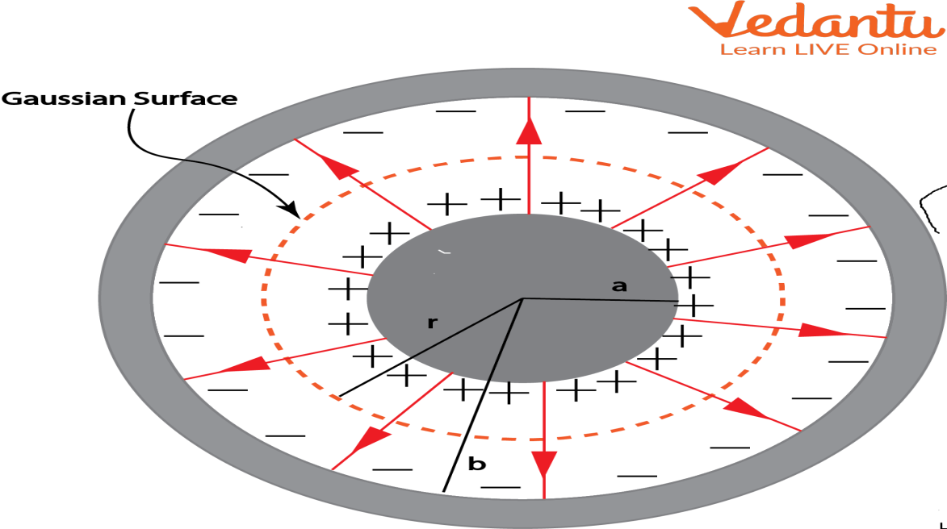

$$V=\frac{q}{4πε_{0}}\frac{b-a}{ab} ≫ ≫ C=\frac{q}{V}=4πε_{0}\frac{ab}{b-a}$$
Example ( 1 ) : How many square meters of sheet metal do you need to make a capacitor with two parallel plates with a capacity of one farad, such that the thickness of the air layer separating the two plates is one millimeter? And what it indicates?
$$C=\frac{σ}{V} ≫ C=ε_{0}\frac{A}{d } ≫ A=\frac{Cd}{ε_{0}}$$
$$A=\frac{1F×1×{10}^{-3}}{8.82×{10}^{-12 }C^{2}N^{-1}m^{-2}}$$
$$=1.13×{10}^{8 }m^{2 }=113Km^{2}$$
If this large number of board area indicates anything, it indicates that the farad is a very large unit for scientific purposes. This is why it is preferable to use micro farads and Pico farads .
Example ( 2 ) : Calculate the capacity of a cylindrical container of length ( 1m ) if you know that the diameters of the inner and outer cylinders are ( 3.0 cm and 10 cm) , respectively, and the air isolates one cylinder from the other?
$$C=\frac{q}{V}=\frac{2πε_{0 }l}{ln({\frac{b}{a }) }}= \frac{2π×8.82×{10}^{-12 }×1}{ln({\frac{5}{1.5 }) }}=46PF$$
Example ( 3 ) : Calculate the capacitance of an electric line consisting of two wires with a length of (10 km) , if you generalize that the radius of each the two wires are equal to (7.5 mm) and the distance between the two thicknesses is
( 40 cm )?
R=7.5mm , l=10$×{10}^{3}$ , d=400mm
$$C=\frac{q}{V}=\frac{2πε_{0 }l}{ln({\frac{d}{R }) }}= \frac{2π×8.82×{10}^{-12 }×10×{10}^{3}}{ln({\frac{400}{7.5 }) }}$$
$$=7×{10}^{-8}F =7×{10}^{-2} μF$$
Example ( 4 ) : A room with two parallel plates has an area ( A ) and the distance between its two plates is ( d ) . Insert a conductive plate between its two plates It is insulated and uncharged. Its thickness is ( t ) . What will the capacity be after this plate is inserted?
Suppose that a positive charge of ( +q ) is placed on the vertical plate and a positive charge of ( -q ) is placed on the plate
Bottom. Before the conductive plate was inserted, the electric field was confined to the entire area between the two plates
The vastus. But after placing the conductive plate, the field only covers a distance of ( d-t ), because the field strength inside this plate must be zero. $E=\frac{q}{ε_{0 }A}$
$$V=Ed ≫V=E\left(d-t\right) ≫ V=\frac{q}{ε_{0}}\frac{(d-t)}{A}$$
Then the capacity changes to the following value
$$C=\frac{q}{V}=\frac{ε_{0}A}{(d-t) }$$
4-The importance of using insulators in expanders:
The benefits of using solid insulators to separate the conductive plates of capacitors With three points:
1- Placing one of the two thin conductive plates of the expander a little apart from the other in a vacuum (or air) without them touching is extremely difficult from a production and practical standpoint, isn't it? It is best, then, to use a solid plate of insulating material to support its two sides Connectors to the vastus ? Doesn't the expanded insulation board give it more elasticity and make it less susceptible to damage?
2- The insulation intensity of insulating materials is usually greater than that of air. This increases the capacity of the expander to withstand voltages and makes it higher than in air. Thus, the capacitor is less susceptible to the occurrence of what is called an electrical breakdown and subsequently to damage.
For example, the insulation intensity for air is 800 V/mm, for paper is 14,000 V/mm, and for mica 1600000 V/m .
3- Placing an insulating board between two expanding boards will make its capacity increase more than it would in a vacuum.
The factor K is called the dielectric constant or the relative permittivity of the insulator. The table below shows the values ​​of the dielectric constant for a number of insulators.
glass | Mica | paper | paraffin wax | air | Vacuum | Insulating material
4 to 10 | 4 to 8 | 2 to 3 | $$\sim 2$$ | 1.0006 | 1 | Insulation constant

The dielectric constant is defined as the ratio between the capacitance of the capacitance when the insulator is between its plates to the capacitance of the capacitance the same when the two plates are in space.
Any $K=\frac{C }{C_{0} } ≫ C=K{ C}_{0}$
$C=ε_{0}\frac{A}{d } ≫≫ C=KC_{0}=Kε_{0}\frac{A}{d }$
$$C=\frac{q}{V}=\frac{2πε_{0 }l}{ln({\frac{b}{a }) }} ≫≫ C=KC_{0 }=\frac{2πε_{0 }Kl}{ln({\frac{b}{a }) }}$$
It is worth noting that the insulation constant may be replaced by another constant called the permittivity of the insulation and symbolized by the Greek letter, according to the relationship
$$ε=Kε_{0 }$$
In the case of vacuum ( K = 1 ), it is ( $ε=ε_{0 }$) equal to the quantity, so the constant is called the permittivity of the vacuum.
Example ( 5 ) : capacity consisting of two panels, each with an area of ​​( 80 m² ) , separated by a thick layer of paraffin
( 5mm ) Calculate the capacitance if you know that the relative permittivity of the insulator is( 2 ) ? Calculate the capacitance charge when a potential difference of ( 200 V ) is applied to it?
$$C= KC_{0} =Kε_{0}\frac{A}{d } =\frac{2×8.85×{10}^{-12}×80×{10}^{-4}}{5×{10}^{-3}} =28.3×{10}^{-12 }PF$$
$$C=\frac{Q}{V}≫≫Q=CV=28.3×{10}^{-3}×200$$
$$=56.6×{10}^{-10 }C=5.66×{10}^{-3} μC$$
Example ( 6 ) : Calculate the capacity of an axial shaft with a length of (50 m ) if you know that the diameter of its internal cylinder is ( 3 mm) the diameter of its outer cylinder is ( 10 mm)
, and the relative permittivity of the insulator is ( 3) ?
$$C=KC_{0 }=\frac{2πε_{0 }Kl}{ln({\frac{b}{a }) }} = \frac{2π×8.82×{10}^{-12 }×3×50}{ln({\frac{5×{10}^{-3}}{1.5×{10}^{-3} }) }}=6930×{10}^{-12} F=6.93×{10}^{-3} μF$$
5-connecting the capacitance:
1-capacitors in series :
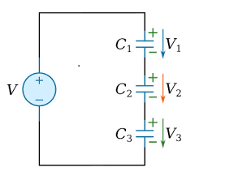
Then all capacitor plates connected in series acquire the same amount of charge (q). ?Why?
,${ V}_{1}=\frac{q_{}}{C_{1} } ,{ V}_{2}=\frac{q_{}}{C_{2} } , V_{3}=\frac{q_{}}{C_{3} }$
Thus, the total potential difference of the group becomes $V=V_{1}+V_{2}+V_{3 }$
$$V=\frac{q}{C_{1}}+\frac{q}{C_{2}}+\frac{q}{C_{3 } } Then \frac{V}{q}=\frac{1}{C_{1}}+\frac{1}{C_{2}}+\frac{1}{C_{3}}$$
$$\frac{V}{q}=\frac{1}{C_{1}}+\frac{1}{C_{2}}+\frac{1}{C_{3 }}$$
However, the equivalent capacitance (C) of this group of capacitors is defined as the capacitance of that capacitance carrying the charge of the same group, (i.e. q), when the same potential difference (V) is applied to it. Any
$$but C=\frac{q}{V } So Van \frac{1}{C}=\frac{1}{C_{1}}+\frac{1}{C_{2}}+\frac{1}{C_{3 }}$$
In general, we can calculate the equivalent capacitance of any number of capacitors connected in series from the relationship :
$$\frac{1}{C}=\sum{i \frac{1}{C_{i}}}$$
2-capacitors in para :
To calculate the equivalent capacitance of the set of capacitors C1, C2, and C3 connected on Parallelism as shown in the figure. Let us assume that both ends of the group are connected to a battery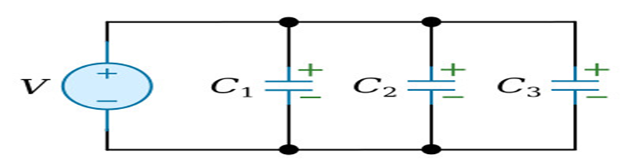
It results in a voltage difference between points( a) and ( b ) of (V), then the voltage difference across each of the... The three expanders, and using the relationship ( q= CV ) we can find the charge of each of the expanders all three
q=CV $≫ ≫$ $q_{1}=C_{1}V , q_{2}=C_{2}V ,q_{3}=C_{3}V$
Thus, the quantitative charge becomes (q) for the group
$$q=q_{1}+q_{2}+q_{3 }$$
$$q=C_{1}V+C_{2}V+C_{3}V Then \frac{ q}{V}=\left[C_{1}+C_{2}+C_{3 }\right]$$
But the equivalent capacitance of the set of capacitors is equal to... $C=\frac{V}{q } Then C=C_{1}+C_{2}+C_{3 }$
We can generalize this result to include any number of capacitors, and then the equivalent capacitance is calculated from the relationship :
$$C=\sum_{i}{C_{i}}$$
Example ( 7 ) : Two capacitors of unknown capacity, separated by air between their plates, are connected in series and become the equivalent capacitance they have (150 pF), and when an insulating plate with a relative permittivity of (6) is inserted into one of the two capacitors, it becomes their equivalent capacitance is (400 pF). Calculate the capacitance of each of the two capacitors?
Let us assume the capacity of the first and second rooms before placing the insulation board C1 and C2. Then the equivalent capacity according to the equation becomes represented by the following relationship
$$\frac{1}{C}=\frac{1}{C_{1}}+\frac{1}{C_{2}}=\frac{C_{1}+{ C}_{2}}{C_{1}C_{2}}$$
Substituting the equivalent value of the group capacity produces:
$$\frac{1}{150}=\frac{C_{1}+{ C}_{2}}{C_{1}C_{2}}$$
After inserting the insulating plate into the second chamber, its capacity increases and becomes... Thus, the equivalent capacity of the group becomes according to the same relationship, represented by the following equation :
$$\frac{1}{C^{'}}=\frac{1}{C_{1}}+\frac{1}{{6C}_{2}}=\frac{C_{1}+{6C}_{2}}{C_{1}{6C}_{2}}$$
Substituting the value of ( $C^{'}$ ) produces:
$\frac{1}{400}=\frac{C_{1}+{6C}_{2}}{C_{1}{6C}_{2}}$
Thus, we obtain two equations containing two unknowns, and solving these two equations produces:
$$C_{1}=200PF , C_{2}=200 PF$$
Example ( 8 ) : Two capacitors connected in parallel have a capacity of (C) with a good difference of (V). Then they are isolated from the charging source. An insulating board was inserted into one of the two spaces so that it filled the space between its two boards. If you know that the relative permittivity of the insulator (K) . is calculated:
(a) New potential difference (V)?
(b) The amount of charge that is transferred from one capacitor to another ($∆Q$ ) as a result of the placement of the insulator ?
A) The equivalent capacitance of two capacitors connected in parallel according to the parallel relationship is equal
$$C+C=2C$$
Now let us assume that the total charge that the two capacitors will acquire when the potential difference (V) is applied to them is equal to (q) Then:
$$2C=\frac{q}{V} ≫ ≫ q= 2 C V$$
But the equivalent capacitance after placing the insulator in one of the two capacitors will
$$C^{' }=C+KC=C\left( 1+K\right)$$
Then it becomes possible to calculate the new potential difference across the two capacitors with the relation:
$$C^{' }= \frac{q}{V^{' }} , ≫ ≫ V^{' }=\frac{q}{C^{' } }$$
Substituting for both C and q results
$$V^{' }=\frac{2 C V }{C \left(1+K\right) }=\frac{2V}{1+K }$$
B/ To calculate the charge that is transferred from one capacitor to another as a result of placing the insulator, we calculate the difference between the charge of any of the two capacitors before and after placing the insulator.
Suppose that the charge of the first capacitor before placing the dielectric( q₁ ) and after placing the dielectric( $q_{1}^{'})$ then results
$C=\frac{V}{q } ≫ ≫ q_{1}$= CV
${q^{'}}_{1}= CV^{' } ≫ ≫ {q^{'}}_{1} =\frac{2V}{1+K }$ $C$
$Then ∆Q=q_{1}-{q^{'}}_{1}=CV-\frac{2V}{1+K }$ $=\frac{CV\left(K-1\right)}{K+1}$
Example ( 9 ) : Two capacitors connected in series with a capacity of (2.00 µF) and (4.00 µF) are applied to them with a potential difference of(150V) Calcuate :
(a)The charge and potential difference for each of the two capacitors?
(b) If the two capacitors are isolated from each other and from the source of applied voltages, and their positive plates are connected together, as are their negative plates together. What is the amount of charge and potential difference in each of the two capacitors ?
a) The equivalent capacitance of the two capacitors in series is equal to..
$$\frac{1}{C}=\frac{1}{C_{1}}+\frac{1}{C_{2}}=\frac{C_{1}+{ C}_{2}}{C_{1}C_{2}}=\frac{2+4}{2×4}=1.33μF$$
From it we find the total charge of the two capacitors
$q_{1}=CV=1.33×150=200μF$,$q_{2 }=1.33×150 =200μF$
This means that : $q_{1}=q_{2}=200μF$
Now it is possible to calculate the voltages across bothcapacitors
$${ V}_{1}=\frac{q_{1}}{C_{1} }=\frac{200}{2}=100V ,{ V}_{2}=\frac{q_{2}}{C_{2} }=\frac{200}{4}=50V$$
B/ The equivalent capacitance of the set of capacitors will become $C^{'}=C_{1}+C_{2 }=2+4=6μF$
This is because the connection becomes based on parallelism in this case. Also, the total charge carried by the two capacitors will be equal $q^{'}=q_{1}+q_{2 }=200+200=400μF$
Therefore,the voltages across each of the two capacitors become
$${ V^{'}}_{1}=\frac{{q^{'}}_{1}}{{C^{'}}_{1} }=\frac{400}{6}=66.7V , { V^{'}}_{1}{=V^{'}}_{2}=66.7V$$
The charge that will settle on each of the two expanders is equal
$${q^{'}}_{1}=C_{1}V_{1}^{'}=2× 66.7=133μF ,$$
$$q_{2}^{'}=C_{2}V_{2}^{'}=4×66.7=267μF$$

$$6- Stored Energy in Capacitors :$$
It is known that the process of charging the capacitor requires work (W) and that this work is stored in the form of potential energy (U) in the capacitor, which can be recovered when the capacitor is discharged. This fact is clearly evident If we imagine that there is an external factor that pulls electrons from the positive plate and then pushes them to The negative plate, thus increasing the charge of the capacitor.
In order to find the work done to charge a capacitor whose capacity is (C), we assume that the amount of charge in the capacitor at a certain moment during the charging process has become $q^{'}$. Then the potential difference between the two plates of the capacitor at that moment will be: $V^{'}=\frac{q^{'}}{C}$
Now, if another small amount of charge, ${dq}^{'}$ was transferred from one plate to another, the work required to move this small charge would be
$$dW= V^{'} dq^{' }$$
From this we can find the total work required to move a total charge q :
$$W=\int{dW}=\int{V^{'} dq^{' }}=\int_{0}^{q}{\frac{1}{C}}q^{'}dq^{'}=\frac{1}{2}\frac{q^{2}}{C}$$
By taking advantage of the relationship ($q=CV$ ) we find that
$$U = \frac{1}{2}\frac{q^{2}}{C} = \frac{1}{2}CV^{2} =\frac{1}{2} qV$$
Since the work done is equal to the energy stored in the volume.
Where is this energy stored?
It is clear that the process of charging the vastus is accompanied by the generation of an electric field in the area between the two plates of the vastus . The magnitude of this field increases with the increase in the charge of the expander and disappears as it disappears Shipment. Therefore, it is very reasonable to consider the energy of the capacitor to be stored in the electric field between its two plates

Example ( 10 ) : Calculate the energy stored in the two capacitors mentioned in the previous example when they are connected in series and (b) after disassembling them and reconnecting them in parallel ?
a) When the equivalent capacitance of the two capacitors connected in series and the total voltages imposed on them. Therefore, the energy stored in them can be calculated according to the relationship:
$$U= \frac{1}{2}CV^{2} =\frac{1}{2} ×1.33×{10}^{-6}×{(150)}^{2}$$
$$=15×{10}^{-3 }J$$
B) After isolating the two capacitors and reconnecting them in parallel, the equivalent capacitance of the group becomes. As for the voltages across the two capacitors, it will become (66.7 V). Thus, we can find the energy stored in the two expanders according to the same relationship, which results
$$U^{'}= \frac{1}{2}C^{'}V_{}^{2^{'}} =\frac{1}{2} ×6×{10}^{-6}×{(66.7)}^{2}$$
$$=13.3×{10}^{-3 }J$$
It is noted from this result that the energy stored in the two expanders has decreased compared to what it was before restoration Connect them. The reason for this is due to the thermal energy generated in the connecting wires as a result of the flow of charges and their redistribution between the two capacitors.

Example ( 11 ) : Apply a voltage difference of (120 V) to a capacitor with a capacity of (8Μf). After the expansion was charged and then isolated from the charging source is connected in parallel to another uncharged capacitor with a capacity of (40μF ). Calculate:
A) The potential difference and charge of each of the two capacitors after connecting them.?
(b) Energy stored in the first space before connecting it to the second space.?
(c) The energy stored in the two expanders after they are connected?
A) We first calculate the charge that the first expansion gained when it is charged, and we obtain:
$$q=C_{1}×V=960μC$$
It is the same charge that will be distributed across both capacitors after connecting them in parallel. But the equivalent capacitance of these two capacitors is equal
$$C=C_{1}+C_{2}=4+8=12μF$$
Then the potential difference across the group becomes
$$V^{1}=\frac{q}{C}=\frac{960}{12}=80 V$$
This is equal to the potential difference across either capacitor.
Now the charge gained by each expander can easily be calculated
$$q_{1}=C_{1}×V^{'}=8×80=640μC$$
$$q_{2}=C_{2}×V^{'}=4×80=320μc$$
b) As for the energy stored in the first space, it can be calculated from:
$$U = \frac{1}{2}C_{1}V^{2}$$
$$U=\frac{1}{2}×8×{10}^{-6}×{(120)}^{2}=57.7×{10}^{-3 }J$$
C) It is also possible to calculate the energy stored in the group consisting of the two capacitors after connecting them from the relationship
$$U = \frac{1}{2}C_{1}V^{2} =\frac{1}{2}×12×{10}^{-6}×{(80)}^{2}=38.4×{10}^{-3 }J$$
So how do you explain this lack of stored energy?

Example ( 12 ) : A capacitor with two parallel plates of area (A) and the distance between its plates is (D). It was charged with a battery and acquired a potential difference of (V) . It was then insulated from the battery and an insulating plate of thickness (d) and relative permittivity (K) was inserted into it. Find the energy stored in the space before and after inserting the insulating plate.
$$U=\frac{1}{2}CV^{2}$$
$$But C=\frac{ε_{0A}}{d}$$
$$U=\frac{1}{2}\frac{ε_{0A }V^{2} }{d}$$
Charging the expander gains a charge of
$$q=C V=\frac{ε_{0A}}{d} V$$
In fact, inserting the insulating plate into the capacitor will not affect the value of this charge, as it remains constant as long as the capacitor is isolated from the battery.
As for the capacity of the isolated capacitance, it is natural for it to increase (K) times and become
$$C^{'}=\frac{ε_{0}KA}{d}$$
Now it becomes possible to find the energy stored in the capacitor after inserting the insulating plate By substituting (q) and c' into the relationship
$$U= \frac{1}{2}\frac{q^{2}}{C^{'}}=\frac{1}{2}×{(\frac{ε_{0A}}{d} V)}^{2}×\frac{d}{ε_{0}KA} =\frac{1}{2}×\frac{ε_{0 }AV^{2}}{dK}=\frac{ε_{0 }AV^{2}}{2dK}$$
Observing this result, it becomes clear that the introduction of the insulating plate led to a decrease in the stored energy by a factor of (1/K). So how did this happen?

