Electric Field
1- Electric Field Strength:
The student must remember from his study of Newton's law of mass attraction that any two bodies affect each other with an attractive force that is directly proportional to the product of their masses and inversely proportional to the square of the distance between them.
For example, the Earth's movement around the sun is affected by this force, despite the vast distance between them and the void that separates them. This is called remote influence. This concept is not limited to the forces of mass attraction only Rather, it extends to include electric and magnetic forces as well.
The electric field strength and its symbol E at a point. It is the force acting on a unit charge on the positive test charge placed at this point. That is: $E = \frac{F}{q_{o}}$
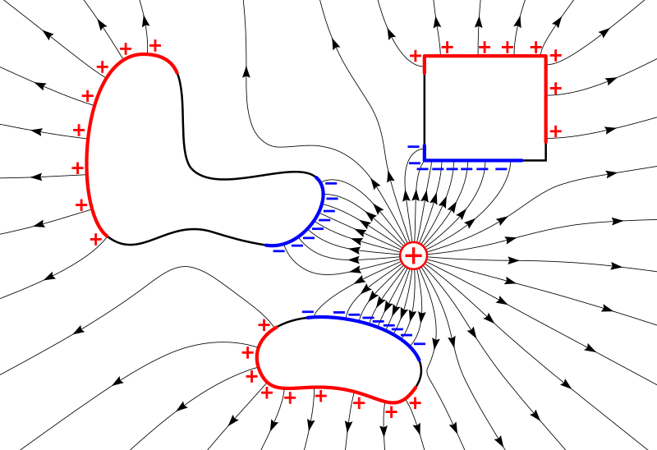
Where E represents the strength of the electric field, which is a vector quantity and its direction is the same as the direction F. It is clear that the electric field unit is the unit of force divided by the unit of charge, i.e. Newton / Coulomb ( N/C).
2- Lines of Force:
The English scientist Michael Faraday (1867-1791) was not entirely convinced by the idea that the electric field, and considered it an easy way to visualize the models of the electric field (and also the magnetic field) Faraday was very interested in the idea of ​​these (imaginary) lines and used in his study, and pictures them as filaments (or filaments) carried through the field but rather And even it has physical properties such as the property of disharmony between them, for example.
Line of force This is the path taken by a positive test charge placed at a point in the electric field. If this charge is left free, it will move towards the practically applied net electric force, F=q_{o}E , which is the result of the net field strength at that point.
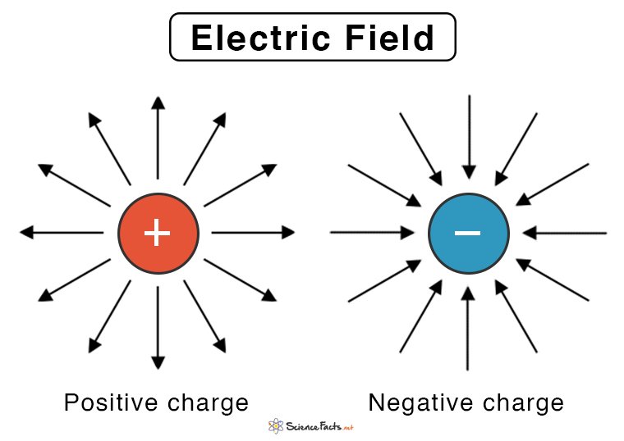
Lines of force around a positive point and a negative charge. Lines of force are often not straight, but rather in the form of curves. The figure shows the field lines arising from two charges of equal value, but one of them is positive and the other negative, separated by a small distance, and this is called the electric dipole.
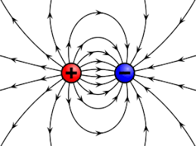
Lines of force around an electric dipole.
It seems clear from the figure that the net force acting on a positive test charge placed at a point in the field is in the direction tangent to the line of force at that point. In other words, the field strength vector E is also in the direction tangent to the force line
Lines of force begin with a positive charge and end with a negative charge. It is also noted that the lines of electric force never intersect with each other, because the electric field cannot have more than one direction at a certain point.
Also, the density of the lines of force is a measure of the amount of field strength. It is meant by the density of the lines that cut a unit area perpendicular to the direction of the field at a particular point.

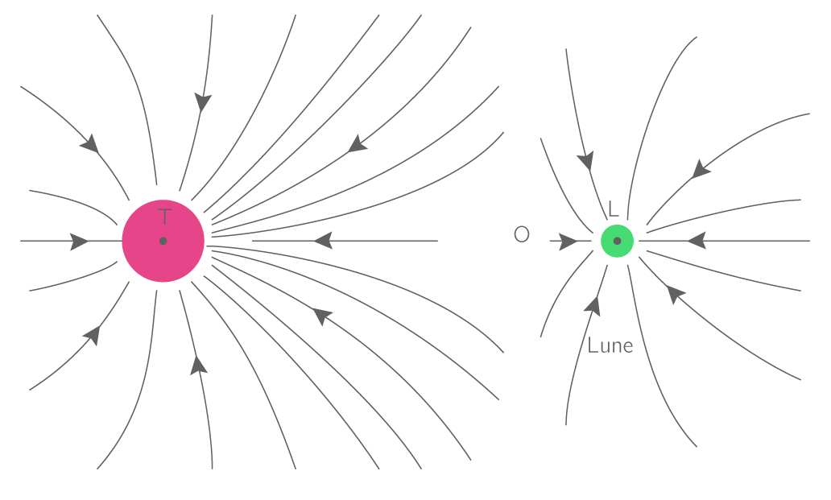
Electric lines of force around charges of equal strength and different sign.
From the foregoing, we can derive two characteristics of electric power lines:
1- The tangent to the force line at any point in the field represents the direction of the field strength E at that point.
2- The number of lines of force per unit area that cut a small area perpendicular to the field at a certain point represents the amount of field strength at that point.
3- electric field strength calculator:
To find the electric field strength of an isolated point charge of (q) at point p in the space surrounding the charge, we assume that there is a test charge (q_{o})at that point, then the force F acting on q_{o} is based on Coulomb’s law:
$$F=\frac{1}{4πε_{0}}.\frac{qq_{0}}{r^{2}}r^{∩}$$
where r is the unit vector in the direction from (q) to (p) and by substituting for (F) we find the field strength (E)
$$E=\frac{1}{4πε_{0 }} \frac{q}{r^{2}} r^{∩}$$
And to find E for a number of point charges (q₁, q₂, ...... etc)., which lie on the dimensions (r₁, r₂, and……. etc). From point p, we calculate (E₁, E₂, .... etc). for each charge separately at point (p). As if it were the only charge present i.e.: $$E_{1}=\frac{1}{4πε_{0 }} \frac{q_{1}}{r_{1}^{2}}{ r_{1}}^{∩}$$
$$E_{2}=\frac{1}{4πε_{0 }}\frac{q_{2}}{r_{2}^{2}} {r_{2}}^{∩}$$
Then we add these computed fields for all charges in a directional sum to get the total field E at that point:
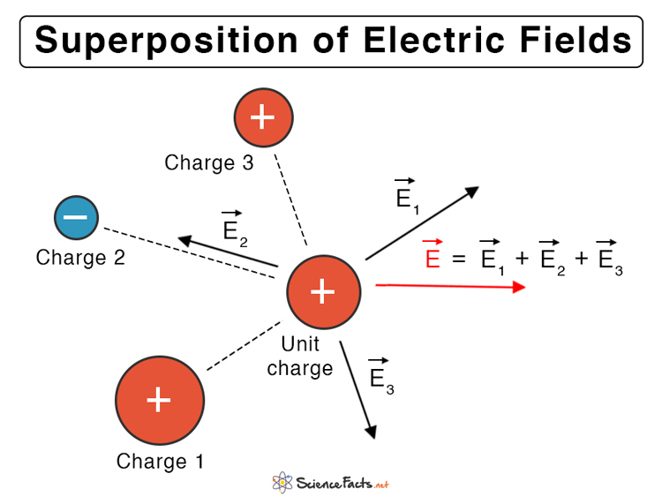
$$E=E_{1}+E_{2}+E_{3}+⋯=ƩE_{n}$$
But if the distribution of charges is continuous, such as if the charge is distributed on the surface of a conducting body, or distributed within a specific volume in a continuous manner, then it is possible to find the field strength arising from it at point P, for example, by dividing the charge into a large number of infinitesimal elements Each is called (dp), then calculates the field(dE)for each element at point p by counting each element as
A point charge Which: d$E=\frac{1}{4πε_{0}} \frac{dq}{r^{2}} r^{∩}$
where r represents the dimension from dq to point p. Then the total field E is calculated by taking the vector integral for all fields arising from these elements, i.e.
$$E=\int{dE=\frac{1}{4πε_{0 }}\int{\frac{dq}{r^{2}} }}r^{∩}$$
5-Applications on how to calculate electric field strength :
1- The field arising from an electric dipole:
The dipole, as shown in the figure, consists of two point charges of equal magnitude, one positive (+q) and the other negative (-q), separated by a distance of (2a). The importance of the dipole is clearly evident on the scale of the atomic structure of matter. The phenomenon of polarization of molecules results from the local isolation between electrons and protons, either as a result of exposure to an external electric field or as a result of the nature of the molecular structure of a substance (such as water molecules, for example), which leads to the formation of a dipole. We will come to explain this in detail in a future chapter. In the following, we will discuss the field arising from the dipole at three points in the space around it:
a- At point (P) along the dipole axis:
Suppose that (P) is a distance r from the center of the dipole as shown in the figure : the field (E₁₎ arising from the positive charge is
$$F=\frac{1}{4πε_{0}}.\frac{qq_{0}}{r^{2}}r^{∩}$$
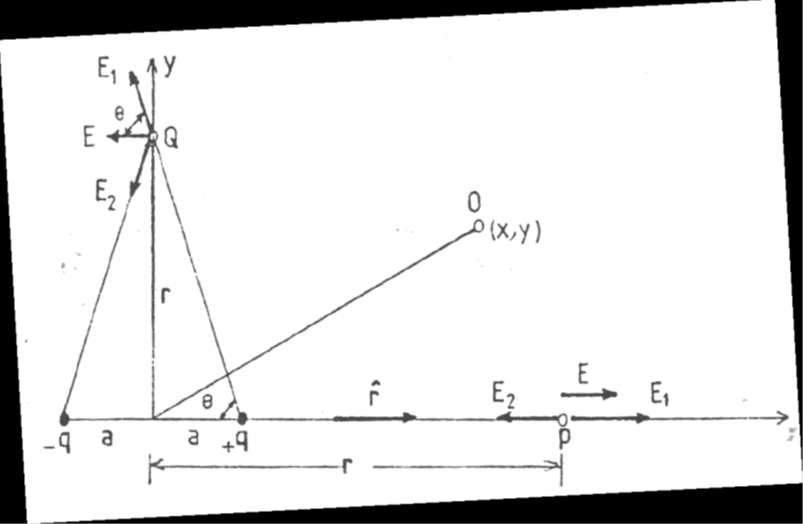
$$E_{1}=\frac{1}{4πε_{o}} \frac{q}{{(r-a)}^{2 }}r^{∩}$$
and the (E₂) field due to the negative charge$$E_{2}=\frac{1}{4πε_{o}} \frac{-q}{{(r+a)}^{2 }}r^{∩}$$
Note that (E₂)is opposite to the direction of (E₁), but the sum of the field E results from the summation of (E₁)and (E₂), that is,
E = E₁ + E₂ , and by substituting for the amount of each of (E₁) and (E₂), it results
$$E_{1}=\frac{1}{4πε_{o}} \frac{q}{{(r-a)}^{2 }}r^{∩}$$
$$E=\frac{1}{4πε_{0 }} \left\lfloor \frac{q}{{(r-a)}^{2}}-\frac{q}{{(r+a)}^{2}}\right\rfloor$$
$$E=\frac{q}{4πε_{0 }} \left\lfloor \frac{4ra}{{(r^{2}-a^{2})}^{2}}\right\rfloor$$
From this it becomes clear that the direction of the field (E) at point (P) lies along the dipole axis and is in the direction of the (x) axis. And if ( a << r ) , meaning that the distance between the two charges is very small compared to (r) , we can neglect (a²) with respect to (r²), then the equation takes the following form:
$$E=\frac{1}{4πε_{o}} \frac{4aq}{{(r)}^{3 }}$$
$$E=\frac{1}{4πε_{o}} \frac{2p}{{(r)}^{3 }}$$
Where ( P = 2 a q ) is the electric moment of the dipole. It is worth noting that the dipole moment is a vector quantity. directionally from negative charge to positive charge.
b-At point (Q) on the bipolar shaft.
Suppose (Q) is a distance r from the center of the dipole, then the magnitude of the field from the positive charge (E₁) is equal to the field from the negative charge (E₂).
$$E_{1}=E_{2}=\frac{1}{4πε_{0}}\frac{q}{r^{2}+a^{2}}$$
In order to find the field arising from the two dipole charges, we carry each of (E₁)and (E₂)into two components, one perpendicular to the dipole axis and the other parallel to it. It is clear that the two components perpendicular to the axis erase each other, that is, their sum is zero, and the two components parallel to their axis are in the same direction. Thus, the sum of the fields (E₁)and (E₂ )is in the direction of the dipole axis and towards the left, as shown In the figure, the sum is: E = E₁ COSƟ + E₂ COSƟ
Substituting in for (E₁ ) and (E₂ ) and for ( cos θ ) , we get;
E = $\frac{2}{4πε_{0}} \frac{q}{r^{2} +a^{2}} \frac{a}{\sqrt{r^{2 +}a^{2}}}$ $≫≫ E= \frac{1}{4πε_{0}} \frac{2aq}{\left(r^{2} +a^{2}\right){}^{3/2}}$
And if ( a ) is very small compared to (r ) . We can leave out the expression (2a )in the denominator, then this relationship becomes:$E≅\frac{1}{4πε_{0 }} 2aq/r^{3}$
$$E≅\frac{1}{4πε_{0 }} P/r^{3}$$
This is ( p) in terms of the dipole moment.
C - At any other point such as (O) :
We can also calculate the domain of a dipole at any point (not on the map) in space .The circumference is in the same way mentioned above and this is the general case that we will come to discuss in the next chapter.

2-The field due to a charge distributed along a straight line :
Suppose the charge extends on the (x axis) uniformly between the points (x = b) and (x = c) as shown in the figure, i.e. the amount of charge per unit length ( λ ), and with a linear density of is equal to( λ C/m) and it is required to calculate the field strength ( E ) at a point p located at a distance (y = a) as shown
in the figure.
Let's imagine that the linear charge is divided into elements of length( dx) . Then the magnitude of the charge of each element is equal to( λ dx) , and it becomes possible to obtain the field strength (dE) at point P arising from one of these elements by taking advantage of the equation, that is:
$dE=\frac{1}{4πε_{0}} \frac{dq}{r^{2}}$ $r^{∩}$
$$dE=\frac{1}{4πε_{0}} \frac{λdx}{r^{2}}r^{∩}$$
Since the linear charge is positive, the direction of (dE) is away from (dq) . To calculate the sum of the field strength arising from all linear charge, (dE) must be analyzed into two components: horizontal, in the ( x-direction), denoted by( dE_{x}), and vertically in the( y-direction), denoted by (dE_{y}) :
$$dE_{X}=dE sinθ ,,dE_{Y}=dEcosθ$$
Substituting in the value of ( E ) , we find
$dE_{X}=\frac{1}{4πε_{0}} \frac{λdx}{r^{2}} sinθ=\frac{λ}{4πε_{0}} \frac{sinθ}{x^{2}{+a}^{2}} dx$
$${dE}_{y}=\frac{1}{4πε_{0}} \frac{λdx}{r^{2}} cosθ=\frac{λ}{4πε_{0}} \frac{cosθ}{x^{2}{+a}^{2}} dx$$
Before we integrate to calculate both ( E_{x} ) and ( E_{y} ), we notice that ( θ ) and (x )are two variable quantities that are related to one another, and one of them must be eliminated, let it be(x). The relationship between these two quantities (see the figure) is:
x= a tanƟ $≫≫≫≫≫≫≫$ dx= a sec² Ɵ dƟ
Substituting in these two values, we get (dE_{x} ) and (dE_{y} )in terms of one variable,
$$dE_{x}= \frac{λ}{4πε_{0 }}\frac{sinθ\left(a \sec^{2 }θ\right)}{a^{2}\sec^{2} θ} dθ$$
$$dE_{y}= \frac{λ}{4πε_{0 }}\frac{cosθ\left(a \sec^{2 }θ\right)}{a^{2}\sec^{2} θ} dθ$$
X² + a² = a² + a tan²Ɵ = a² sec²Ɵ
Now we can find the horizontal component of the sum of the
( E_{x}) domain as well as the vertical component( _{Ey)} by integrating on (dE_{x}) and (dE_{y}) respectively, noting the two limits of the integration:
$$E_{X}=\int{{dE}_{X}}=\frac{λ}{4πε_{0 }a}\int_{θ_{2}}^{θ_{1}}{sinθdθ\frac{λ}{4πε_{0 }a}\left[cosθ_{1 }-cosθ_{2}\right] }$$
$E_{y}=\int{{dE}_{y}}=\frac{λ}{4πε_{0 }a}\int_{θ_{2}}^{θ_{1}}{cosθdθ=\frac{λ}{4πε_{0 }a}\left[sinθ_{1 }-sinθ_{2}\right] }$
One of the special cases worthy of discussion and which gives us simpler results is when the charge is extended On both sides of the x axis and for a very long distance. Then the limits of the integral become ( θ₁= π/2) and (θ₂= - π/2) . By substituting these two values ​​into the above equations, we find
$E_{X }= \frac{λ}{4πε_{0 a}}$[cos ( - π/2 ) – cos (π/2 ) ]$=0$
$E_{y }=\frac{λ}{4πε_{0a }}$[sin ( π/2 ) – sin ( - π/2) ]$= \frac{λ}{4πε_{0 a}}$
The fact that( E_{x}=0 )can be observed from the symmetry in this case, where it turns out that for each element of the charge on the right side there is an element corresponding to it on the left side, and this leads to the equality of the two components of their fields in the direction of the (x-axis), while we see that
( dE_{y} )is always the same Direction whether the charge element is to the right of the( x-axis) or to the left. Therefore, we find that the vertical components of all the elements are added to each other. As for the net field, it can be found from
$$E=\sqrt{{E^{2}}_{X}+{E^{2}}_{Y}}=\frac{λ}{4πε_{0}a}$$
It is in a positive (y-axis). From this result, it is clear that the intensity( λ )is away from the charge, because the field of the charge extending regularly on a long straight line is inversely proportional to the vertical distance from it a, not to its square.
3- The field arising from a charged ring:
The figure represents a positive charge of (q) that is uniformly distributed in the form of a ring of radius (R) .
It is required to calculate the field strength at the point (P) located on the axis of the ring and at a distance a from its center.
We take a small element from this loop of length (ds) and contain a charge of equal to the electric field strength and denoted (E) at a point as the force exerted by a unit charge on the positive test charge placed at that point. That is:
$$dq=\frac{q}{2πR} ds$$
The field strength ( dE) generated by this element at point( P) can be found from :
$E=\frac{1}{4πε_{0 }} q/r^{2 }r^{∩}$ $≫≫≫≫ dE=\frac{1}{4πε_{0}} (\frac{qdq}{2πRr^{2}})r^{∩}$
As for the field strength (E) arising from all the charge elements, it can be calculated by integrating the small fields originating from all the elements that make up the charge of the ring, i.e.:
$$E=\int{dE}$$
To perform this directional integration, (dE) must be analyzed into two components, one in the direction of the x-axis (dEx) and the other perpendicular to it, (dEy) , and then we integrate each of them separately:
$$E_{x}=\int{{dE}_{X}}=\int{dEcosƟ}$$
Substituting for ( cosθ ) and( dE ), we get :
$$E_{x}=\int{1/4πε_{0 }} \frac{qds}{2πRr^{2 }}\frac{a}{r}$$
It is noted that the value of r in this case is equal for all the elements of the charge, so it is possible to Bringing it out of the integral with the rest of the constants, thus yielding:
$$E_{x}=\frac{1}{4πε_{0 }} \frac{qa}{2πRr^{3 }}\int{ds}$$
But r³ =(r²+a²)^{3/2} and $\int{ds}=2πR$
That is, the product of the integral is equal to the length of the circumference of the ring , so:
$$E_{x}=\frac{1}{4πε_{0 }} \frac{qa}{({R^{2}+a^{2})}^{3/2}}$$
As for the field component that is perpendicular to the ( E_{y} ) axis, it is clear from the symmetry that it will vanish, because each element of the charge generates a field that has a perpendicular component that is equal to another component of it in magnitude and opposite in direction, originating from another element of charge on the other side of the ring , i.e. that ( Ey$=\int{E_{Y}}=ZER0$ ) Therefore , the magnitude of the granularity of the field (E) becomes:
$${E=E}_{x}=\frac{1}{4πε_{0 }} \frac{qa}{({R^{2}+a^{2})}^{3/2}}$$
As for its direction, it is towards the axis away from the charge because it is positive. From this result, it is clear that the field strength at the center of the ring is equal to zero, Because(a = 0)
as expected from the symmetry. But if the point( P) is very far
from the center of the ring i.e. (a >>R), then (R²) can neglected be from the denominator of this equation compared to(a²) and the field strength value becomes $≫≫≫ E=\frac{1}{4πε_{0}}\frac{q}{a^{2}}$
However, at large distances, the ring charge is treated as if it were a point charge.

Example (1) : Figure show represents a curved wire in the shape of a semicircle, carrying a distributed charge of (+q ) value distributed uniformly along its length . What is required is to calculate the field strength at point( P) in the center of the circle, noting that The radius of the circle is (R)?
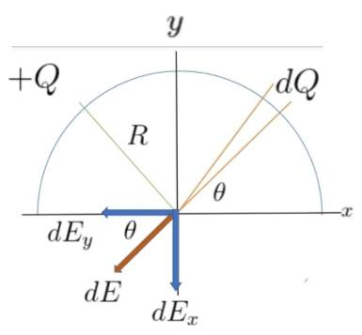
We take an element of this wire of length (dS, dQ) that contains an of charge of : $dq=\frac{q}{πR}ds$
the field arising from this element at point (p) is its magnitude :
$$dE= \frac{1}{4πε_{0}} \frac{dq}{R^{2}} =\frac{1}{4πε_{0}} \frac{qds}{R^{3}}$$
To calculate the total field strength at point (P), we decompose (dE) into two components : one is horizontal(dE_{x}) and the other is vertical(dE_{y}). Then we integrate each of them separately, and let us first start with the horizontal component, and we find that it is equal to zero. Any : $E_{X}=\int{{dE}_{X}=0}$
This is clear from symmetry, as each charged element on the right side has a field with a horizontal component equal in magnitude and opposite in direction to the field of its corresponding element on the left side of the wire. While we find that the perpendicular components of all the elements are added to each other due to them being in the same direction, so..
$$E_{y}=\int{E_{y}=\int{E_{Y}sinθ}=\int{\frac{1}{4πε_{0}} \frac{qds}{{πR}^{3}}sinθ}}$$
It is clear from the figure that $ds=Rdθ$By substituting this value and taking the constant expressions outside the integral sign, we get:
$$E_{y}=\frac{1}{4πε_{0}} \frac{qR}{{πR}^{3}}\int_{0}^{π}{sinθ}=\frac{1}{4πε_{0}} \frac{q}{{πR}^{2}}(-cosθ){}_{0}^{π}{}$$
$$Ey=\frac{1}{4πε_{0}} \frac{q}{{πR}^{2}}\left(-1-\left(-1\right)\right)= \frac{1}{4πε_{0}} \frac{2q}{{πR}^{2}}$$
$$∴ E = E_{x }+E_{Y }= \frac{1}{4πε_{0}} \frac{2q}{{πR}^{2}}$$
6 - The effect of an electric field on charged particles:
If a particle carrying a charge of q (which is positive) is placed in a uniform electric field E, it will exert a force of $F=qE$.
This is according to the definition of field strength represented by the equation( E = F / q) and as is clear from Newton’s second law, this particle will move with a constant acceleration of :
$$a =\frac{F}{m} =\frac{qE}{m}$$
where m is the mass of the positively charged particle. If we look at this equation, we will find that the acceleration of the particle is in the same direction as the field. We will take two cases : of the movement of a charged particle in a uniform electric field:
First, when a particle is placed at rest in an electric field
If we assume that a particle of mass m and charge q puts a rest in the field, as shown in Figure , for this particle to move in a straight line with a constant acceleration of : ( a = q E / m )
Note that this movement is similar to the movement of objects falling on the surface of the earth under the influence of gravity, and thus we can apply the laws of constant acceleration, which the student must remember in his previous study in mechanics. So the velocity of the particle after a time of ( t ) becomes$$V=V_{0}+at=at=\frac{qE}{m} t$$
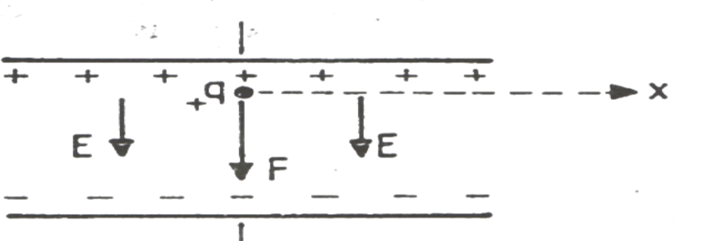
A particle left at rest in a uniform electric field.
Since the initial velocity of the particle is zero and the distance ( y) traveled by the particle after the same time becomes : $y=\frac{1}{2}at^{2 }=\frac{qE}{2m}t^{2} we also find that$
$$V^{2}=2ay=\frac{2qE}{m} y$$
Example ( 1) : An electron rests in a uniform electric field of intensity (10⁴ N/C )as in the previous figure. Calculate (a) the acceleration with which the electron moves? (b) its speed after it travels a distance of ( 1 cm.) ? (C) its kinetic energy after it travels this distance ?
(a) Since the charge of the electron is negative, so the acceleration of the electron is in the opposite direction of the( E) field, i.e. towards the top. As for finding it from the equation
$$(a) a=\frac{qE }{m}=\frac{1.6×{10}^{-19}×{10}^{4}}{9.1 ×{19}^{-31 }}=1.8×{10}^{15} m/S^{2}$$
(b) The velocity of the electron becomes
$$V=\sqrt{2ay}= \sqrt{2×1.8×{10}^{15}×{10}^{-2} }$$
$$V=6×{10}^{6} m/s$$
c) Thus, its kinetic energy is
$$K=\frac{1}{2} mV^{2}=\frac{1}{2}×9.1×{10}^{-31}×\left(6×{10}^{6}\right){}^{2}$$
K$=1.6×{10}^{-17 } J$

Second, when the particle is ejected with a velocity perpendicular to the field:
Suppose an electron is ejected with an initial velocity ( v_{o} ) perpendicular to a uniform electric field of strength ( E ) as shown in the figure. The motion of the electron will be similar to the motion of a horizontally ejected particle in the Earth's gravitational field. We find that it is possible to consider the movement of the electron to consist of two movements:
(horizontal) towards the ( X- axis) , which is a movement with a constant speed, and( vertical) towards the (Y- axis), which is a movement with constant acceleration. Thus, the horizontal distance ( x) that the electron travels after a time t of it is( x=v₀t)
While we find that the vertical distance ( y) that it travels after the same time is ( y=1/2 at² ) :
$$y=\frac{1}{2} at^{2} =\frac{eE}{2m }t^{2}$$
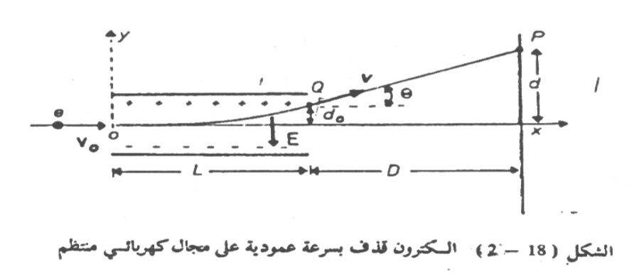
And by removing t from these two equations, we get :
$$y =\frac{eE}{2m {v_{o}}^{2}}x^{2}$$
It is the equation that represents the path of electrons in the electric field, and it is a cutoff equation.
Equivalent, and by means of this equation can calculate the deviation that occurs in the path of electrons at any point under the influence of the electric field. But after the electrons exit the field between the two plates, they are ejected in the direction tangent to the parabola at their exit point (note the figure) at a constant speed of (v). Thus, the electrons deviate from the direction of their original path by a certain angle, let it be(θ). After a certain distance from the two plates, a small bright spot appears on the screen where the electrons collide with it The deviation of electrons due to their being affected by the electric field appears on the screen and this is the basic idea for the work of the catholic or cathodes ray oscilloscope. In order to calculate the amount of deflection on the fluorescent screen d, we suppose that the length of the parallel plates is (L) by calculating the slope of the path at the point of exit of the electrons from the electric field, so we get the deflection angle θ :
$$tanƟ=\frac{dy}{dx} {}_{X=L} =\frac{eEL}{2m{v_{0}}^{2}}{}_{X=L} =\frac{eEL}{m{{v_{0}}^{2}}_{}}$$
And if the screen is a distance (D) from the two parallel panels, we find that the tangent of the angle : $tanθ≅d/D$.
And from these two equations we get the amount of deflection that occurs on the screen. $d=\frac{eELD}{m{v^{2}}_{o}}$
By measuring the quantities(d , E , L and D) we can find the initial velocity of electrons ${(v}_{0 })$if we know the ratio between the charge of an electron to its mass e/m or vice versa if we know (v₀).
Example ( 2) : In the previous figure, if the electric field strength between the two plates in a cathode ray oscilloscope device is ( (2 x 10⁴ N/C), what is the amount of deviation that occurs in the path of the electron 1- when it exits from the electric field point (Q ₂) when it falls on the screen point (P) , if the electron is ejected in a way Perpendicular to the field and a kinetic energy of (3. 6 x 10⁻¹⁶ J ) ? The length of the panels is (2 cm) and the distance between the screen and the panels is (40 cm ) ?
Solution
1- Since the kinetic energy of the electron is K=1/2 m V² then the equation can be written $y =\frac{eE}{2m {v_{o}}^{2}}x^{2}$ in terms of ( K ) ,
$$as following y=\frac{eE}{4K} x^{2}$$
Since the coordinates of the point (Q are x=L and y=do ), then it is possible to get The deviation of the electron do from the equation: y = e E / 4 K L²

$y=1.6×{10}^{-19}×2×{10}^{4}×\frac{\left(2×{10}^{-2} \right){}^{2}}{4\left(3.2×{10}^{-16}\right)}$
$$=0.001m=1mm$$
To calculate the deflection that occurs on the fluorescent screen at the point( P):
d = e E L D / ( mv_{o}²) $$d=\frac{eELD}{2K}=$$
$$1.6×{10}^{-19}×2×{10}^{4}×2×{10}^{-2}×40{×10}^{-2}×\frac{}{2\left(3.2×{10}^{-16}\right)} =0.04m=40mm$$
7- Electron charge:
The electric charge ,as proven by experiments ,is not continuous, but is made up of integer multiples of a certain quantity, which is the charge of the electron, which is symbolized by the letter (e) . Thus, any charge present in nature, regardless of its origin, is equal to: ( q = n e)
The charge of the electron was measured for the first time accurately by the scientist Millikan and his assistants between (1909 and 1913) , more than (10 years ) after its discovery by Thomson. The figure shows a schematic diagram of the device used by Millikan. It consists of two parallel metal plates isolated from each other and separated by air, and a regular electric field is generated between them by connecting them to a high-voltage electric battery. A mist of oil flies from a sprayer in the form of very small drops over the vertical plate, then a part of these drops is allowed to enter through a hole in the vertical plate to the area between the two plates where a beam of light falls horizontally. Then these lit droplets can be seen and their movement tracked with a microscope.
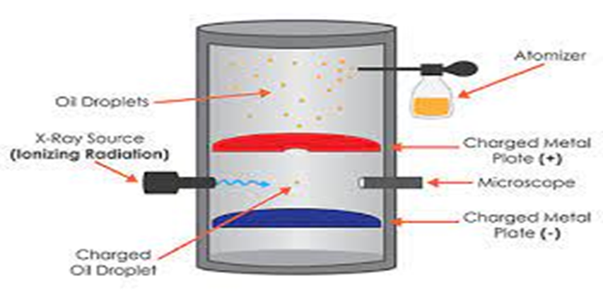
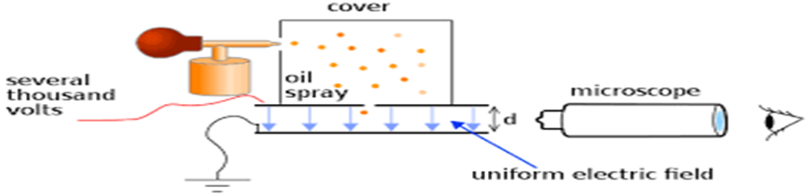
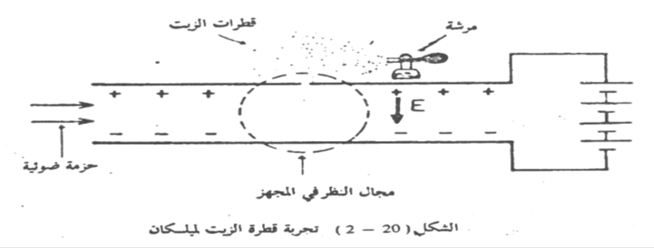

If we assume that one of these drops has acquired a negative electric charge of ( q) and that the uniform electric field between the two plates was directed downwards, we will find that there are three forces acting on this drop. As shown in the figure they are:
F
F

B
B
V
E

mggg
mggg
Static oil drop oil drop move down
1-Wattage (F) upwards.
2- drop weight (mg) downward.
3- The buoyant force of air (B) is upward.
By changing the strength of the electric field, we can balance the droplet and keep it suspended in the field between the two plates at a certain point. Then it will be:
$qE+B= mg$
Substituting for m equal to the volume of the droplet times its density, and for b equal to the volume of displaced air (whose volume is the same as the droplet) multiplied by the air density and the acceleration (g) yield:
$$E+\left(\frac{4}{3}\right) π R^{3} d g=\left(\frac{4}{3}\right)π R^{3 }D g$$
where (R) is the droplet radius, (D) is the density of the oil and d) is the density of the air. Simplifying this equation, we get)
$$q E=\left(\frac{4}{3}\right) π R^{3 }g \left(D-d\right)$$
To calculate the amount of charge (q) carried by a drop, we find that all quantities in this equation can be measured easily, except for( R) , which is the radius of this very small drop, which can be measured directly. Millikan used Stokes' law of viscosity to calculate (R). This law states that the force of friction acting on a sphere of radius(R) , falls in (a) fluid of viscosity (η) with(a) velocity of (v) is f = 6 π η R V
If the electric field is removed and the drop is left to fall due to gravity, we will find that its velocity increases until it reaches a constant value of ( v ). Then equilibrium occurs and the sum of the forces acting on it becomes zero, (see the previous figure) these forces are
1- drop weight (mg) downward
2- the buoyant force of air (B) towards the top.
3- viscosity force (f) upwards
Thus, we find that
f + B = mg
By substituting each value for its equivalent, it is produced
$6 π η R V+ \left(\frac{4}{3}\right)π R^{3} dg=\left(\frac{4}{3}\right) π R^{3 }$Dg
Simplifying this equation, we get
$$2 R^{2}g\left(D-d\right)=9ηV$$
By measuring the drop's falling velocity, its radius( R) can be calculated, as( D, d, and g, η) are known quantities. Then it becomes possible to calculate the charge (q) carried by the drop from the equation
q E = ( 4 / 3 ) π R³ g ( D – d )
Millikan and his co-workers have measured the charges of a few thousand droplets of oil, and found that the charge of any drop can never be less than a certain quantity, and that the charge of each drop is always integer multiples of this fundamental quantity. Thus, they concluded that it is not possible to obtain a charge less than this basic charge, which must be the charge of the electron (e) and its amount
e = 1.6 × 10⁻¹⁹ C

Example 1 // In Millikan experiment it is found that the Oil drop falls a distance (2mm) in (54.3sec )when the field is removed .when the drop remains of intensity (2.37×10⁴ N/C) is applied the drop remains stationary between the plates .if ($η)$ for air is (1.8×10-5 N.s/m² ) (D=824 Kg/m²) and (d=1.3KG/M²) .Calculate the charge of the drop?
Solution :we can find the oil drop radius by :
$$2R^{2}g\left(D-d\right)=9ηV$$
V = X / t = 2 × 10 ⁻³ / 54.3 = 3.68 × 10 ⁻⁵ m / s
$$2R^{2}g\left(D-d\right)=9ηV$$
$$D=\frac{824Kg}{m^{3}} d=\frac{1.30Kg}{m^{3}}, η=1.8×{10}^{-5} N.s/m^{2}$$
$$2R^{2}×9.8\left(824-1.3\right)=9×1.8×{10}^{-5}×3.68×{10}^{-5}$$
$$R=6.08×{10}^{-7}m$$
The drop must be equilibrium , then we can find the charge value by :
$$qE=mg$$
$$qE=\frac{4}{3}πR^{3}g(D-d)$$
$$q×2.37×{10}^{4}=4/3×3.14×9.8×{(6.08×{10}^{-7)}}^{3}×(824-1.3)$$
$$q=3.2×{10}^{-19}c$$
$$the number of electron=3.2× {10}^{-19} /1.6×{10}^{-19}=2e$$

