GAUSS'S LAW
Flux of Electric Field Intensity:
When explaining the lines of electric force, the number of these Lines, per unit area, that intersect a surface perpendicular to the electric field equal to the field strength In that area where the surface was drawn.
$$E=\frac{No. of lines}{A}$$
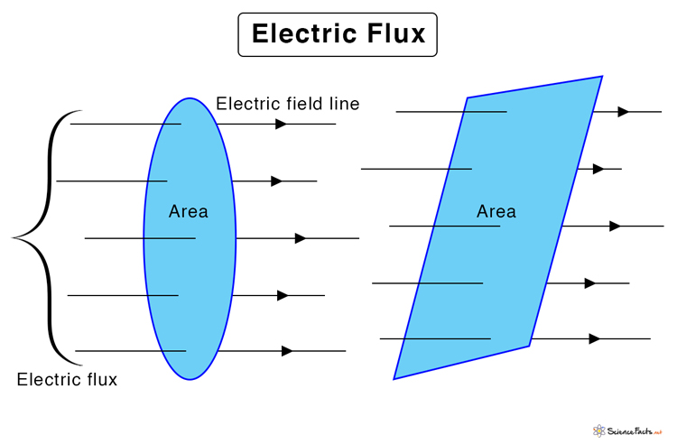
The total number of lines of force that cross the surface is called: The electric field surge is usually symbolized by the Greek symbol Ø.
$$∅=ES N.m^{2}/C$$
This relationship is valid to use in all cases where the magnitude of the field strength is equal for all points on the surface. The direction of the field is perpendicular to the surface. Let us now take one of these special cases. We calculate the electric field flux resulting from positive point charge.
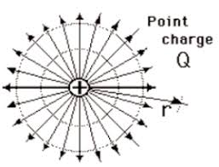
Surrounded by an imaginary spherical surface called Gaussian surface . The electric field at any point at any surface
$E=\frac{1}{4πε_{0}} \frac{q}{r^{2}} but Ø=E S$ $Ø=\frac{1}{4πε_{0}} \frac{q}{r^{2}} 4πr^{2 } Ø=q/ε_{0 ------- 1}$
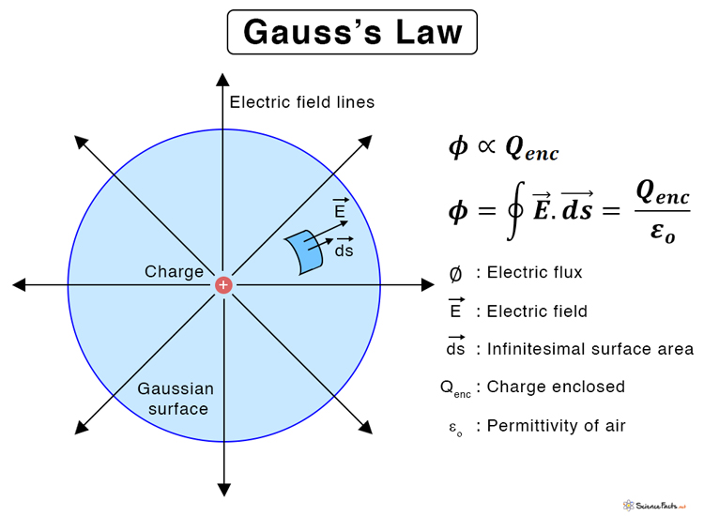Gauss law : the electric flux through any closed surface is equal to the net charge (Q) inside the surface divided by permittivity of the space (Ɛ₀)
Ø = q / Ɛ₀ --------(1)
Equation(1) , means that the a mount of flux depend on the charge(q) and does not depends on the radius (r).
The lines of force passing through a surface of a given area is dependent on three factors ;
1-strength of the electric field .
2-Area of the surface .
3-Orientation of the surface with the linear of force .
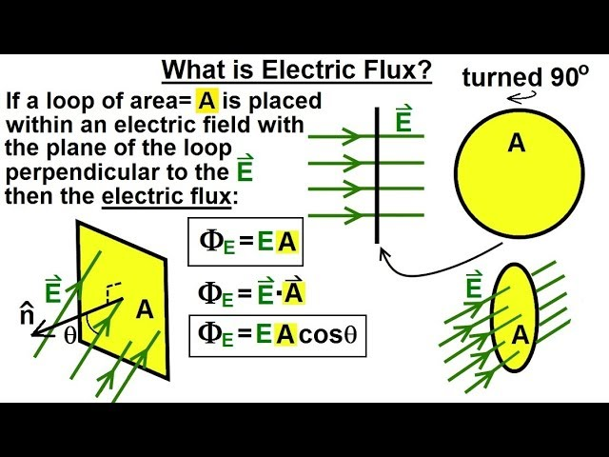
cosƟ Ɵ=90 , Ø=min Ɵ=0 , Ø=max ∞ Ø
--If the electric intensity varies from point at another on a surface and if the surface is not everywhere at right angles to field the number of lines can be expressed as follows;
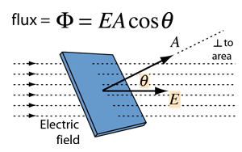
(dA) is at infinites element of area whose normal makes an angle (Ɵ) with field (E) . the projected are of (dS) perpendicular to (E) is (dAcosƟ) . so the flux (dØ) is $dØ=EdAcosƟ$
We can also express that as follows ${ E}_{n}=EcosƟ$
$$dØ=EcosƟ dA ≫≫ dØ=E_{n}dS$$
The total flux Ø can be found by integration of equation
$Ø =\int{dØ =\int{E dS =\int{EdScosƟ{}}}}$
If the surface is closed then :
$Ø= \oint{EdS= \oint{EdS}cosƟ = \oint{EcosƟdS} }$
Gauss law :the total number of liner of force crossing it is equal to the net charge with in the surface divided by the permittivity constant (Ɛ₀) $Ø=\oint{Eds=q/ϵ_{0 }}$
----- the flux with in Gaussian surface (closed surface) is Zero if the surface contains no charge or the not charge inside it is zero .
----- The flux is negative if it is in ward , and the flux is positive if it is out ward .
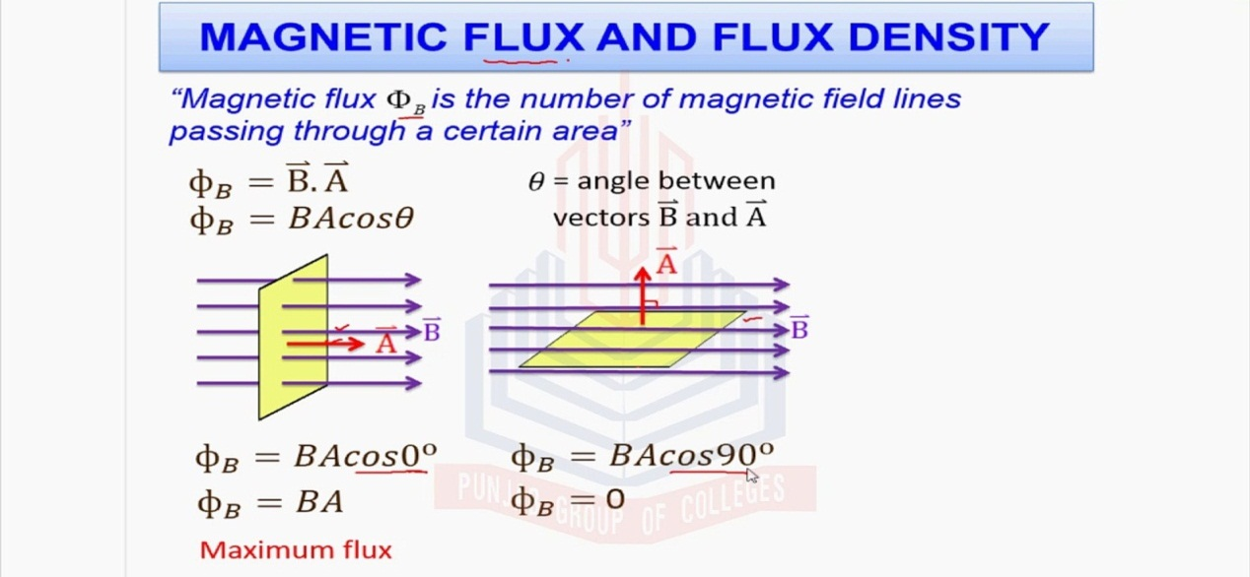
Application of Gauss's Law
Q 1 // Find the electric filed due to the point charge (use Gauss's Law)?
OR / Derive the coulomb's Law from Gauss's Law ?
Solution : IN order to find the electric filed at point(p)at a distance (r) from the charge . We draw Gaussian surface as spherical surface with radius (r).
from Gauss Law $\oint{EdS}=\frac{q}{ε_{0}}$
$$\oint{EdS COS}θ=\frac{q}{ε_{0}} ≫≫ θ=0$$
E$\oint{dS}=\frac{q}{ε_{0}} ≫≫ EdS=\frac{q}{{ ε}_{0}} ≫≫ S=4πr^{2}$
$$∴E=\frac{1}{4π}\frac{}{ε_{0}}\frac{q}{r^{2}}$$
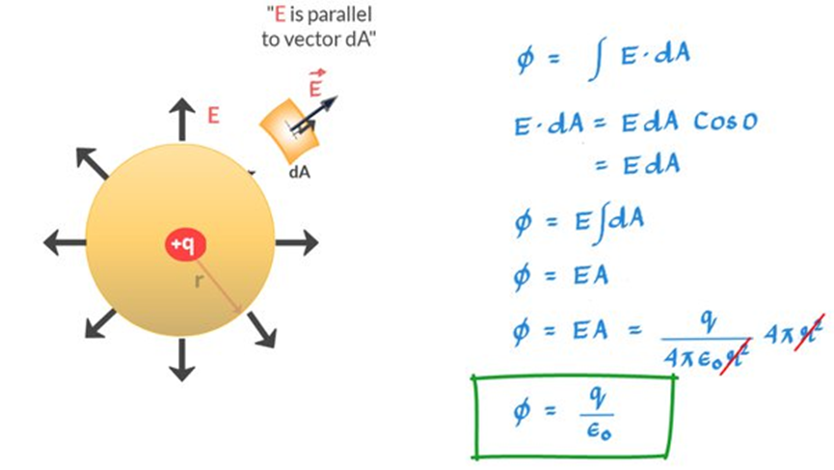
Q 2 // Find the electric filed due to continues distributions of charge (long charge wire) ( infinitely charge wire) ??
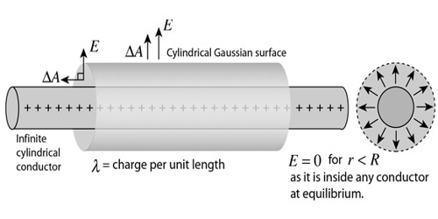
The diagram show's uniformly charged wire with charge per unit length ( λ C/m ) . In order to fined (E) at (p)at distance (a) from the wire , we choose the Gaussian surface in the form of a closed cylinder of radius (a) and length (h). we divide the surface in to three part S₁, S₂ , and S₃ :
$$\oint{EdS }=\oint_{S_{1}}{EdS }+\oint_{S_{2}}{EdS }+\oint_{S_{3}}{EdS }$$
$$\oint_{S_{2}}{EdS }=\oint_{S_{3}}{EdS }=Zero θ=90$$
$$\oint_{S_{1}}{EdS }=\oint_{S_{1}}{EScosθ }=Ecos0S_{1}=ES_{1}=E.2πah$$
$$\oint{EdS }=2πah.E+0+0 ≫≫$$
$$∴\oint{EdS }=\frac{q}{ε_{0}} ≫≫ 2πah.E=\frac{λh}{ε_{0}} ≫≫E=\frac{λ}{2πaε_{0}}$$
Q 3 // The electrical filed due to Spherical charge ?
A charge (q) distributed uniformly in the form of sphere of radius (R) .
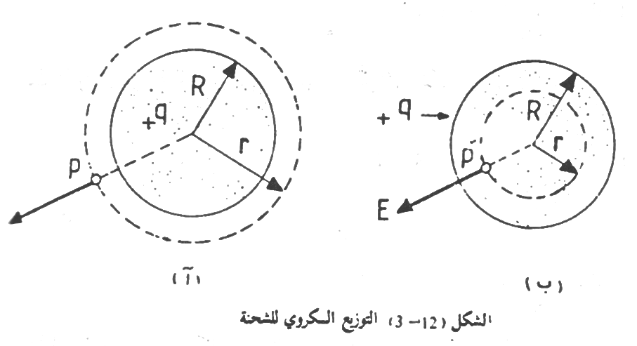
A /// the electric filed outside the radius (R ) r > R
We choose the Gaussian surface in the form of spherical surface of (r) :
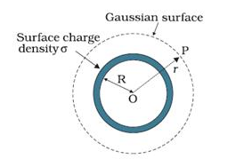
$$\oint{EdS }=\frac{q}{ε_{0}} ≫≫\oint{EdS cosθ}=\frac{q}{ε_{0}} ≫≫≫θ=0$$
$$E 4πr^{2}=\frac{q}{ε_{0}} ≫≫≫E=\frac{1}{4π}\frac{}{ε_{0}}\frac{q}{r^{2}}$$
B /// the electric filed inside the sphere radius (R ) r < R
We choose the Gaussian surface in the form of spherical surface of (r) r<R and contain a charge $q^{/}$:
$$q^{/}=\frac{q}{4π}\frac{}{R^{3}}\left(\frac{4}{3}πr^{3}\right)≫≫≫q^{/}=q\frac{r^{3}}{R^{3}}$$
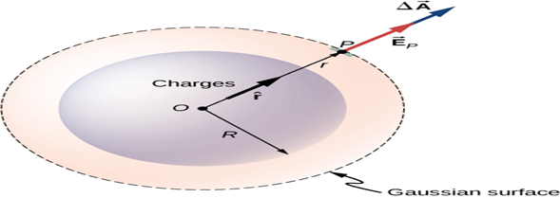
$$\oint{EdS }=\frac{q^{/}}{ε_{0}} ≫≫\oint{EdS cosθ}=\frac{q}{ε_{0}}\frac{r^{3}}{R^{3}}$$
$$E 4πr^{2}=\frac{q}{ε_{0}} ≫≫ E=\frac{1}{4π}\frac{}{ε_{0}}\frac{q r}{R^{3}}---\left(2\right)$$
From equation 2 :
1-the magnitude of E= 0in the center of the sphere ( r = 0 ) .
2-E increases linearly with (r) inside the sphere and it reaches maximum velum when ( r = R ).
$E= \frac{1}{4}\frac{}{πε_{0}}\frac{qR}{R^{3}}$ $≫≫≫ E= \frac{1}{4π}\frac{}{ε_{0}}\frac{q}{R^{2}}$
3 // Outside the sphere the field E is inversely proportional with (r²) .
Outside the charge, the field strength decreases inversely proportional to the square of the distance. The figure shows a graphic curve of the relationship between E and the distance r from the center of the charge.
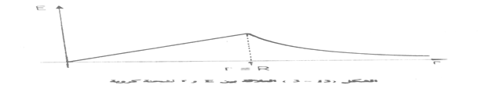
Q 4 // Find the electric filed due to non conducting sheet.?
The figure show apparition of thin infinite insulating sheet with a charge of uniform surface charge density ($σ$) (charge per unit area ) .We choose a Gaussian cylinder with length (2a) since the charge is positive E must point away from the sheet
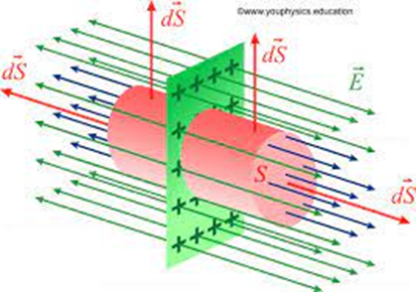
$$\oint{EdS }=\oint_{S_{1}}{EdS }+\oint_{S_{2}}{EdS }+\oint_{S_{3}}{EdS }$$
$$\oint_{S_{1}}{EdS }=\oint_{S_{1}}{EdScosθ }=Zero θ=90$$
$$\oint_{S_{2}}{EdS }=\oint_{S_{2}}{EScosθ }=Ecos0S_{2}=ES_{2}$$
$$\oint_{S_{3}}{EdS }=\oint_{S_{3}}{EScosθ }=Ecos0S_{3}=ES_{3}$$
$$\oint{EdS }=ES2+ES3=2ES$$
$$∴ \oint{EdS }= 2ES=\frac{q}{ε_{0}} ≫≫ 2ES=\frac{σS}{ε_{0}} ≫≫E=\frac{λ}{2ε_{0}}$$
Example
Example(1): the three rectangular component of electric intensity are : E_{x}=10⁴ E_{y}= E_{z} = Zero
1-Calculate total flux with the surface of the cube(d=9cm)?
2- Calculate the net charge thought the surface?
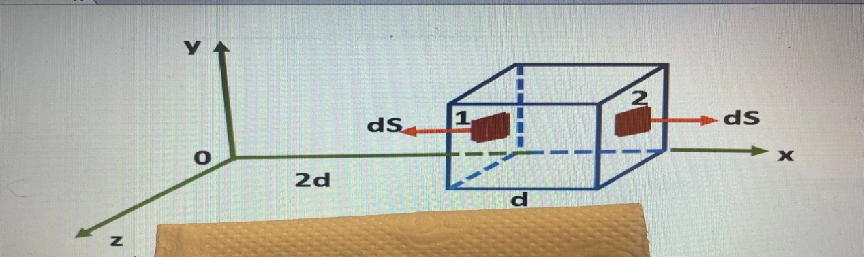
$$E_{X_{1}}={10}^{4}X^{\frac{1}{2}}={10}^{4}\left(2d\right){}^{\frac{1}{2}}={10}^{4}\left(2×0.09\right){}^{\frac{1}{2}}=4.2×{10}^{4}N/C$$
$$∅_{1}=\int{E_{X_{1}}}COSds=4.2×{10}^{4}COS\left(180\right)ds=4.2×{10}^{4}\left(0.09\right){}^{2}= -34 N m^{2}/ C$$
$$E_{X_{2}}={10}^{4}\left(3d\right){}^{\frac{1}{2}}={10}^{4}\left(3×0.09\right){}^{\frac{1}{2}}=5.2×{10}^{3}N/C$$
$$∅_{2}=\int{E_{X_{2}}}COSds=5.2×{10}^{3}COS\left(0\right)ds=5.2×{10}^{3}\left(0.09\right){}^{2}= 42 N m^{2 }/C$$
$$∅=∅_{1}+∅_{2}=42-34=8 N{ m}^{2}/ C$$
$$2- ∅=\frac{q}{ε_{0}} ≫≫≫q=∅ε_{0}=8×8.85×{10}^{-12}=70.8×{10}^{-12}C$$
Example(2) : A uniform electric field ( E ) , directed along the (x- axis), penetrates a cube of length ( L ) as in the figure in the field region. Calculate the total flux of the ( E ) field from the surface of the cube??
The total flux can be found by calculating the flux from each of the six faces of the cube separately, and then add the resulting values ​​together. We notice from the figure that the flux of the field from four faces is equal to zero, since ( E ) is perpendicular to ( dA ) at these faces. Figure two shows From these faces, the numbers(3 and 4) where the angle is perpendicular and therefore
$$dØ=\int{EdA}=\int{EdAcosƟ}=\int{EdAcos90=0 }$$
Similarly, the field flux of the two parallel sides of the ( xy ) plane is zero for the same reason.
It remains to calculate the field flux from sides ( 1 and 2 ) , parallel to the ( yz ) plane, where it is:
$$dØ=\int_{1}{EdA}+\int_{2}{EdA}$$
The field ( E ) is regular and is in plane ( 1 ) , while ( dA ) is outside of it, so the angle is (180 ) , and then we conclude that
$$dØ=\int_{1}{EdA}=\int_{1}{EdAcosƟ}=\int_{1}{EdAcos180}=-\int{EdA=-EA=-EL^{2}}$$
The field E is out of plane ( 2 ) in the same direction as ( dA ) for this face, so the angle is zero, from which:
$$dØ=\int_{2}{EdA}=\int_{2}{EdAcosƟ}=\int_{2}{EdAcos0}=\int{EdA=EA=EL^{2}}$$
From the foregoing, we find that
$$Ø=-EL^{2}+EL^{2}=0$$
It can be seen from the result of this example that the flux of the field from the closed surface is zero. not from It is necessary for the closed surface to be a cube in order to reach the same results as above ( A ) closed cube can be applied to any other closed surface.
Example(3) : A positive point charge of (10 μC ) is placed at the center of a cubic Gaussian surface of side length ( 20 cm ). Calculate the electric field flux through this closed surface???
$$Ø=\frac{q}{Ɛ_{0}} =10×{10}^{-6 }C/8.85×{10}^{-12}C^{2}N^{-1}m^{2}=1.13×{10}^{6 }N m^{2 }/C$$
Example(4) : Two metal plates carrying charges of equal magnitude and opposite sign, the distance between them (10 cm) If you know the strength of the electric field formed in the region between the two waves ( 50 N/C ) The area of ​​each plate is ( 10 cm² ) . Find the charge of both plates???
The strength of the electric field formed in the space between the two plates is ---
-$E=σ/ε_{0}$
But the density of the surface charge is equal to the product of the charge carried by the plate divided by its area
,$σ =q/A$
$$q=σA=Eε_{0} A=ε_{0}EA$$
$$=8.85×={10}^{-12}×50×100×{10}^{- 4}$$
$$=4.4×{10}^{-12}C$$

