Matter and Charge
1- Electric charges
Every body contains a huge number of atoms. These atoms are electrically equivalent (non-ionized) and the body's charge is considered zero. If this natural balance of charges is disturbed, the body may gain an electron or lose part of its electrons to become electrically charged.
If a glass rod was rubbed with silk, for example, some electrons would be transferred from the glass to the other Silk then the glass becomes positively charged due to the deficiency that occurs in its electrons. Silk becomes negatively charged due to the increase in its electrons. Thus, experiments indicated Both the sign and the massaged are electrified, and each acquires an electrical charge that is different in type and equal in amount. these phenomena indicated that there are two types of electric charges, positive and negative charges. This means that electrification occurs as a result of the transfer of electrons.
2- Charge and Matter
The atoms of the substance are mainly composed of three important minutes: the proton, the neutron, and the electron. The neutron, as it is known, is electrically neutral, as it does not carry an electrical charge,while the proton carries an electrical charge positive equivalent to the negative charge of the electron in the amount.
The atom consists of a nucleus in which protons and neutrons are stacked, so it is positively charged, surrounded by a cloud of negative electrons.
An ordinary uncharged atom is theoretically electrically neutral because it contains an equal number of electrons and protons.
The mass of a proton is approximately equal to the mass of a neutron. (while we find that the mass of the stationary electron is about (1840) times smaller than the mass of the proton).
The Charge | The Mass | The particle
- 1.6021×10⁻¹⁹ C | 9.1091×10⁻³¹ kg | Electron
+1.6021×10⁻¹⁹ C | 1.6725×10⁻²⁷ kg | Proton
0 | 1.6748×10⁻²⁷ kg | Neutron
Therefore, the mass of the atom is concentrated in its nucleus.
(((There are many other particles such as the positron - a particle that carries the same amount of charge as the electron, but it is positive and has the same mass - and the neutrino - and other stable and unstable elementary particles that were discovered in cosmic rays and in the products of interactions generated in accelerators atomic))).
If we imagine the nucleus of the atom in the shape of a ball, then its radius varies between (1× 10⁻¹⁵ m) ,( for the nucleus of the hydrogen atom, which is the simplest and smallest atom, to about (7× 10⁻¹⁵ m) for a heavy atom whose nucleus contains a large number of protons , such as uranium, for example) , while the diameter of the atom varies between (1× 10⁻¹⁰ m) to about (3 ×10⁻¹⁵ m). Observing these numbers, it becomes clear that the diameter of an atom is about (100,000) times larger than the diameter of the nucleus.
As we mentioned, the atom of any element in its natural state is neutral in charge, and the number of electrons revolving around the nucleus is equal to the number of protons inside the nucleus.
This number is called the Atomic number and is symbolized by the letter (Z). The letter (N) stands for the number of neutron in the nucleus. On When the letter (A) stands for the quantum number of protons and neutrons, it is called the Mass number.
So: A = Z + N

The atoms that have the same atomic number (Z) but differ in their mass number (A) are called Isotopes.
And from this it is clear that the atoms of different isotopes of the same element have the same number of electrons outside the nucleus. Since the chemical properties of the elements depend mainly on the number of electrons and their distribution outside the nucleus, the isotopes are similar in chemical properties.
While they differ in some of their physical properties as a result of the difference in their mass.
To clarify this, we take the simplest atom structure, which is the hydrogen atom, which exists in the form of isotopes, and is expressed by the following symbols: ₁H¹ , ₁H² , ₁H³ .
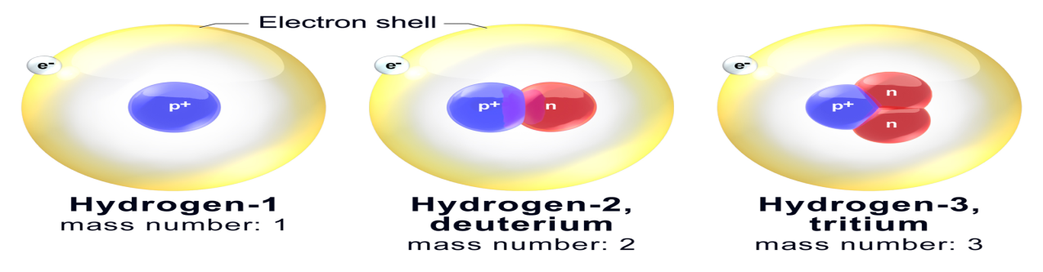The number written at the bottom of the chemical symbol for the element towards the left indicates the atomic number (Z) and its amount is one, while the symbol towards the right indicates the mass number (A), which varies from one isotope to another. From this we find that the nucleus of the first isotope of hydrogen contains one proton. The nucleus of the second isotope, called Deuterium or Heavy Hydrogen, contains one proton and one neutron. The nucleus of the third isotope called Tritium contains one proton and two neutrons.
Hydrogen follows in the periodic table the element helium, which exists in the form of two isotopes: ₂He³ , ₂He⁴ .
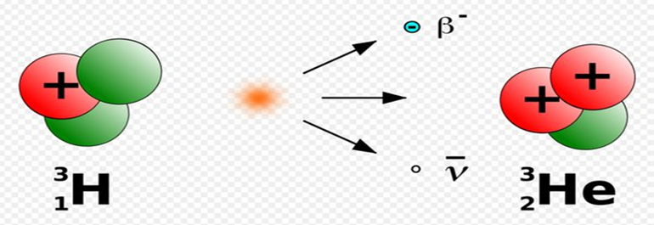
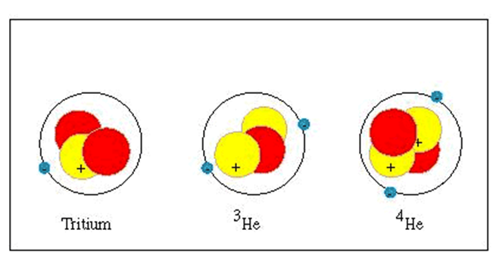
The nucleus of the first isotope contains two protons and one neutron, and two electrons orbit around them. This isotope is found in nature in a very small proportion. As for the second isotope, its nucleus contains two protons and two neutrons, and two electrons orbit around them. This isotope contains a large proportion of the element lithium, and its nucleus is called Alpha Particle.
Thus, the atomic number and the mass number of the elements increase as we gradually advance in the periodic table until we reach the heaviest element in nature, which is the element uranium, which is found in the form of a mixture of three isotopes:
₉₂U²³⁴ , ₉₂U²³⁵ , ₉₂U²³⁸ .
3- Law of Conservation of Charge:
It is clear from the above that the rubbing process does not create the charge, but rather facilitates its transfer from one body to another, thus disturbing the state of electrical neutralization of the bodies. Thus, the shipment is not annihilated nor created. This is known as the law of conservation of charge.
The evidence that proves this is true is many, for example, when Electron combines with positron to form gamma rays, and both minutes are converted into energy according to Einstein's distorted equation (E = mc² ). It is known that the charge of the electron and symbolized by (-e), is equal and opposite to the charge of the positron and symbolized by (+e), and it is very clear that the sum of the two minute charges is zero before and after the interaction.
Another example we give to demonstrate the correctness of the law of conservation of charge is what happens during nuclear reactions, when beryllium bombards with minutes fast alpha, the neutron is emitted leaving the carbon residual nucleus. This interaction can be represented by the following equation:
2He⁴ + 4Be⁹ → 6C¹² + 0n¹
(From observing this equation, it becomes clear that the algebraic sum of the atomic numbers before the interaction is equal to the algebraic sum of the atomic numbers resulting from the interaction, which confirms the validity of the law of conservation of charge).
4-Conductors and Insulators
Materials differ in terms of their ability to transfer electric charges through them, and in general they can be divided into three varieties.
a-conductive material:
They are the materials in which the electric charge is transmitted instantly. Metal is one of the finest materials an electrical receipt, on top of which is silver, followed by copper and aluminum. This is due to the Crystal Structure for these minerals, where a number of atoms align, forming a specific geometric system ,It is called a crystal lattice, and this arrangement repeats in three orthogonal directions, forming the object we see.
The electrons in the outer orbits of atoms, which are called valence electrons (their number ranges from 1 to 3 in metals), are all common to all atoms, so they do not belong to a specific atom. While we find that the electrons of the inner orbits are bound to the nucleus of the atoms by strong electrical forces, and they are called bound electrons. Accordingly, the connection of the outer electrons is weak to the nucleus of the atom and they are free to move within the crystalline structure of the metal, and for this reason they are also called free electrons.
b- Insulation Materials:
They are the materials through which the electric charge does not move instantly because they do not contain electrons free, as all the electrons of the outer orbit of the atom are attached to the crystal lattice or molecular structure for the article. Examples of such materials are mica, sulfur, glass and plastic.
c- semiconductor materials :
They are those materials that have intermediate properties between conductors and insulators in terms of their ability to Electrical conductivity, including germanium and silicon. These two elements are of particular importance in technology for use in the manufacture of transistors and solar cells. Germanium is tetravalent like silicon and carbon.
5-Rutherford Experiment
The objective of the experiment is to discover the components of the atom. Rutherford was studying the effect of solid bodies on the path of alpha particles, and the reality of these particles was known at the time in that they were any helium nucleus that carried two positive charges, and that measuring the speed of these particles was possible by the means available at the time, as it reached about (19000 km / s).
The experiment consisted of a device consisting of:
1-Athick tube of lead containing a small piece of the radioactive element polonium, from which alpha particles come out.
2 -Lead metal plates placed parallel to the radioactive source in order to obtain a straight beam of alpha particles.
3 - A very thin plate of gold, about (0.0001 cm) thick.
4 -A metal plate in the form of an incomplete circle covered from the inside with a layer of zinc sulfide, which flashes when alpha particles collide with it.

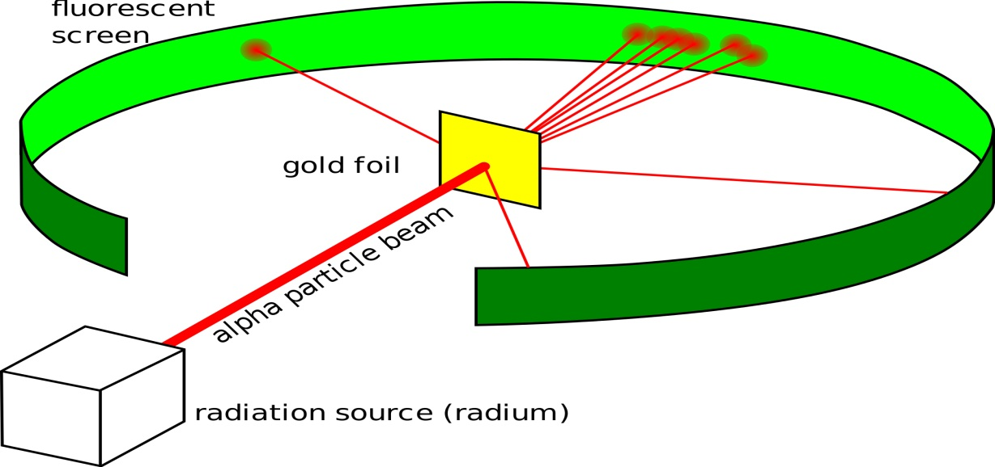
Results of Rutherford's experiment:
(Most of the alpha particles penetrated the plate without deflection) This indicates that most of the atom is empty (a small percentage of the alpha particles bounced back) indicates this on collision with the dense nucleus in which most of the mass of the atom gathers. (A small percentage of the alpha particles deviated from their path) This indicates Repulsion of alpha particles with the positive nucleus.
The atom according to Rutherford's model, is:
Positively charged nucleus in which most of the mass of the atom is concentrated with negative electrons revolving around the nucleus at vast distances from it. Note: Rutherford fails to explain the linear spectrum of the elements and the stability of the atom.
6-Coulomb's Law :
French scientist Charles Augustin Coulomb (1736-1816) was the first to make an extensive study of forces between charged bodies in (1785). The practical results of this study can be summarized as follows:
1- Similar charges repel each other and different charges attract each other.
2- The magnitude of the force of attraction or repulsion between two charges is inversely proportional to the square of the distance between them.
3- The magnitude of the force of attraction or repulsion between two charges is directly proportional to the product of the two charges.
4- The direction of the force lies along the straight line connecting the two charges.
These results are true for Points Charge. They are charges whose dimensions are small relative to the distances between them. From these results, Coulomb deduced the law of electric attraction and repulsion, which is similar to the law of universal attraction that Newton had established more than 100 years .
Coulomb's law states that the electrostatic force between two point charges at rest is directly proportional to the product of the magnitude of the two charges and inversely proportional to the square of the distance between them.
Its mathematical formula can be put as follows: $F∞\frac{q_{1}q_{2}}{r^{2}}$

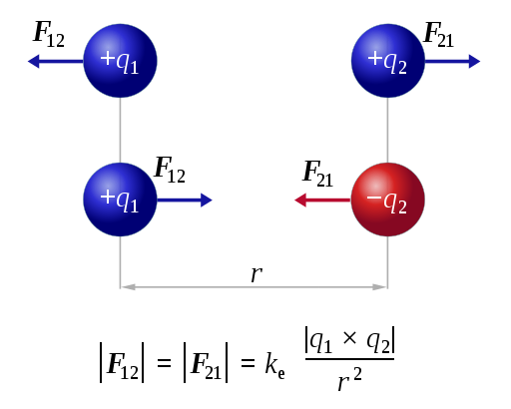
The electrostatic force (F=F₁₂=F₂₁) acting from the second point charge q₂ on the first point charge q₁) is the same as the force acting on the second point charge q₂ on the first point charge q₁ but in the opposite direction (r represents the distance between the two charges. Since force is a vector quantity and displacement is also a vector quantity, it is best to write Coulomb's law in a mathematical form indicating the direction of the force as well as its magnitude.
After converting the proportionality in the above equation into an equality, Coulomb's law becomes as follows:
$$F^{←}=K\frac{q_{1}q_{2}}{r^{2}} r^{^}$$
Where( k) represents a fixed quantity whose value depends on the system of units used as well as on the type of medium separating the two charges, and the letter with an arrow above it indicates that it represents a vector quantity, and the symbol( ^ ) represents a vector with a magnitude of one and its direction from q₁ to q₂ and it is called the unit vector.
The coulomb is defined as the amount of charge that passes in a specific section of a thickness in one second if a continuous current of one ampere is in this thickness. A coulomb is a relatively large charge, so a smaller and more convenient unit is often used, the micro coulomb ( μ C ), which is one millionth of a coulomb. After determining the units of force (F) in newton (N), distance r in meters (m) and charge q in coulombs (C) (according to the SI system), it becomes easy to find the unit of constant (K) according to Coulomb's law. As for the magnitude of this constant, it can be found experimentally , and it was found that it is equal in space: K= 8.987 × 10⁹ Nm²C⁻¹
This value may be approximated to (8.99 × 10⁹) or (9.0 × 10⁹) for the purpose of solving problems related to charges placed in vacuum and even in air as well. In most cases, (k) is replaced by another constant called the space permittivity. It is denoted by the Greek letter( $ε_{0})$, according to the following relationship:
( K = 1 /4 π Ɛ ₀ ) The purpose is to simplify the equations derived from Coulomb's law in the advanced branches of this topic, and to avoid the appearance of the factor(4π) in them. Therefore, Coulomb's law takes the following form:
$F=\frac{1}{4πε_{0}}\frac{q_{1}q_{2}}{r^{2}}$ From equation we can find the value and unit space permittivity: $ε_{0 }=8.85×{10}^{-12}C^{2}N^{-1}M^{-2}$
But if the medium separating the two charges is not a vacuum , then Coulomb's law is written as follows:
$$F=\frac{1}{4πε_{0}}\frac{q_{1}q_{2}}{r^{2}}=\frac{1}{4πε_{}}\frac{q_{1}q_{2}}{r^{2}}$$
Thus, it replaces the vacuum permittivity constant (with a constant called the Permittivity of the medium, symbolized by (Ɛ) and has the same unit(Ɛ₀) . As for the constant (K), it is called the Relative Permittivity or the Dielectric Constant, and it is known It is the ratio between the permittivity of the insulating medium and the permittivity of the vacuum, i.e.(K=Ɛ ⁄Ɛ₀) , and it has no unity.
The value of the insulator constant for a vacuum is equal to one true, and its value for air is equal to (1.0006), while its value ranges between one and ten for most materials, although there are some liquids and crystals that are characterized by the fact that their dielectric constant is much higher than that range, and we will come to explain that in the materials buffer.
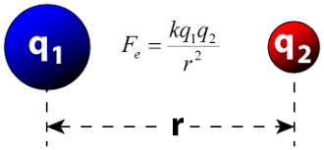
Examples, Exercises, and assignments:

Example ( 1 ) : In (1913) Bohr put his famous theory of the hydrogen atom and said that it consists of a nucleus containing one proton around which one electron revolves in a circular path. Compare the force of electrostatic attraction with the force of mass attraction between the electron and the nucleus, given that the radius of rotation is(5.3×10⁻¹¹m) ?
The electromagnetic force (F_{e}) can be calculated from Coulomb's law:
$$F_{e}=\frac{1}{4πε_{0}}\frac{q_{1}q_{2}}{r^{2}}=\frac{9× {10}^{9}(Nm^{2}C^{2})(1.6×{10}^{-19}){}^{2}}{\left(5.3×{10}^{-19}m\right){}^{2}}=8.2×{10}^{-8} N$$
As for the force of mass attraction(F_{g}), we calculate it from Newton's law of universal gravitation:$F_{g}=G \frac{m_{1}m_{2}}{r^{2}}$
$$F_{g}=\frac{\left(8.2×{10}^{-8 }Nm^{2}{Kg}^{-2}\right) (9.1×{10}^{-31}Kg)(1.7×{10}^{-27}Kg)}{ (3.7×{10}^{-11}m){}^{2}}$$
=3.7×10⁻⁴⁷ N
So the ratio between the two forces is:
$=2.2×{10}^{39}$ $\frac{F_{e}}{F_{g}}=\frac{8.2×{10}^{-8}N}{3.7×{10}^{-47}N}$
From this it is clear that the electric force is greater than the force of mass attraction by about (2.2 × 10³⁹ )and from this it becomes clear that the forces that have no greater importance in the world of the atom are the electric forces, if compared with the forces of attraction.
Example ( 2 ) : What is the magnitude of the repulsive force between two protons in the nucleus of an Iron atom, given that the distance between them is 4×10⁻¹⁵ m?
By substituting in Coulomb's law for the charge of a proton in coulombs and the distance in meters, we get the repulsion force
F= $\frac{(9×{10}^{9}Nm^{2}c^{-2})(1.6×{10}^{-19}C){}^{2}}{(4×{10}^{-15}m){}^{2}}=14N$
From this it becomes clear that the repulsive force between the protons inside the nucleus is a huge force, and perhaps a questioner asked why the nucleus of an atom does not crumble and its contents scatter as long as there are great repulsive forces working between them? The reason lies in the nature of the enormous forces that attract the two components of the nucleus of protons and neutrons to each other. These forces affect the case of the very small dimensions between protons and neutrons and they are called nuclear forces, and the research is still going on until the present time to learn more about the properties and nature of these forces.
Example( 3 ) : The figure shows three point charges - q₁, q₂ and q₃ Calculate the force acting on the charge q₁? Note that r₁₃= 4 m q₃=4.8x10⁻⁶ C , q₂= - 3.6x10⁻⁶ C , q₁= + 1.0x10⁻⁶ C , r₁₂=3 m
By observing the signs of positive and negative charges, we can determine the direction of the two forces F₁₂ and F₁₃. They are the two forces that act on q₁ by the charges q₂ and q₃respectively, as shown in the figure. From Coulomb's law we can calculate the magnitude of each of these forces.
F₁₂= $\frac{ 1}{4π{ ε}_{0 }}\frac{q_{1}q_{2}}{r_{12}^{2}}$ = $\frac{(9×{10}^{9})(1×{10}^{-6})(3.6×{10}^{-6})}{3^{2}}=3.6×{10}^{-4} N$
F₁₃= $\frac{ 1}{4π{ ε}_{0 }}\frac{q_{1}q_{2}}{r_{13}^{2}}$ = $\frac{(9×{10}^{9})(1×{10}^{-6})(4.8×{10}^{-6})}{4^{2}}=27×{10}^{-4}N$
The quantum force acting on the charge q1 is, of course, the vector sum of both forces:
F =F₁₂+F₁₃
Since the forces F₁₂ and F₁₃ are perpendicular, then the magnitude of their sums F is equal to
F= $\sqrt{(36×{10}^{-4}){}^{2}+\left(27×{10}^{-4}\right){}^{2}}=45×{10}^{-4}N$
The direction F shown in the drawing can be determined by calculating the angle θ:
Tan Ɵ = $\frac{F_{13}}{F_{12}}=\frac{27×{10}^{-4}}{36×{10}^{-4}}=0.75 → θ=36. 9$
Example (4) : Three point charges are placed at the vertices of a triangle as shown in the figure. If you know that (q₁ = q₃ = 7 $μc$) , ( q₂ = -3 $μc$) , ( a = 0.1 m ) ? Calculate the net force acting on the charge (q₃)?
We first begin by drawing a free-body diagram of the charge, (q₃), taking into account whether the force acting on it is attractive or repulsive, as in Figure. Then we use Coulomb's law to find the magnitude of the two forces (F₃₁) that charge (q₁) exerts on charge (q₃) and (F₃₂) that charge (q₂) exerts on (q₃)
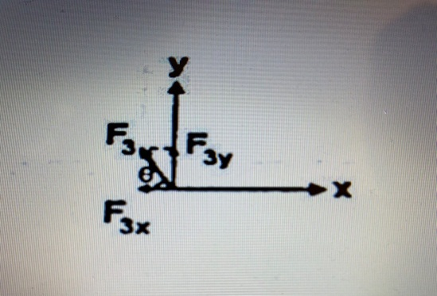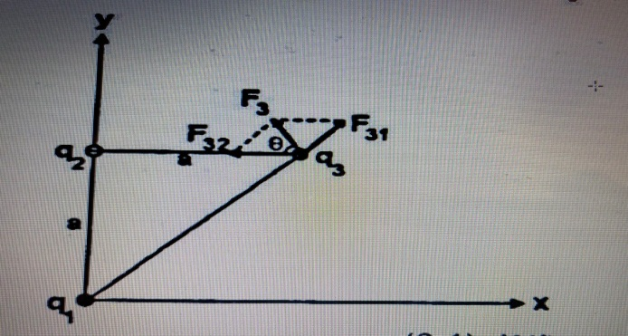
$$F_{31}=\frac{1}{4πε_{0}}\frac{q_{3}q_{1}}{√2a^{2}}= 9×{10}^{9} \frac{{7×10}^{-6}×7×{10}^{-6}}{(√2×0{.1)}^{2}}=22.5N$$
$$F_{32}=\frac{1}{4πε_{0}}\frac{q_{3}q_{2}}{a^{2}}= 9×{10}^{9} \frac{{7×10}^{-6}×3×{10}^{-6}}{(0{.1)}^{2}}=18.9N$$
You notice from the figure that force (F31) makes an angle of (45⁰) with the positive x axis. This force can be analyzed into two components (equal in magnitude), as follows:
F₃₁(x)=f₃₁ Sin45⁰= F₃₁(y)= f₃₁Cos 45⁰ = $\frac{22.5}{√2} =15.9 N$
As for the force (F₃₂), it is in the direction of the negative (x-axis), and therefore the resultant force acting on it is q₃ in the direction of the x-axis :
F₃(x) = F₃₁ (x) - F₃₂ (x) = 15.9 - 18.9 = 3.0 N
Likewise, the resultant force on (q3) towards the vertical (y) axis is:
F₃(y) = F₃₁(y ) = 15.9N
$$F_{3}=\sqrt{{ F_{3}^{}}^{2}(x)+{ F_{3}^{}}^{2}(y)}=\sqrt{{-3}^{2}+{15.9}^{2}}=16.2N$$
$θ=\tan^{-1}\left(\frac{|F(y)|}{|F(x)|}\right)=\tan^{-1}\left(\frac{15.9}{-3}\right)= ≫ ≫ ≫{ 79}^{0}$
Where (Ɵ) is the angle that the resultant force on charge (q₃)makes with the negative (x-axis ),as shown.
Example (5) : Calculate the net force acting on the charge q₄ as shown in the figure, given that q₁=1x10⁻⁶ C , q₂ = - 1x10⁻⁶ C ,
q₃ = - 2x10⁻⁶ C , q₄ = + 2x10⁻⁶ C , r =10 cm ?
We determine the directions of the three forces F₄₁ , F₄₂ and F₄₃ that act on charge q₄ by the charges q₁ , q₂ and q₃ in amounts respectively. Using Coulomb's law, we can calculate the magnitudes of these forces.
$$F_{41}=\frac{1}{4πε_{0}}\frac{q_{4}q_{1}}{r_{41}^{2}}= 9×{10}^{9} \frac{{2×10}^{6}×1×{10}^{-6}}{(0{.1)}^{2}}=1.8N$$
$$F_{41}=\frac{1}{4πε_{0}}\frac{q_{4}q_{2}}{r_{42}^{2}}= 9×{10}^{9} \frac{{2×10}^{-6}×1×{10}^{-6}}{2(0{.1)}^{2}}=0.9N$$
$$F_{41}=\frac{1}{4πε_{0}}\frac{q_{4}q_{3}}{r_{43}^{2}}= 9×{10}^{9} \frac{{2×10}^{-6}×2×{10}^{-6}}{(0{.1)}^{2}}=3.6N$$
The sum of these three forces is equal to the vector sum of the:
F= F₄₁ + F₄₂ + F₄₃
To calculate the sum of the sum, we first find the sum of the horizontal components (F_{x}) of the three forces, then we find the sum of the vertical components (F_{y}) ,so we get:
F_{X} = F₄₃ +F₄₂ COSƟ = 3.6 + 0.9 COS 45 = 3.6 + 0.6 = 4.2 N
F_{Y} = F₄₂ SIN Ɵ - F₄₁ = 0.9 SIN 45 - 1.8 = 0.6 - 1.8 = -1.2 N
The negative sign means that the direction of Fy is down, that is, in the negative direction of the y axis and finally we get amount of the net from the following equation:
F =$\sqrt{\left(F_{x}\right){}^{2}+\left(F_{y}\right){}^{2}}=\sqrt{\left(4.2\right){}^{2}+\left(-1.2\right){}^{2}}=4.4N$
To determine the direction of the net force. We calculate the angle F with the x axis:
TanØ = $\frac{F_{y}}{F_{x}}=\frac{4.2}{1.2}=3.5 ≫≫≫\tan^{-1}\left(3.5\right)= 74.05$
Example( 6 ) : Two point charges placed in a vacuum of (400 μC) and ( -500 μC) that are (500 cm) apart Determine the point along the distance between them at which the force on a positive (q) point charge becomes zero?
First we must determine the position at which the net force acting on the charge (q) is likely to be zero. This site is definitely not between the two shipments. As it is impossible for the sum to be zero in this region. Because the two forces acting on (q) are in the same direction, on the one hand. On the other hand, the distance of the site from the small charge must be less than its distance from the large charge in order for the two forces acting on the charge (q) to be equalized according to Coulomb's law. Now suppose that the distance of the charge q from the small charge is ((x) meters). As shown in the figure, then its distance from the other charge becomes ( -0.5 + x meters). By applying Coulomb's law, we can find each of the two forces acting on the charge (q):
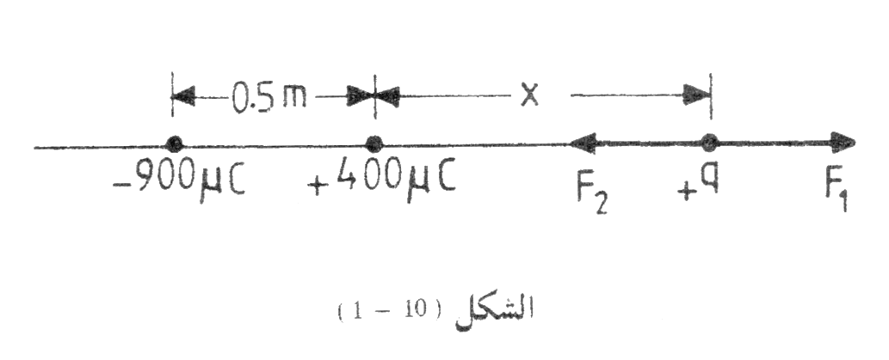
$$F_{1}=\frac{1}{4πε_{0}}\frac{q_{1}q_{2}}{r_{}^{2}}= 9×{10}^{9} \frac{9×400×{10}^{-6}}{({X)}^{2}}$$
$$F_{2}=\frac{1}{4πε_{0}}\frac{q_{1}q_{2}}{r_{}^{2}}= 9×{10}^{9} \frac{9×900×{10}^{-6}}{({X+0.5)}^{2}}$$
As the two forces are opposite directions. As shown in the figure. The net force becomes zero when the first force is equal to the second power by:
$$\frac{9×{10}^{9}}{} \frac{9}{}\frac{×400×{10}^{-6}}{(x){}^{2}}=\frac{9×{10}^{9}}{} \frac{9×900×{10}^{-6}}{(x+0.5){}^{2}}$$
2 ( x + 0.5 ) = 3x
By solving this equation : we get the value of
x=1 (x)equal to one meter.
Example ( 7 ) : The electric current in a given conductor c changes with time according to the equation{ i=2t+5 (A)} Calculate the charge passing through the conductor in one minute ?
$$i=\frac{dq}{dt} ≫ ≫ ≫ dq=idt$$
$$q=\int{dq}=\int_{0}^{t}{idt}=\int_{0}^{t=60s}{\left(2t+5\right)dt}$$
$$=t^{2}+5{t ]}_{0}^{60}=3600+300=3900 C$$

Example ( 8 ) : If you know that the charge passing through a metal wire changes with time according to the equation
{ q (t) = 3t² + 2} , Where q in coulombs and t in seconds,
what is the intensity of the instantaneous current passing through the wire when t = 2 sec ?
$$i\left(t\right)=\frac{dq}{dt}= \frac{d}{dt}\left(3t2+2\right)=6t$$
But t=2 → i=12 A

Example ( 9 ) : A stream of (5μA) electrons falls on a television screen for one hour. Find (1) the charge transferred by this current (2) the number of electrons transferred during this period(3)the mass of all electrons transferred during this period?
1/ $i=\frac{dq}{dt} ≫≫≫ dq=id ≫≫≫ q=\int_{0}^{q}{dq}=\int_{0}^{t}{idt }$
$$q=i t=\left(5×{10}^{-6}\right)×1h×\left(3.6×{10}^{3} \frac{s}{h}\right)$$
$$=1.8×{10}^{-2} A.s =1.8×{10}^{-2} C$$

2 / $N=\frac{q}{e}= \frac{1.8×{10}^{-2} C}{1.6×{10}^{-19} C}=1.13×{10}^{17} C$

3/ $M=mN=9.11×{10}^{-31} Kg×1.13×{10}^{17}$
= $1.03×{10}^{-31} Kg$

Exercise
Q1 // Imagine two alpha minutes located at a distance of (10⁻¹³ m) , what is the magnitude of the force that one of the two minutes exerts on the other. Note that the alpha minute consists of two neutrons and two protons ?
Q2 // The sodium chloride molecule consists of a sodium ion that has a positive charge $(1.6×{10}^{-13}μC$), and the chlorine ion has a negative charge of the same amount, The distance between
two ions was(1 x 10⁻¹⁰ m). What is the magnitude of the force of attraction between them ?
Q3 // Three point positive charges of ( 2 , 3 and 4 micro columns) are placed on the vertices of an equilateral triangle with a side length of (0.1 m). Calculate the magnitude of the net force acting on the (4 μC) charge and determine its direction?
Q4 // Calculate the repulsive force between the two argon nuclei when the distance between them is (1×10⁻³ μm) . Note that the argon nucleus contains (18 protons) ?
Q5 // Calculate the electrostatic force acting between two identical charges, each of which is (1C) , placed in the air, given that the distance between them is (1m) ?
Q6 // Calculate the number of electrons that make up a charge of (1C) ?
Q7 // What is the distance between two electrons in a vacuum if you know that the electrostatic force between them is equal to the force of attraction of the earth for the electron ?
Q8 // Calculate the speed at which the electron rotates in a hydrogen atom in light of the information given in Example (1)?
Q9 // Two charges (q₁=100 x10⁻⁸ μC), (q₂ = -400 x 10⁻⁸ μC), are placed in air at a distance of (5 m),A third charge of (q₃=100 x 10⁻¹⁰ μC) is placed halfway between them. Calculate the magnitude and net force on the third charge and determine its direction?
Q10 // Two identical metal balls carry charges of (+2 µC) and ( -4.4 µC),I Brought one of them to touch the other, then they are placed at a distance of (6 cm).What is the magnitude of the electrostatic force working between them? Is it a repulsive force or an attractive force?
Q11 // Three point charges were placed. The amount of each (q coulomb) at the vertices of an equal triangle ribs Calculate the force on each charge if you know the side length of the triangle equals 10cm?

