The Electric potential
1- Eelectrical Voltage:
It is known that if you put an electric charge in an electric field, it would be affected by a force.
This means that moving this charge from one point to another requires the completion of work.
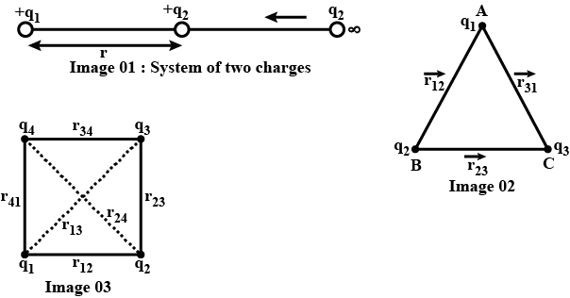
In terms of this work, we will know the electric potential (and symbolize it by the voltage ( V ) to help us describe and study electric fields along with the electric field strength E and the voltage is a scalar quantity.
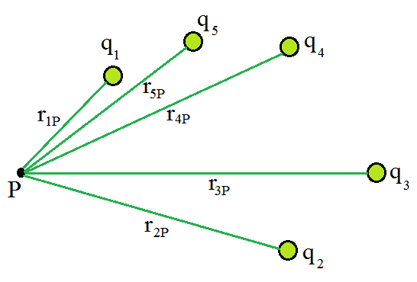
And to find the potential difference at these points (A) and ( B ), which are located in an electric field, as in the figure. The work that needs to be done by an external factor must be calculated to move the positive test charge( q_{o} ) from point ( A ) to ( B ) so that it always remains in equilibrium, and the potential difference between points ( A ) and ( B ) is known as the work done per unit charge:
$V_{B}-V_{A}=W_{AB} /q_{0}$
If we choose the point ( A ) at infinity, then the voltage ( A ) will be zero. $V=W /q_{0}$
That is, the electric potential at any point is the work per unit charge that must be done to move a small test charge from infinity to that point.
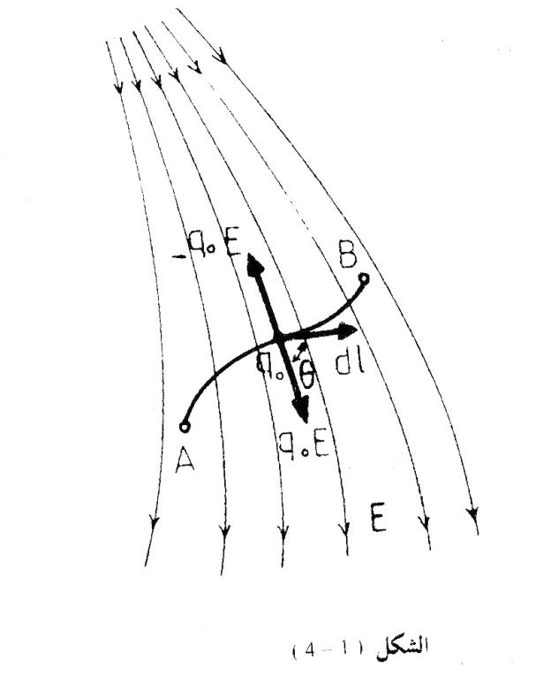
It is necessary to note here two points related to the recognition of voltage:
1-First, the test charge q_{o} must be so small that moving it from one point to another does not change the original electric field. Note that from this condition was provided in the definition of E field strength as well.
2- Secondly, to measure the voltage at any point, a reference point must be chosen that is agreed upon in advance with the value of the effort. In our definition of voltage, we chose the point in infinity and considered the voltage at it as zero.
Although in many electrical circuit problems, the earth voltage is taken as a reference to measure the voltage and its voltage is considered equal to zero.
From the equation ( V=W / q₀ ) it is clear that the voltage near an isolated positive charge is positive. This is because it must be affected by an external force to move the positive test charge in a direction opposite to the field from infinity to that point, that is, the work done by the external factor to move the test charge is positive.
We also note that the voltage near an isolated negative charge is negative. This is because an external factor exerts a restraining force on the positive test charge (which is attracted towards the negative charge, as it comes from infinity and moves it toward the field, so this time the work done is negative)
It is also clear from the equation that voltage is a scalar quantity (not vector) because work and charge are scalar quantities.
The unit of voltage according to the International System of Units is joule/coulomb and is called volt, meaning that (1Volt = 1 joule/ coulomb).

2-The relationship of voltage to field strength:
Calculates the work done by an external factor to move the positive test charge ( q_{o} ) from point ( A ) to ( B ) in a non-uniform electric field as shown (in previous Fig. 1). Let's say that the charge ( - q_{o} ) If you follow the path shown in the figure, we first calculate the work done to move the charge by differential displacement ( dl ) value. Then we perform the integration process along the path from point ( A ) to ( B ) , it is that the magnitude of the intensity. The electric field at the path element dl is E and makes the angle ( θ ) with which the charge is affected Experimental
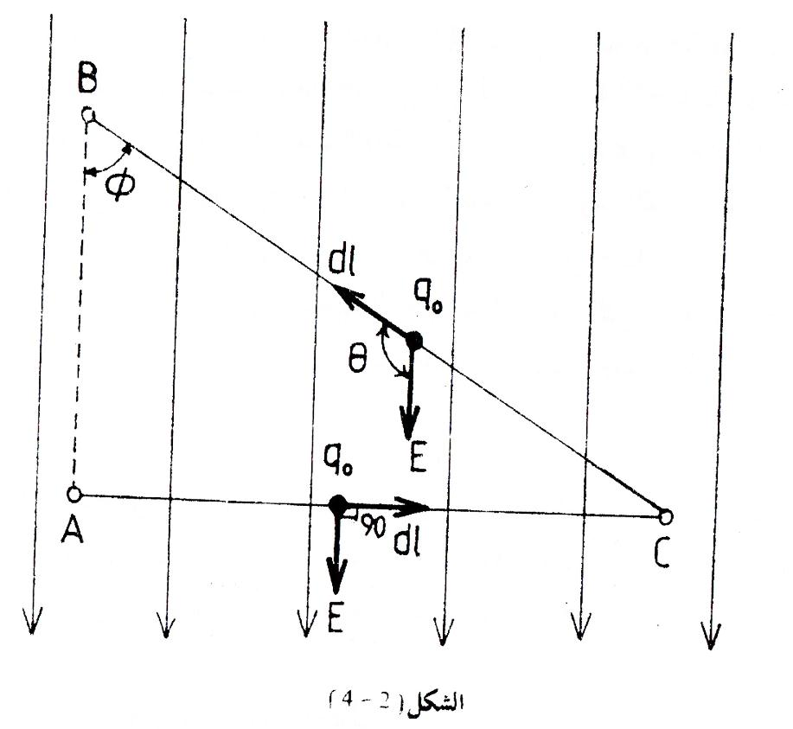

with a force of q_{o} E in the direction of the field, The force that must be applied by the external factor to move the charge without acceleration is ( q_{o} E) .
$W_{AB}=\int_{A}^{B}{F.dl} = -q_{0}\int_{A}^{B}{E .dl } ,,$ V_{A}-V_{B}=W_{AB}/q₀
$${ ∴V}_{A}-V_{B} =-\int_{A}^{B}{E .dl }$$
Thus, we get another definition of the potential difference, which is the linear integration of the field strength along the path from point ( A ) to ( B ) .
And if we assume that point A is located at infinity and that the voltage at this point is equal to zero. to become the equation
$$V_{B}=-\int_{A}^{B}{E .dl }$$
One of the special cases worthy of attention in which the equation can be written without the need to perform linear integration of the field strength is when the field is uniform and parallel to the charge path in a direction opposite to the field strength, so that the angle between (E) and (dl) is equal to 180º , so the
$$V_{A}-V_{B}=-\int_{A}^{B}{Ecos180 .dl=E\int_{A}^{B}{dl}}$$
$$V_{A}-V_{B}=Ed$$
where d is the distance between points A and B .
From this equation, it becomes clear that there is another unit for field strength, which is volts / meter , and it is symbolized by (V / m) .
3-Application for the calculation of the electric potential :
A // Potential due to electric dipole :
We will find the value of the electric potential at any point in the dipole field such as point (P) Look at the figure was located in polar coordinates ( θ , r ) . It is known that a dipole consists of two charges of equal magnitude and opposite in sign, separated by a distance of ( 2a ).
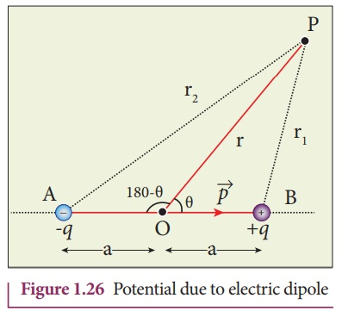
We find that the voltage at point P for charge +q is
$V_{1}=\frac{1}{4πε_{0 }}q/r_{1}$
As for the voltage at the same point for the other charge -q, its value is $V_{2}=\frac{1}{4πε_{0 }} -q/r_{2}$
Therefore, the total potential of both charges is equal to the algebraic sum of their potentials,
$${V=V}_{1}+V_{2} =\frac{1}{4πε_{0 }}(\frac{q}{r_{1}}-\frac{q}{r_{2 }})$$
$$V=\frac{q}{4πε_{0 }}(\frac{r_{1 -}r_{2}}{r_{21}})$$
We can find another approximate expression for the voltage in terms of r and θ when it is after the point P is large For 2a , i.e. r >> 2a . Observing the figure, we can deduce the following close relationships:
$r_{1}r_{2}≅r^{2} ≫≫ r_{2}-r_{1}≅2cosƟ$
$${V=}_{}\frac{q}{4πε_{0 }} \frac{2cosƟ }{{r^{2}}_{}} ≫≫ {V=}_{}\frac{1}{4πε_{0 }}\frac{pcosƟ}{{r^{2}}_{}}$$
Because p stands for a dipole , which is 2aq . It can be seen from this equation that the potential is zero at all points on the perpendicular line denominated from the midpoint between th e two dipole charges. That is, when the angle is perpendicular .
B // is the potential of a charged loop:
We assume that a charge of q is uniformly distributed in the form of a ring of radius ( R ) , and we need to find the voltage at a point ( P ) located on the ring axis and a distance of a from its center. We take a differential element from the ring with a charge ( dq ) which can be taken as a point charge at a distance of r from point (p).
From the equation, we can find the amount of effort generated by this element:
$${dV=V}_{} =\frac{1}{4πε_{0 }}\frac{dq}{r_{}}=\frac{1}{4πε_{0 }}\frac{dq}{\left(R^{2}+a^{2}\right)1/2}$$
The voltage generated by the entire loop is
$$V=\int{dv}=\int{\frac{1}{4πε_{0 }}\frac{dq}{\left(R^{2}+a^{2}\right)1/2}=\frac{1}{4πε_{0 }}\frac{}{√\left(R^{2}+a^{2}\right)}\int{dq}}$$
$$V_{} =\frac{1}{4πε_{0 }}\frac{q}{\left(R^{2}+a^{2}\right)1/2}$$
C // The potential of a charged disk
The figure shows a circular disk of radius (R) charged with a uniform charge, its surface density (σ), and it is required to find the voltage at the point (P) located on the axis of this disk, which is a distance from it of (a).
We take a differential element of charge in the form of a circular ring of radius (y), width (dy), and containing a charge of (dq). And according to the equation, the potential of this element at point - (P) is equal to
$$dV=V =\frac{1}{4πε_{0 }}\frac{dq}{r}=\frac{1}{4πε_{0 }}\frac{dq}{\left(R^{2}+a^{2}\right)1/2}$$
As for the charge (dq), it can be calculated by multiplying the area of ​​the ring by the surface charge density $dq=σ (2πy) (dy)$
$$dV =\frac{1}{4πε_{0 }}\frac{σ (2πy) (dy)}{\left(R^{2}+a^{2}\right)1/2}$$
To find the total potential, we integrate to cover all the rings that make up the disk, and we get
$$V=\int{dV} =\frac{σ}{{2ε}_{0 }}\int_{0}^{R}{\frac{ (y) (dy)}{\left(R^{2}+a^{2}\right)1/2}}$$
The integration process can be done easily if the variable( y) is replaced by another variable and let (x) be as at
$$X=\left(y^{2}+a^{2}\right)1/2 dx=\frac{ (y) (dy)}{2\left(R^{2}+a^{2}\right)1/2}$$
Substituting for this value, take the following equation:
$$V=\int{dV} =\frac{σ}{{2ε}_{0 }}\int{dx=\frac{σ}{{2ε}_{0 }} } x$$
Then the variable y is returned to the equation, and we get
$$V =\frac{σ}{{2ε}_{0 }}\left[\left(y^{2}+a^{2}\right) {}^{1/2}\right] {}_{0}^{R}{}$$
$$V =\frac{σ}{{2ε}_{0 }}\left[\left(y^{2}+a^{2}\right){}^{1/2}-a \right]$$

Exercises
Example 1 // Calculate the electric potential produced by the nucleus of a hydrogen atom at a point located at a distance of (r = 5.3×10⁻¹¹ m ) . It is the average radius of the electron cycle in a hydrogen atom?
The nucleus of a hydrogen atom contains one proton. And if we remember that the charge of the proton is 1.6×10⁻¹⁹ We can calculate the voltage by applying the equation:
$$V =\frac{1}{4πε_{0 }}\frac{q}{r}=\frac{9×{10}^{9}×1.6×{10}^{-19}}{5.3×{10}^{-11}}=27 V$$
Example 2 // Calculate the electric potential produced by the quadruple at point P on its axis, see Fig
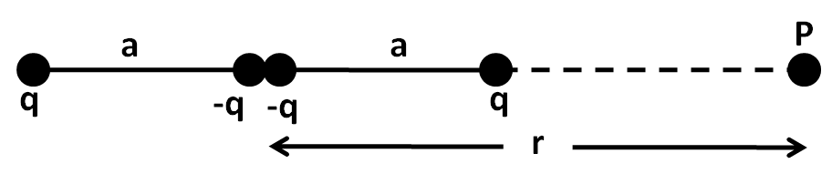
$$V=V_{n}=V_{1}+V_{2}+V_{3}+V_{4}$$
$$V =\frac{1}{4πε_{0 }}\frac{q}{r}= \frac{1}{4πε_{0 }}\left(\frac{q}{r+a}-\frac{q}{r}-\frac{q}{r} +\frac{q}{r-a} \right)$$
$$= \frac{q}{4πε_{0 }}\left(\frac{\left(r-a\right)r-\left(r-a\right)\left(r+a\right)-(r-a)(r+a)+\left(r+a\right)r}{\left(r+a\right)\left(r-a\right)r}\right)$$
$$V= \frac{q}{4πε_{0 }}\left(\frac{r^{2}-ra-r^{2}+a^{2}-r^{2}+a^{2}+r^{2}+ra}{\left(r+a\right)\left(r-a\right)r}\right)$$
$$V= \frac{q}{4πε_{0 }}\left(\frac{2ra}{\left(r^{2}-a^{2}\right)r}\right)$$
And if we assume that r >> a , then it becomes possible to neglect a² from the denominator of the fraction, so
$$V= \frac{q}{4πε_{0 }}\frac{2ra}{\left(r^{3}\right)}$$
Example 3 // Three small bodies are placed on the vertices of a regular triangle whose side length is 10 cm Objects have charges of 2 x 10⁻⁶ C , 3 x 10⁻⁸ C , and -4 x 10⁻⁸ C , find voltage at the center of the triangle?
First we find after the center of the triangle from its three vertices r, we get
$r=\frac{2}{3}× \frac{\left({10}^{2}-5^{2}\right)1/2}{}=\frac{2}{3}×5×\frac{\left(3\right)1/2}{}=5.77cm$
$$V =\frac{1}{4πε_{0 }}\sum_{n}{\frac{q_{n}}{r_{n}}}=\frac{1}{4πε_{0 }}\frac{q_{1}+q_{2}+q_{3}}{r}$$
$$=\frac{9×{10}^{9} }{5.77×{10}^{-2}}\left(\frac{2+4-8}{} \right)×{10}^{-8 }=1.56×{10}^{3 }V$$
Example 4 // Find the electric potential of a point 5.25×10⁻¹¹ from a proton with charge e+ ?
$$V=\frac{1}{4πε_{0 }}\frac{q }{r}=9×{10}^{9}×1.6×{10}^{-19}/5.25×{10}^{-11}=27.2 V$$
Example 5 // If you know that the electric potential of a point charge 1m away from it is 500 V , find the magnitude of the charge?
$V=\frac{1}{4πε_{0 }}\frac{q }{r} ,, 500=9×{10}^{9}× q/1$
$$q=5.56×{10}^{-8} C$$

Example 6 // Two conducting balls, the radius of the first ball R₁ =1 Cm and the radius of the second ball R₂= 2Cm, put a charge on the small ball q =.020 μC, leaving the large ball without shipment. If the two balls are connected by a long, fine conductive wire, calculate (a) the charge (b) the voltage (c) the surface density of charge for each of the two balls.??
The solution
We first calculate the potential of each of the two conducting balls according to the equation $V=\frac{1}{4πε_{0}}\frac{q}{R}$
$$V_{1}=\frac{1}{4πε_{0}}\frac{q_{1}}{R_{1}}$$
$$V_{2}=\frac{1}{4πε_{0}}\frac{q_{2}}{R_{2}}$$

But the potential of the two balls must be equal after they connect, so..
$$\frac{q_{1}}{R_{1}}= \frac{q_{2}}{R_{2}}$$
$$\frac{q_{1}}{1×{1O}^{-1} } =\frac{q_{2}}{2×{10}^{-2}}$$
2q₁=q₂
But q₁+q₂ = $2×{10}^{-6}$
By solving these two equations, we obtain the value of each of the two charges :
$q_{1}=6.7×{10}^{-8 }C ,, q_{2}=13.4×{10}^{-8}$C

Then we return to the equation $V=\frac{1}{4πε_{0}}\frac{q}{R}$ and calculate the effort of each ball :
$$V=V1=V2=9×{10}^{9}\frac{6.7×{10}^{-8 }}{1×{10}^{-2}}=60×{10}^{3 } V$$
Finally, we calculate the surface charge density on each of the balls :
$$σ_{1}=\frac{1}{4π}\frac{q_{1}}{{R_{1}^{2}}^{}}=\frac{6.7×{10}^{-8 }}{4π×(1×{10}^{-2}){}^{2}}=5.3×{10}^{-5 }Cm{}^{2}$$

$$σ_{2}=\frac{1}{4π}\frac{q_{2}}{R_{2}^{2}}=\frac{13.4×{10}^{-8}}{4π×(2×{10}^{-2}){}^{2}}=2.7×{10}^{-5 }Cm{}^{2}$$

4 - Equipotential surfaces:

If we consider the relationship E_{l}=-dv/dl carefully, we notice that if the path were$.3$ perpendicular to E, it would be a value
The component of the field strength in the direction of the path (E_{l}) is zero. And therefore :
dv/dl = 0 $≫≫$ v = constant
That is, v is equal to a constant value.
This means that all points of this path are of equal potential and the surface is equal to all points . The potential is called the
equipotential surface . The equipotential surfaces are perpendicular to the field strength E .
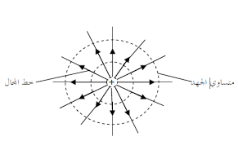
The work required to move the test charge between any two points on an equipotential surface The voltage must be zero
This is based on the equation V_{B} - V_{A} = W_{AB} / q₀.
From the above, we conclude that the equipotential surface must be perpendicular to the lines of electric force.
This is because the line of force represents the direction of the field, as we mentioned above.
The figure shows the equipotential surfaces drawn as continuous lines for three different forms of electric fields. When it isThe field is generated by a point charge, as in (a). The equipotential surfaces are spherical in shape and are uniform of center .
In the case of a regular field, such as that created between two parallel plates, as in (b), the equipotential surfaces are flat and parallel, while the field resulting from a dipole is as in (c). It has another shape as shown in the figure Where the potential difference between the isopotential surfaces is equal - we find that Equipotential surfaces are crowded and close together when the field is strong While they are far apart when it is the field is weak.
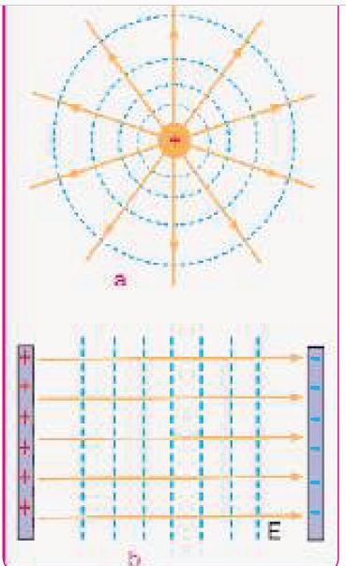

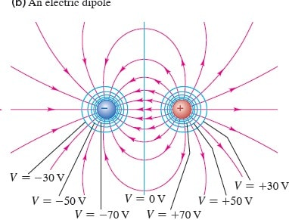
5 - The Van de Graff generator :
In 1931, Van de Graff was able to build a huge electrostatic generator to generate a high voltage difference.
Very high, up to 10,000,000 volts. One of the main uses of this generator is to utilize high potential difference to generate x-rays and also to accelerate charged particles and give off
High energy. If a particle with charge q moves in a vacuum under the influence of a potential difference of value V, it gains kinetic energy of
W = K = q V
Its unit is in joules when charge is measured in coulombs and potential difference in volts .
There is another unit of energy that has wide use in the field of atomic physics. It's called an electron volt
(eV) . It is the amount of energy gained by a particle carrying the charge of one electron. When it accelerates through
A potential difference of one volt . By substituting the value of the electron charge into the above equation We get the value of electron volts in joules.
1( e v ) = ( 1.6×10⁻¹⁹ Coulomb )× ( 1 )Volt
Joule =1.6×10⁻¹⁹
The basis of the work of the Van de Graff generator is that if a charged conductor is inserted into a hollow conductor and touches it from the inside, all the charge carried by the first conductor will be transferred to the second conductor. Whatever charge this final conductor carries. But instead of repeatedly inserting charged objects into the hollow conductor of the Van de Graff device. The shipments are transported continuously by a rotating belt .
The figure shows a schematic diagram of a simple model of a Van de Graff generator used for illustration the basic idea on which this device works. It consists of a hollow conductive sphere mounted on An insulating column rests on a conductive base connected to the ground. There is a belt of insulating material running over it Two buffer rollers. The lower pulley can be rotated by electric motor. These two rollers are painted
With two different materials so that when the belt touches the lower pulley, it gains a positive charge. While it gains a negative charge when it touches the upper pulley Thus, the left side of the belt continuously transfers the positive charge during its upward movement to the metal ball through connected pointed points.
One side for this ball. When the belt leaves the upper pulley, it carries a negative charge. Move with the right side of the belt down. This negative charge is then transferred through the lower spikes to the base and then seeps into the ground. Thus, both sides of the belt work to increase the accumulated positive charge On the metal ball.
From the above, it is clear that if there were no difficulties in isolating the metal ball electrically, it would be possible to increase the charge on it and thus increase its electrical potential to any desired amount. Thus, the highest voltage that can be obtained is determined by the value at which a balance occurs between the rate of charge leakage from the ball Minerals
through the insulating column and through the air surrounding it and the rate of charges gained by the ball .
