University of Mosul
College of Science
Department of Physics
Third Stage
Lecture Nine

Physical Optics
2024-2025
Lecture Nine
Preparation
Dr. Marwa Thamer Al-Shammaa

Diffraction of the Light
It is the phenomena of bending of light around the corners of obstacle / aperture of the size of the wavelength of the light as shown in figure (1) .

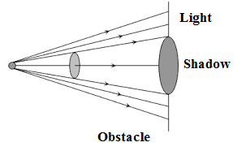
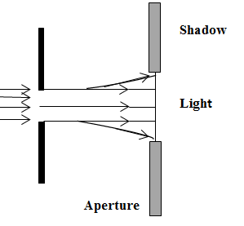
figure (1)

Diffraction effect (phenomena) depends upon the size of the obstacle or aperture, the wavelength of the light source, and the location of the screen. Diffraction of light takes place if the size of the obstacle is comparable to the wavelength of light. Light waves are very small in wave length, i.e., from 4×10⁻⁷ m to 7 × 10 ⁻⁷ m. If the size of aperture or obstacle is near to this limit, only then we can observe the phenomenon of diffraction. As shown in figure (2) below.
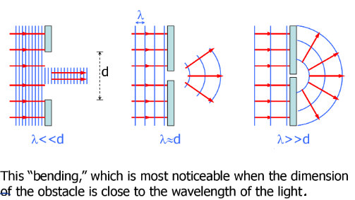
Figure (2): Diffraction of light passes through different aperture diameters.

Notes:
- Diffraction is the characteristic of all types of waves.
- Greater the wavelength of wave, higher will be it is degree of diffraction.
- Experimental study of diffraction was extended by Newton as well as Young. Mast systematic study carried out by Huygens on the basis of wave theory.
- The minimum distance $(x)$ at which the observer should be from the obstacle to observe the diffraction of light of wavelength$(λ)$ around the obstacle of size$(d)$ is given by $( x=\frac{d^{2}}{λ} )$.

- There are several common diffraction patterns are shown in figure(3), where the
figure (3-a) is a typical diffraction pattern for HeNe laser light passing through a circular pinhole. Figure (3-b) is a typical diffraction pattern for HeNe laser light passing through a narrow (vertical) slit. And Figure (3-c) is a typical pattern for diffraction by a sharp edge.
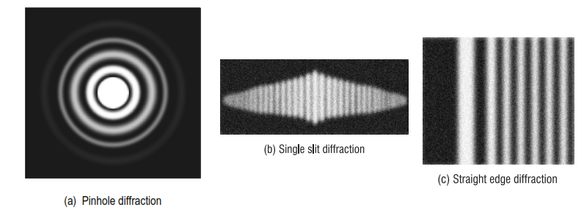
Figure (3)

- Define the diffraction?
- What does diffraction depend on?
- Draw the common diffraction patterns?
(1-2): Types of diffraction
There are two types of diffraction
- 1- Fresnel diffraction.
- 2- Fraunhofer diffraction

Difference between fresnel and fraunhofer diffraction.
- In fresnel diffraction:
- Source and screen are not far away from each other, or if either source or screen or both are at finite distance from the diffracting device (obstacle or aperture).
- Incident wave fronts are spherical.
- Wave fronts leaving the obstacles are also spherical.
- The convex lens is not needed to converge the spherical wave fronts.
- Common examples: Diffraction at a straight edge, narrow wire or small opaque disc etc.
As shown in figure (4) below.
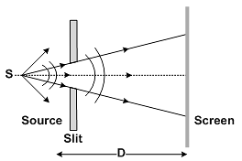
Figure (4)

- In fraunhofer diffraction
- Source and the screen are far away from each other, or if either source or screen or both are at infinite distance from the diffracting device (obstacle or aperture).
- Incident wave fronts on the diffracting obstacle are plane.
- Diffraction obstacle gives rise to wave fronts which are also plane.
- Plane diffracting wave fronts are converged by means of a convex lens to produce a diffraction pattern.
- Common examples: Diffraction at a single slit, double slit and diffraction grating.
As shown in figure (5) below.
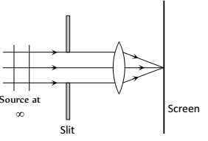
Figure (5)

- How many types of diffraction, state and explain the difference between them?

Diffraction by a single slit
When light passes through a single slit whose width (d) is on the order of the wave length of the light. The diffraction pattern on the screen will be at a distance D >> d away from the slit. Figure (6) shows a single slit diffraction pattern. Note that the central maximum is larger than those on either side, and that the intensity decreases rapidly on either side. In contrast, a diffraction grating produces evenly spaced lines that dim slowly on either side of center.
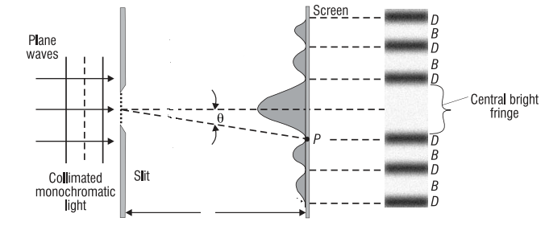
Figure (6): diffraction pattern for single slit

D

Mathematical procedure to determine the position of fringe
Assumption of infinite source distance gives plane wave at slit so that all amplitude elements are in phase and for $\left(D>>d\right),$ This approaches leads to that$θ'$ and $θ$ is equal ($θ'$ $≈ θ$) , so that $\tan{θ = }\frac{ẞ}{D}$ as shown in figure (7) below:

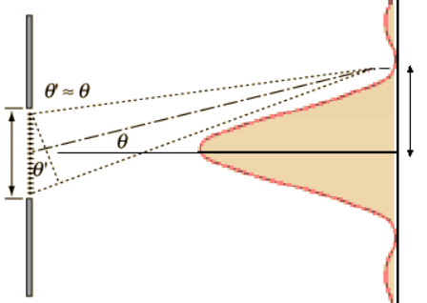

d
ẞ
d sin$θ$

D

Figure (7)

When the angle is small we can repels tan$θ$ by sin$θ$
$$\tan{θ ≈\sin{θ≈\frac{ẞ}{D}}}$$
The path difference ( $∆ =d\sin{θ)},$The condition for minimum(destructive interference):
$$d\sin{θ=n λ}$$
$ẞ= \frac{n λ D}{d}$, where n=1,2,3,…..
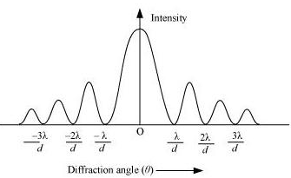
Figure (8)

- Comparison between interference and diffraction

Interference | Diffraction
Result due to the superposition of waves from two coherent sources. | Result due to the superposition of wavelets from different parts of same wave font. ( single coherent source).
Condition of the constructive  Interference $$d\sin{θ=n λ}$$  Condition of the destructive  Interference  $$d\sin{θ=\left(n+\frac{1}{2}\right) λ}$$ | Condition of the constructive  Interference $$d\sin{θ=\left(n+\frac{1}{2}\right) λ}$$  Condition of the destructive  Interference  $$d\sin{θ=n λ}$$
All fringes are of same width $ẞ= \frac{ λ D}{d}$. | All secondary fringes are of same width but the central maximum is of double the width $ẞ_{0}=2ẞ=2 \frac{ λ D}{d}$.
All fringes are of same intensity. | Intensity decreases as the order of maximum increases.
Position of nth maxima and minima  $ẞ_{n(Bright)}= \frac{ n λ D}{d}$,  $$ẞ_{n(Dark)}=(n+\frac{1}{2}) \frac{ λ D}{d}$$ | Position of nth secondary maxima and minima  $$ẞ_{n(Bright)}=(n+\frac{1}{2}) \frac{ λ D}{d}$$  $ẞ_{n(Dark)}= \frac{ n λ D}{d}$

- The intensity pattern for diffraction due to a single slit can be calculated using phasors as
$$\frac{I}{I_{0}}={\left(\frac{\sin{\frac{∅}{2}} }{\frac{∅}{2}}\right)}^{2}$$
$∅$ is phase difference= $\frac{2π }{λ}∆ = \frac{2π d sinθ }{λ}$,

Q1/ Why the central band is bright always in diffraction pattern?
Because amplitude elements are in phase.
Q2/ Why the first dark above and below (m=1,m=-1) is important in diffraction?
Because between two first darks we have the central bright which receives nearly all light energy passing through the slit.

Q3/ In a single slit diffraction experiment, the width of the slit is made double the original width. How does this affect the size and intensity of the central diffraction band?
- The size of the central maximum is given by $(2 D \frac{λ}{d} )$, It is clear if a is doubled, size of the central maximum is halved, The width of the central diffraction maximum is inversely proportional to the width of the slit , if we increasing the width size, the angle $(θ)$ at which the intensity first becomes zero decreases, resulting in a narrow central band. This is true for single slits, double slits, and diffraction gratings. The larger the object the wave interacts with, the less spread there is in the interference pattern.
- The intensity changes because of two factors.
One, doubling the width of the slit causes twice the light energy fall on the screen as compared to that with the original width.
Two, the light energy is now squeezed into half of the area on the screen because the size of the central maximum is halved.
The two factors make the intensity four times.

Ex1: Light of wavelength 640 nm shines through a single slit of width 0.05 mm and projected on screen 4 m away.
- What is the angular position of the first minimum ?
Solution:
Using the equation $(d sinθ=n λ)$, the first minimum means n=1.
$$sinθ_{1}=\frac{nλ}{d}=\frac{1\left(640×{10}^{-9} m\right) }{0.05 ×{10}^{-3} m}=0.0128$$
$$θ_{1}=\sin^{-1}\left(0.0128\right)={0.73}^{°}$$
- What is the distance on the screen between the first minimum above and below the central maximum (m=1 and m=-1).
Solution:
Using the equation $ẞ_{n(Dark)}= \frac{ n λ D}{d}$ we get
$$ẞ_{1(Dark)}= \frac{ 1 (640×{10}^{-9} m ×4)}{0.05 ×{10}^{-3} m}=0.0512 m$$
اذاً عرض الهدبة المركزية تساوي:
$$2×0.0512 m=0.0256 m$$
المقصود في هذا الفرع ايجاد المسافة بين (m=1,m=-1) والتي هي عرض الهدبة المركزية
Ex2: Visible light of wavelength 550 nm falls on a single slit and produces its second diffraction minimum at an angle of ${45}^{°}$ relative to the incident direction of the light. (a) What is the width of the slit? (b) At what angle is the first minimum produced?
A graph of the single slit diffraction pattern is analyzed in this example.
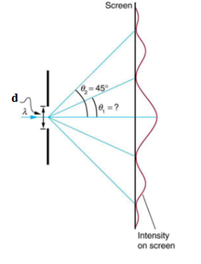

Solution for (a)
We are given that $(λ=550 nm)$, $\left(n=2\right), and$ ${(θ}_{2}= {45}^{°})$ . Solving the equation $(d sinθ=n λ )$ for$(d)$ and substituting known values gives:
$$d=\frac{nλ}{sinθ_{2}}=\frac{2\left(550nm\right) }{sin {45}^{°}}=1.56 ×{10}^{-6} m$$
Solution for (b)
substituting the known values gives in above equation we get:
$$sinθ_{1}=\frac{nλ}{d}=\frac{1\left(550×{10}^{-9} m\right) }{1.56 ×{10}^{-6} m}=0.345$$
Thus the angle $θ_{1}$ is
$$θ_{1}=\sin^{-1}\left(0.354\right)={20.7}^{°}$$
Discussion
We see that the slit is narrow (it is only a few times greater than the wavelength of light). This is consistent with the fact that light must interact with an object comparable in size to its wavelength in order to exhibit significant wave effects such as this single slit diffraction pattern. We also see that the central maximum extends ${20.7}^{°}$ on either side of the original beam, for a width of about ${41}^{°}$. The angle between the first and second minima is only about ${24}^{°}$. Thus the second maximum is only about half as wide as the central maximum.

Ex3: Coherent laser light of wavelength 633 nm is incident on a single slit of width 0.25 mm. The observation screen is 2.0 m from the slit. (a) What is the width of the central bright fringe $ẞ_{o}$? (b) What is the width of the bright fringe between the 5th and 6th minima?
Solution:
- The width of the central bright fringe is ( 2$ẞ$), where $ẞ_{1}$ is the distance to the first minimum (n=1), by using the equation below we get:

$$ẞ_{o}=2ẞ_{1(Dark)}=2 \frac{ n λ D}{d}$$
$$ẞ_{o}=2ẞ_{1(Dark)}=2× \frac{ 1× 633×{10}^{-9} ×2.0}{0.25×{10}^{-3}}=0.01 m$$
The width of the central bright fringe is about 1 cm.

- Width = $ẞ_{6}- ẞ_{5}$= $\frac{ 6 λ D}{d} – \frac{ 5 λ D}{d}= \frac{ λ D}{d}$ $\frac{ 633×{10}^{-9} ×2.0}{0.25×{10}^{-3}}=5.06 × {10}^{-3} m=0.005 m=0.5 cm$

The width of bright fringe between the 5th and 6th minima is about half the width of the central bright fringe.

EX4: Intensity in Single-Slit Diffraction Light of wavelength 550 nm passes through a slit of width 2µm. (a) Find the locations of the first two minima in terms of the angle from the central maximum and (b) determine the intensity relative to the central maximum at a point halfway between these two minima.

Solution:
a): The equation $(d sinθ=n λ)$, The first two minima are for n=1 and n=2, can be used to determine the intensity once the angle has been worked out.
$$θ_{n}=\sin^{-1}\left(\frac{nλ}{d}\right)$$
$$θ_{1}=\sin^{-1}\left(\frac{1×\left(550×{10}^{-9} m\right) }{2.0 ×{10}^{-6} m}\right)=+16°$$
$$θ_{2}=\sin^{-1}\left(\frac{2×\left(550×{10}^{-9} m\right) }{2.0 ×{10}^{-6} m}\right)=+33.4°$$
b): The halfway point between $θ_{1} and θ_{2}$ is
$$θ=\frac{θ_{1}+θ_{2}}{2}= \frac{16+33.4}{2}=24.7°$$

$∅=\frac{2π d sinθ}{λ}= \frac{2π \left(2.0 ×{10}^{-6} m\right) sin(24.7)}{\left(550×{10}^{-9} m\right)}$= 3.04 $π$ or 9.54 rad
$\frac{I}{I_{0}}={\left(\frac{\sin{\frac{ ∅}{2}} }{\frac{ ∅}{2}}\right)}^{2}= {\left(\frac{\sin{4.77} }{4.77}\right)}^{2}= {\left(\frac{-0.9985 }{4.77}\right)}^{2}$=0.044

Significance This position, halfway between two minima, is very close to the location of the maximum, expected near $\frac{3π }{2}$ or 1.5 $π$

Ex5: Monochromatic light is incident on a single slit of width 0.30 mm. On a screen located 2.0 m away, the width of the central bright fringe is measured and found to be near 7.8 mm. What is the wavelength of the incident light?

