University of Mosul
College of Science
Department of Physics
Third Stage
Lecture Three

Physical Optics
2024-2025
Lecture Three
Preparation
Dr. Marwa Thamer Al-Shammaa

Types of Polarization
Following are the three types of polarization
- Linear polarization
- Circular polarization
- Elliptical polarization

Linear Polarization
In linear polarization, the electric field of light is limited to a single plane along the direction of propagation. Both E_{x} and E_{y} components oscillate with a phase difference $\left(δ=±mπ\right),$where m = 0, 1, 2,…..

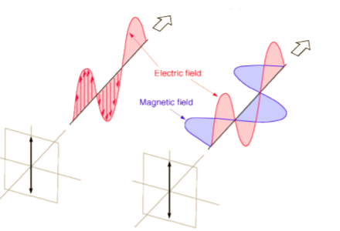

Circular Polarization
Let us consider that two harmonic waves are linearly polarized, so that the polarization direction of one is perpendicular to the direction of the other's polarization. And they have the same electric field amplitude ${(E}_{0})$. The phase difference between them is ($δ=\frac{π}{2}$), Suppose the electric field direction of one of them is an axis (x) while its direction in the other is an axis (y).

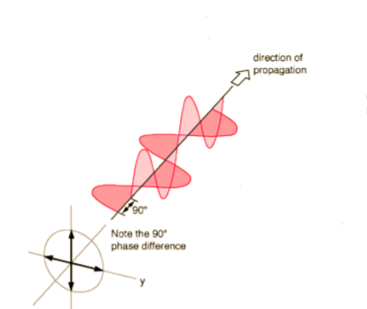

- Elliptical polarization
If the amplitudes of the components of the real electric fields are not equal,
$E_{0}≠$ $E_{0}^{'}$, the phase difference between them is ($δ=\frac{π}{2}$)

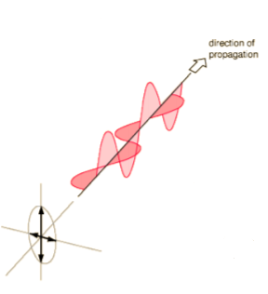

Matrix Representing of Polarization
This topic is to facilitate the equations of types of polarization, if we take the vector $\overset{⃑}{E}$ in z-axis it decomposes into two components, if we represented the vector $\overset{⃑}{E_{x}}$ (in the x-axis) and the vector $\overset{⃑}{E_{y}}$ (in the y-axis) with unit vectors:
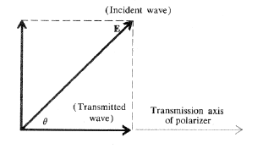
$$E_{x}$$
$$E_{y}$$

$$\overset{⃑}{E}=\hat{i} \overset{⃑}{E_{x}}+\hat{j} \overset{⃑}{E_{y }} …(1)$$
Each of the $\overset{⃑}{E_{x}}$ , $\overset{⃑}{E_{y}}$ can be represented at any moment by the following two relationships:
$$E_{x}=E_{0x} e^{i(k_{z}-ωt+∅_{x})} …(2)$$
$$E_{y}=E_{0y} e^{i(k_{z}-ωt+∅_{y})} …(3)$$
Whereas $E_{0x}$ , $E_{0y}$ the amplitudes of the two waves and $∅_{x}$ , $∅_{y}$the phase difference respectively. If we separate the function (e) and substitute equation (2) and (3) in equation (1) and simple arrangement, we results:
$$E=E_{0} e^{i(k_{z}-ωt)}$$
$$E=(\hat{i}E_{0x} e^{i∅_{x}} + \hat{j}E_{0y} e^{i∅_{y}})$$
It is worth noting that the magnitude and direction of the resultant fields do not change during the propagation of the polarized wave in the medium, that is ($k_{z}-ωt=constant$)For any type of the mentioned polarizations
($E_{0}$) is the complex amplitude of electric field can be formulated as follows and in a matrix of two components:
$$E_{0}=\left[\begin{matrix}E_{0x} & e^{i∅_{x}} \\ E_{0y} & e^{i∅_{y}}\end{matrix}\right] …(4)$$
This matrix can be utilized to formulate Jones vectors for linear, circular and elliptic polarization types.
Suppose in the following figure which represents a vertical linear polarized light traveling in a (z) direction.
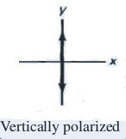
$$\overset{⃑}{E}$$

Since E oscillates between (-) and (+), passing zero, at a certain moment $E_{0x}=0 , E_{0y}=A$ , the equation (4) become:
$$E=\left[\begin{matrix}0 \\ A\end{matrix}\right]=A\left[\begin{matrix}0 \\ 1\end{matrix}\right]$$
Whereas (A) is the amplitude of the wave , if we assume it to equal 1.
$$E=\left[\begin{matrix}0 \\ 1\end{matrix}\right]$$
The matrix represents the Jones vector of vertical linear polarization.
Likewise, if we counted the following figure, we would find that the Jones vector of the horizontal linear polarization is equal to $\left[\begin{matrix}1 \\ 0\end{matrix}\right]$
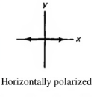

General case: To formulate the matrix as follows
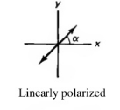

The linear polarized light acts at an angle (α) with the x-axis, and here both ($E_{x}, E_{y}$) are present together which is a general case of linear polarization, but on the condition that they are ($E_{x}, E_{y}$) in the same phase and pass through the origin at the same time, which means that ($∅_{x}=∅_{y}$).
If the (A) resultant amplitude, then the amplitude for horizontal and vertical components is:
$$E_{0x}=A\cos{α}$$
$$E_{0y}=A\sin{α}$$
Jones vector:
$E_{0}=\left[\begin{matrix}E_{0x} e^{i∅_{x}} \\ E_{0y} e^{i∅_{y}}\end{matrix}\right]= \left[\begin{matrix}A\cos{α} \\ A\sin{α}\end{matrix}\right]$= A $\left[\begin{matrix}\cos{α} \\ \sin{α}\end{matrix}\right]$
This vector can be calibrated by A=1 because ($\cos^{2}{α}+ \sin^{2}{α}=1)$. This represents a general formula for linear polarization, when ($α=90$) it represents the vertical polarization, while when ($α=0$) it represents horizontal polarization, but when the angle ($α=60$) and assuming that (A=1) the matrix is:
$E=\left[\begin{matrix}\cos{α} \\ \sin{α}\end{matrix}\right]= \left[\begin{matrix}\frac{1}{2} \\ \frac{\sqrt{3}}{2}\end{matrix}\right]$ = $\frac{1}{2}$ $\left[\begin{matrix}1 \\ \sqrt{3}\end{matrix}\right]$
$$α=\tan^{-1}{(\frac{b}{a}})$$
Matrix = $\left[\begin{matrix}a \\ b\end{matrix}\right]$
For the circular pattern, assume that one of the two components ${(E}_{x}, E_{y})$ precedes the other by a phase difference of its magnitude ($∅=\frac{π }{2}$), meaning that $∅_{x}=0 , { ∅}_{y}= \frac{π }{2}$, the amplitudes of the two components are equal (${(E}_{0x}=E_{0y}=A)$.
$E_{0}=\left[\begin{matrix}E_{0x} e^{i∅_{x}} \\ E_{0y} e^{i∅_{y}}\end{matrix}\right]= \left[\begin{matrix}A e^{i0} \\ A e^{i\frac{π }{2}}\end{matrix}\right]=A$ $\left[\begin{matrix}1 \\ i\end{matrix}\right] …(5)$
And the normalized formula for this vector is as follows:
$$E_{0}=\frac{1}{\sqrt{2}}\left[\begin{matrix}1 \\ i\end{matrix}\right] …(6)$$
Here this vector rotates counterclockwise (left circular polarization).
Likewise, if it were here, we would substitute ($∅=-\frac{π }{2}$) into the equation (5), and we get a Jones vector calibrated to represent right- circular polarized light.
$$E_{0}=\frac{1}{\sqrt{2}}\left[\begin{matrix}1 \\ -i\end{matrix}\right] …(7)$$
We notice from the two equations (6,7) that one of the elements of the Jones vector of circular polarization is imaginary and the other is real, and the numerical value of them is equal.
$$\overset{⃑}{E_{R}}\left(z,t\right)=E_{0}\left[i\cos\left(kz- ωt\right){+ j\sin\left(kz- ωt\right)}\right]$$
$$\overset{⃑}{E_{L}}\left(z,t\right)=E_{0}\left[ i\cos\left(kz- ωt\right){- j\sin\left(kz- ωt\right)}\right]$$
In this equation, the positive sign is of left circular polarization, while the sign is the negativity is for right- circular polarization

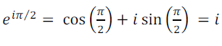
Let's take another case where the phase difference between the two components $E_{x}, E_{y}$ is constant and equal to ($∅=\frac{π }{2}$), but ($E_{0x}≠ E_{0y}$). And assume the $E_{0x}=A$, $E_{0y}$= B in equation (5) we get:
$$E_{0}=\left[\begin{matrix}A \\ iB\end{matrix}\right]$$
This matrix represent the Jones vector of the left elliptical polarization.
$$E_{0}=\left[\begin{matrix}A \\ -iB\end{matrix}\right]$$
This matrix represent the Jones vector of the right elliptical polarization.
The normalized formula of these vector preceded by factor : $\frac{1}{\sqrt{A^{2}+B^{2}}}$
The main axis in this type of polarization is either located on the x-axis or on the y-axis according to the difference between the two amplitudes ($E_{0x}, E_{0y}$)and as shown in the figure:
E_{0y}
E_{0y}

E_{0x}
E_{0x}

E_{0x} > E_{0y}

>
E_{0y} > E_{0x}

An important application of Jones' mathematics is to calculate the sum of two or more waves at a given polarization.
This is done by adding Jones vectors, an example of this, to find out the result of adding two waves of the same amplitude, one of which has a right polarization and the other is left, so the result is as follows:
$\left[\begin{matrix}1 \\ -i\end{matrix}\right]$+$\left[\begin{matrix}1 \\ i\end{matrix}\right]=\left[\begin{matrix}1+1 \\ -i+i\end{matrix}\right]=\left[\begin{matrix}2 \\ 0\end{matrix}\right] =2\left[\begin{matrix}1 \\ 0\end{matrix}\right]$
The output is horizontal linear polarized light of twice the amplitude of the two circular waves.
Orthogonal Polarization
if ( E₁, E₂) they are the amplitude compound of the electric field in two polarized waves, so that the following condition is achieve:
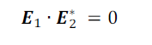
These two waves are in a state of perpendicular polarization. Also, (*) denotes the compound conjugate of the quantity, i.e. that The angle between these vectors is 90º (the scalar product). For example, the left circular polarization is
polarization perpendicular to right circular polarization. We can express the condition of orthogonal polarization in terms of a vector Jones is as follows:
If the Jones vector of the amplitude electric field in two polarized waves they are: $\left[\begin{matrix}A_{1} \\ B_{1}\end{matrix}\right]$, $\left[\begin{matrix}A_{2} \\ B_{2}\end{matrix}\right]$ , the condition of orthogonal vectors must fulfill the following:
$$A_{1}A_{2}^{*}+ B_{1}B_{2}^{*}=0$$
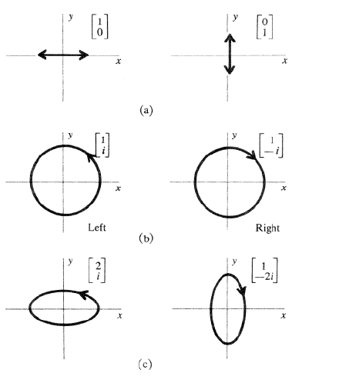
Some cases of orthogonal Jones vectors.

Q8: What type of polarization is the waves that the Jones vectors have the following:
- $\left[\begin{matrix}1 \\ 2\end{matrix}\right]$
- $\left[\begin{matrix}1 \\ 0\end{matrix}\right]$
- $\left[\begin{matrix}1 \\ 2i\end{matrix}\right]$
- $\left[\begin{matrix}1 \\ -i\end{matrix}\right]$
Q9: Prove that the following two Jones vectors: $\left[\begin{matrix}2 \\ i\end{matrix}\right]$, $\left[\begin{matrix}1 \\ - 2i\end{matrix}\right]$
represent a case of polarization perpendicular to the elliptical polarization?

Representing polarization plates with Jones matrix
There are a number of optical elements that allow light to penetrate through them and change either the state of polarization or rotate the plane of polarization. These optical elements are known as polarization plates. These plates are divided into three types according to their work:
- Polarizing plate
- Phase retarded plate
- Rotator plate

- Polarizing plate:
I n the polarization plate industry, a dichroic (selective) crystal is used, as this crystal has the property of selective absorption. The Jones vector can be used to conclude an algebraic matrix representing the polarization plate (2$×$2).
If a vertical polarized light falls on the polarizing plate, the light will transmitted from the plate in a vertical polarized pattern as well.
That is, the Jones matrix is $\left[\begin{matrix}0 \\ 1\end{matrix}\right]$. Now if we symbolize the elements of the matrix for the plate with letters (a,b,c,d), the matrix can be represented in the polarization pattern (type) with the following relationship:
$$\left[\begin{matrix}a & b \\ c & d\end{matrix}\right]\left[\begin{matrix}0 \\ 1\end{matrix}\right]=\left[\begin{matrix}0 \\ 1\end{matrix}\right]$$
This process leads to the following two algebraic equations:
(a$×$0)+(b$×1$) = 0
(c$×$0)+(d$×1$) = 1
From the two equations we find that (b=0) and (d=1), To find the two elements (a and c), assume that the same plate affects a horizontal linear polarization pattern $\left[\begin{matrix}1 \\ 0\end{matrix}\right]$ , This effect can be represented by the following relationship:
$$\left[\begin{matrix}a & b \\ c & d\end{matrix}\right]\left[\begin{matrix}1 \\ 0\end{matrix}\right]=\left[\begin{matrix}0 \\ 0\end{matrix}\right]$$
(a$×$1)+(b$×0$) = 0
(c$×$1)+(d$×0$) = 0
From the two equations we find that (a=0) and (c=0). Thus the algebraic matrix (M) representing the polarizing plate with the vertical penetration axis is:
M= $\left[\begin{matrix}0 & 0 \\ 0 & 1\end{matrix}\right]$
In the same way, it is possible to obtain the Jones matrix for the polarization plate with the horizontal transmitted axis is:
M= $\left[\begin{matrix}1 & 0 \\ 0 & 0\end{matrix}\right]$
The general formula for a polarizing plate matrix is as follows:
M= $\left[ \begin{matrix}\cos^{2}θ & sinθcosθ \\ sinθcosθ & \sin^{2}θ\end{matrix} \right]$

Where ($θ$) it represents the angle between the transmission axis and the coordinate (z).

- Phase retarded plate:
A phase retarded plate is made of crystals that have double refraction and cut the crystal so that its optical axis is parallel to the surface of the crystal. When an unpolarized light beam falls perpendicular to the surface of the crystal (the plate), it will form two components (o-ray , e-ray) and spread on the same path, but differ in speed, Thus, a phase difference (∆$∅$) occurs between the two components, and this difference increases with the thickness of the crystal.
When (∆$∅=90)$the plate is called a quarter wave plate.
By picking the right thickness we can change the relative phase by exactly 90º . This changes linear to circular polarization and is called a quarter wave plate
$M=\left[\begin{matrix}1 & 0 \\ 0 & -i\end{matrix}\right]$….. fast vertical axes
$M=\left[\begin{matrix}1 & 0 \\ 0 & i\end{matrix}\right]$….. fast horizontal axes
$M=\frac{1}{\sqrt{2}}\left[\begin{matrix}1 & i \\ i & 1\end{matrix}\right]$…..fast axis at +45º
$M=\frac{1}{\sqrt{2}}\left[\begin{matrix}1 & -i \\ -i & 1\end{matrix}\right]$….. fast axis at - 45º

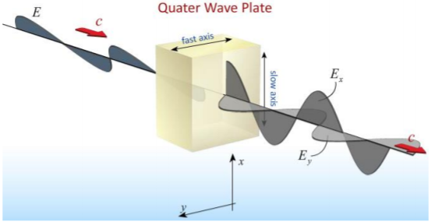

When (∆$∅=180)$the plate is called a half wave plate.
$M=\left[\begin{matrix}-1 & 0 \\ 0 & 1\end{matrix}\right]$…… fast vertical axes
$M=\left[\begin{matrix}1 & 0 \\ 0 & -1\end{matrix}\right]$…… fast horizontal axes
Quarter Wave Plates
To obtain circularly polarized light, sheets (plates) of a certain thickness are used, which are made of crystals , It has the property of double refraction example Calcite, Quartz. The behavior of the wave plate (half-wave, quarter-wave) depends on the thickness of the crystal, wavelength, and change in refractive index.
Suppose the thickness of the plate is (d), therefore the optical path length for polarized light in slow and fast axis direction ( $n_{1}d, n_{2}d$) respectively. In order for the optical path difference for these two rays to be equal to a quarter of a wavelength of light, the thickness of the plate must be as follows:
$$d=\frac{λ_{0}}{4\left(n_{1}-n_{2}\right)}$$
$∆∅=\frac{2π}{λ_{0}}$ $\left(n_{1}-n_{2}\right)d$

Q1: If the refractive indexes of the mica plate in the direction of the slow axis and the fast axis are as follows: $n_{1}=$1.5977, $n_{1}$= 1.5936, Find the thickness of this plate needed to make the optical path difference between the two rays passing through the plate equal to a quarter of the wavelength if light of its wavelength was passed through $λ=5890 nm.$

Q2: How we change the phase difference between E_{x} and E_{y}?

- Rotator plate:

When a polarized light beam travels towards the optical axis of a quartz crystal, for example, the level of its polarization rotates around the optical axis of the crystal, and the angle of rotation depends on the thickness of the crystal, the plate that is made of this crystal is called a rotator plate. To obtain the matrix of a rotating plate of a polarization plane at an angle with respect to its original position, we assume that the plate rotates the plane of polarization from angle (θ) to (θ+ẞ) and this means that the matrix elements achieve the following relationship:
$$\left[\begin{matrix}a & b \\ c & d\end{matrix}\right]\left[\begin{matrix}\cos{θ} \\ \sin{θ}\end{matrix}\right]=\left[\begin{matrix}\cos{(θ+ẞ)} \\ \sin{(θ+ẞ)}\end{matrix}\right]$$
After opening the two matrix’s above, by simple mathematical operations, we get Jones's matrix for a rotator plate:
$$M=\left[\begin{matrix}\cos{ẞ} & -\sin{ẞ} \\ \sin{ẞ} & \cos{ẞ}\end{matrix}\right]$$
Q3:
Linearly polarized light at angle (45º) falling onto a quarter-wave plate, use Jones matrices to find the type polarizing transmitted light?
$\frac{1}{√2}\left[\begin{aligned}1 \\ 1\end{aligned}\right]$ $\left[\begin{matrix}1 & 0 \\ 0 & -i\end{matrix}\right]$= $\frac{1}{√2}\left[\begin{aligned}1 \\ -i\end{aligned}\right]$
right- circular polarized light.

