University of Mosul
College of Science
Department of Physics
Third Stage
Lecture Eight

Physical Optics
2024-2025
Lecture Eight
Preparation
Dr. Marwa Thamer Al-Shammaa

Theory of Partial Coherence:
We have previously considered that the light used is completely identical, monochromatic and has a fixed amplitude, but in fact the interference of two or more sources of light waves, the amplitudes and phases change with time and randomly. Therefore, we note that the intensity of light at a moment in a point changes rapidly. So it is better to deal with the time rate of the field.
$$I=〈E^{2}〉=〈E.E^{*}〉= 〈{(E}_{\left(1\right)}+ E_{\left(2\right)}).(E_{\left(1\right)}^{*}+E_{\left(2\right)}^{*})〉$$
$=〈{\left|E_{1}\right|}^{2}+{\left|E_{2}\right|}^{2}+2{Re(E}_{1}.E_{2}^{*})〉$
$${ I =I}_{1}+I_{2}+ 2Re〈E_{1}E_{2}^{*}〉 …(1)$$
The two fields ($E_{1},E_{2}$) originate from the same source and differ due to the difference in the optical path (path difference), and the figure shows this:
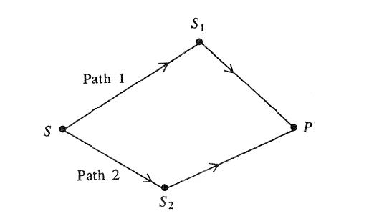
Different optical paths in interference. experiments.

Suppose (t) represent the time it took for one of the light waves to reach (P) through the path (1), (t + τ) and is the time of arrival of the other wave through path 2 . Therefore, the interference term can be expressed in equation (1) in the following mathematical form:
$$2ReΓ_{12}(τ)$$
$$Γ_{12}\left(τ\right)= 〈E_{1(t)}E_{2(t+τ)}^{*}〉$$
The function ($Γ_{12}\left(τ\right)$ is called the mutual coherence function or the correlation function of the two fields ($E_{1},E_{2}$).
$Γ_{11}\left(τ\right)$ is called the self – coherence function.
$$Γ_{11}\left(τ\right)= 〈E_{1(t)}E_{1(t+τ)}^{*}〉$$
$$Γ_{11}\left(0\right)= 〈E_{1\left(t\right)}E_{1\left(t+0\right)}^{*}〉= 〈E_{1\left(t\right)}E_{1\left(t\right)}^{*}〉=I_{1}$$
$$Γ_{22}\left(0\right)= 〈E_{2\left(t\right)}E_{2\left(t+0\right)}^{*}〉= 〈E_{2\left(t\right)}E_{2\left(t\right)}^{*}〉=I_{2 }$$
can use normalized correlation function called degree of partial coherence:
$$γ_{12}\left(τ\right)=\frac{Γ_{12}\left(τ\right)}{\sqrt{Γ_{11}\left(0\right)Γ_{22}\left(0\right)}}=\frac{Γ_{12}\left(τ\right)}{\sqrt{I_{1}I_{2}}}$$
The intensity becomes:
$${ I =I}_{1}+I_{2}+ 2 \sqrt{I_{1}I_{2}} Re γ_{12}\left(τ\right) …(2)$$
The function ($γ_{12}\left(τ\right)$) is a complex periodic function of (τ). The condition for obtaining an interference pattern is $\left|γ_{12}\left(τ\right)\right|≠0$.
The types of coherence can be classified according to the limits of this function ${(γ}_{12}\left(τ\right))$ as follows:
- complete coherence… happens when $\left|γ_{12}\right|=1$.
- partial coherence… happens when $0<\left|γ_{12}\right|<1$.
- incoherence…happens when $\left|γ_{12}\right|=0$.

Therefore, the interference fringe pattern has a finite intensity between the following two magnitudes, the upper limit of the intensity (maximum value)(I_{max}) and the lower limit of the intensity (minimum value)(I_{min}), from the equation (2):
I_{max} = ${ I =I}_{1}+I_{2}+ 2 \sqrt{I_{1}I_{2}} \left|γ_{12}\right|$
I_{min} =${ I =I}_{1}+I_{2}- 2 \sqrt{I_{1}I_{2}} \left|γ_{12}\right|$
fringes visibility degree (Ѵ) is defined as:
$$Ѵ=\frac{I_{max}-I_{min}}{I_{max}+I_{min}}$$
$$Ѵ=\frac{2 \sqrt{I_{1}I_{2}} \left|γ_{12}\right|}{I_{1}+I_{2}}$$
In particular, if it $I_{1}=I_{2},$ then the degree of visibility of the fringes becomes as follows:
$$Ѵ=\left|γ_{12}\right|$$
That is, the degree of fringes visibility is equal to the degree of partial coherence.
Sometimes, the degree of visibility of the fringes is called the contrast of the fringes. For example, the contrast is greater in the case of complete coherence, and it is equal to zero in the case of incoherence (there is no interference between the two rays at all).

