University of Mosul
College of Science
Department of Physics
Third Stage
Lecture Two

Physical Optics
2024-2025
Lecture Two
Preparation
Dr. Marwa Thamer Al-Shammaa

The Victorial (Directional) Nature of Light
It is known that the electromagnetic wave is composed of two fields, electric field ($\overset{⃑}{E}$) and magnetic ($\overset{⃑}{H}$) field, and now we want to find the relationship between them.
Suppose a complex exponential function representing the harmonic plane wave:
$$\exp{i(\overset{⃑}{k}.\overset{⃑}{r}- ωt)}$$
We take the derivative of the function with respect to time:
$$\frac{∂}{∂t}exp{i\left(\overset{⃑}{k}.\overset{⃑}{r}- ωt\right)}$$
$$=(-iω)exp{i\left(\overset{⃑}{k}.\overset{⃑}{r}- ωt\right)}$$
And take the derivative of the function with respect to place and be in one dimension (x-axis):
$$\frac{∂}{∂x}exp{i\left(\overset{⃑}{k}.\overset{⃑}{x}- ωt\right)}=i \overset{⃑}{k} \exp{i\left(\overset{⃑}{k}.\overset{⃑}{x}- ωt\right)}$$
But in three dimensions we enter ($∇$)
$$\overset{⃑}{∇}=i\frac{∂}{∂x}+j\frac{∂}{∂y}+k\frac{∂}{∂z}$$
$$\overset{⃑}{∇} exp i\left(\overset{⃑}{k}.\overset{⃑}{r}- ωt\right){\begin{aligned}=i \overset{⃑}{k}\exp{i\left(\overset{⃑}{k}.\overset{⃑}{r}- ωt\right)} \\ \end{aligned}}$$
We have two operators :
$$\frac{∂}{∂t}=-iω$$
$$\overset{⃑}{∇} = i \overset{⃑}{k}$$

Maxwell's equations in a homogeneous (non-conductive) medium
$$\overset{⃑}{∇}. \overset{⃑}{E}=0 …(1)$$
$$\overset{⃑}{∇}. \overset{⃑}{H}=0 …(2)$$
$$\overset{⃑}{∇}× \overset{⃑}{E}=-μ \frac{∂\overset{⃑}{H}}{∂t} …(3)$$
$$\overset{⃑}{∇}× \overset{⃑}{H}=ε \frac{∂\overset{⃑}{E}}{∂t} …(4)$$

By inserting the two operators into the above equations, we get:
$$i \overset{⃑}{k}. \overset{⃑}{E}=0$$
$$i \overset{⃑}{k}. \overset{⃑}{H}=0$$
$$i \overset{⃑}{k}× \overset{⃑}{E}=-μ \left(-iω\right)\overset{⃑}{H}$$
$$\overset{⃑}{k}× \overset{⃑}{E}=μ ω\overset{⃑}{H}$$
$$\overset{⃑}{k}× \overset{⃑}{H}=-ε ω \overset{⃑}{E}$$
We conclude that the vectors ($\overset{⃑}{E},$ $\overset{⃑}{H}, \overset{⃑}{k})$of the electromagnetic wave are perpendicular, meaning that the electric field is perpendicular to the magnetic field, and both of them are perpendicular to the vector propagation of the wave in the medium
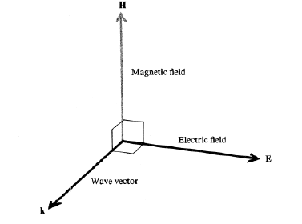

$$\overset{⃑}{k}× \overset{⃑}{H}=-ε ω \overset{⃑}{E}$$
$$-k H\sin{90}=-ε ω E$$
$$k H=ε ω E$$
$$H=\frac{ε ω}{k} E$$
$$H=ε u E$$
K=$\frac{ε}{ε_{0}}$ = n²
$$ε= ε_{0} n^{2}$$
$$H=ε_{0} n^{2} u E$$
$$H=ε_{0} n^{2} \frac{c}{n} E$$
$$H=ε_{0} n c E$$
$$H= \frac{n ε_{0} }{\sqrt{μ_{0}ε_{0}}} E$$
$$H= \frac{n E }{\sqrt{\frac{μ_{0}}{ε_{0}}}}$$
$$H= \frac{ n }{Z_{0}} E$$
Where ($Z_{0}$) is the impedance of free space and equal (377 ohm).
We notice from this equation that the ratio between the value of the magnetic field to the value of the electric field is directly proportional to the refractive index of the medium in which that electromagnetic wave propagates, for example when this wave travels from air to glass, this ratio increases by 1.5.

Electromagnetic Energy Flow: Poynting Vector
One of the most important characteristics of the electromagnetic wave is that it transmits energy, and half of this energy is with the electric vector and the other half with the magnetic vector.
Poynting theorem: states that the time rate for the passage of electromagnetic energy per unit area is given by the vector ($\overset{⃑}{S}$). The vector is called a Poynting vector which is known as the cross multiplication of both the electric field ($\overset{⃑}{E}$) and the magnetic field ($\overset{⃑}{H}$).
$$\overset{⃑}{S}= \overset{⃑}{E}× \overset{⃑}{H}$$
Unite of ($\overset{⃑}{S}$) is (watt/m²) and can be written ($\overset{⃑}{S}$) as:
$$\overset{⃑}{S}=\frac{P}{m^{2}}$$
($\overset{⃑}{S}$) Determines the direction and magnitude of the energy flux.
Let us consider the equation of the harmonic plane electromagnetic wave in which the mathematical formulas for electric and magnetic fields are expressed in terms of the real part of the exponential complex function, i.e.:
$$\overset{⃑}{E}=\overset{⃑}{E_{0}} \cos{ (\overset{⃑}{k}.\overset{⃑}{r}- ωt)}$$
$$\overset{⃑}{H}= \overset{⃑}{H_{0}}\cos{ (\overset{⃑}{k}.\overset{⃑}{r}- ωt)}$$
Therefore, the instantaneous value of the Poynting vector is :
$$\overset{⃑}{S}= \overset{⃑}{E}× \overset{⃑}{H}= \overset{⃑}{E_{0}}× \overset{⃑}{H_{0}} \cos^{2}(\overset{⃑}{k}.\overset{⃑}{r}- ωt)$$
Since the average value for the cosine function is equal to (1/2), So the average value of Poynting vector is :
$$<\overset{⃑}{S}>=\frac{1}{2} \overset{⃑}{E_{0}}{× \overset{⃑}{H_{0}}}_{ }$$
But ($\overset{⃑}{S}$) in optical frequencies it is a function that is rapidly changing with respect to time. Therefore, its instantaneous magnitude cannot be measured, and accordingly practical methods have been proposed to rate the value, such as the absorption of the radiant energy during some time using the electric cell, for example. The average time of Poynting vector is a measure of another amount called brightness, sometimes called intensity (I) and equal:
$$<\overset{⃑}{S}>=I \frac{\overset{⃑}{k}}{k}=I \hat{n}= \frac{1}{2} \overset{⃑}{E_{0}}{× \overset{⃑}{H_{0}}}_{ }$$
$$H_{0}=ε u E_{0}$$
$$<\overset{⃑}{S}>=\frac{1}{2} \overset{⃑}{E_{0}}{ ε u \overset{⃑}{E_{0}}}_{ }$$
$$<\overset{⃑}{S}>=\frac{n}{2Z_{0}} {\left|\overset{⃑}{E_{0}}\right|}^{2}=I$$
Physically, this means that the rate of energy flow is proportional to the square of the amplitude of the electric field wave. In the case of homogeneous media the direction of energy flow is direction-specific $(\overset{⃑}{S} ).$ It is the same direction of ($\overset{⃑}{k}$), while in inhomogeneous media the ($\overset{⃑}{S}$) and ($\overset{⃑}{k}$) are not in the same direction.

Polarization:
One of the most important characteristics of electromagnetic waves is that they are a transverse wave with respect to the direction of their propagation, where an electric field ripples perpendicular to a magnetic field, and both of them ripple perpendicular to the direction of propagation of the electromagnetic wave.
In nature, the oscillation of these fields is random, meaning that their direction is in full directions and not limited to a specific direction, and therefore it is said that this electromagnetic wave (or light) is unpolarized.
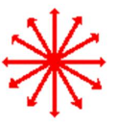
Unpolarized light.

But if the direction of the electric field fluctuation (or the magnetic field) is limited to a specific direction it is said that this wave is polarized. In practice, it is agreed In any direction of the electric field in an electromagnetic wave is the determinant of the direction of polarization.
Some terms
Polarizer:
It is a device for converting unpolarized light into polarized light.
Transmission axis:
It is that axis in the crystal that, if the light falls on it (toward it), is transmitted executed with little or no loss.

Optical axis:
It serves as an axis of symmetry for the shape of the crystal. It is that axis (the direction) in the crystal which, if the light falls on it in the same direction, the ordinary rays (o) and extraordinary rays (e) have the same speed in this direction.
Ideal polarizer:
Linearly polarized light is allowed to completely pass through it, and polarized light is completely blocked in a direction perpendicular to the transmission axis.

Types of Polarization
Following are the three types of polarization
- Linear polarization
- Circular polarization
- Elliptical polarization
Polarization methods
There are several methods for polarizing an electromagnetic beam (for example light):

- Polarization by Reflection:
When light falls on a shiny surface with a specific refractive index, it is at a special angle that the reflected and refracted ray are polarized, and this angle is called the angle of polarization. And in honor of the scientist Brewster, who discovered that the reflected and refracted ray are perpendicular, this angle was called the Brewster angle.

Brewster angle is the angle of incidence to the surface where the reflected ray is completely linearly polarized.

Only about 8 percent of incident light is reflected from a glass surface at the polarizing angle. by using a bundle of thin glass plates, say seven or eight, the intensity of the reflected beam may be increased to about 40 percent of incident light. This light is all linearly polarized, with the direction of vibration parallel to the glass surfaces.
A small percentage of the light will be absorbed by the glass plates, and the remainder will be transmitted. if the number of reflecting surface is large , the transmitted beam will consist principally of light whose direction of vibration is perpendicular to the reflecting surface.
Where $(n=tan θ_{p})$., n=refractive index , $θ_{p}$= Brewster angle.

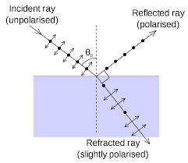

1
2

r

Ex: Prove that the refractive index is equal to the tangent of the angle of polarization $(n=tan θ_{p})$.
$$\hat{1}+\hat{2}={90}^{°}$$
$$(90- \hat{i})+(90-\hat{r})={90}^{°}$$
$$- \hat{i}-\hat{r}={-90}^{°}$$
$$\hat{i}+\hat{r}={90}^{°}$$
$$\hat{i}={90}^{°}-\hat{r}$$
$$sin \hat{i}=sin ({90}^{°}-\hat{r})$$
$$sin \hat{i}=cos \hat{r}$$
From Snell law
$$n_{1} sin i= n_{2} sin r$$

If we assume that $n_{1}$ for air equal to (1) and $n_{2}$ for glass equal to (n)
$$n=\frac{sin i}{sin r}$$

$$n=\frac{sin i}{sin (90-i)}$$

$$n= \frac{sin i}{cos i}$$

$$n=tan i$$

$$n=tan i=tan θ_{p}$$

Ex: Find the Brewster angle for the water if it has its refractive index 1.33.
$$i= θ_{p}= \tan^{-1} 1.33={53}^{°}$$

- Polarization by Double Refraction
Physical media can be classified as follows: Isotropic materials, which are substances that have the same distribution of molecules. Examples include gases and liquids, where the speed of light is constant within these materials and does not depend on the direction inside the crystal. Anisotropic materials, which are materials in which the distribution of particles is different and not equal, in addition to a difference between the tensile and bonding forces of two materials. An example of these materials is the calcite crystal, in such crystals, the light varies with the velocity inside them in different directions.
When a narrow beam of unpolarized light is sent through certain transparent crystals, such as calcite and quartz, the refracted beam is split in to two parts which travel through the crystal and emerge as two separate beams, as shown . when an object is viewed through such a crystal, two separate images are seen.

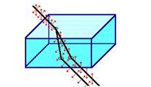

These two rays, one of them follows Snell’s law called (ordinary ray (o-ray)) and the other one does not follow Snell’s law called (extraordinary ray (e-ray)) . Note that the two rays are polarized, the first (o-ray) perpendicular to the plane of the paper, it has a single velocity in a crystal and the other (e-ray) parallel to the plane of the paper, it has several different speeds for different directions . Since the incident ray produces two rays inside the crystal, this means that there are two refractive index (n_{o}, n_{e}) in this crystal, which means that there is two speed of light inside crystal. Why?

- Polarization by Selective Absorption

There are some crystalline materials that have a special characteristic that depends on their crystalline form, as they penetrate light in one plane of polarization and absorb it in other planes of polarization. This means that one of the two compounds perpendicular to normal light absorbs and the other penetrates, and some organic compounds may show the characteristic of duality, and tourmaline is the most famous of them.
In a tourmaline crystal, there is an optical axis in a certain direction, and this axis is determined by the atomic structure of the crystal. When a light beam falls on the tourmaline crystal, the electric field component perpendicular to the optical axis of the crystal will absorb it, while the compound parallel to the optical axis will pass easily and as the thickness of the crystal is greater, the selective absorption completely.
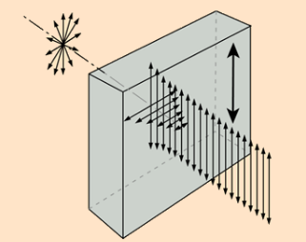

- Polarization by Scattering
When an unpolarised ray of light travels through a medium, it undergoes scattering. The medium is composed of many atoms and a ray of light contains a number of light photons. When a light ray strikes the atoms in the medium, they transfer their energy to the atoms, and as a result, the electrons in the atoms are set for vibration. These vibrating electrons emit electromagnetic radiation (in the visible range i.e., light) in all directions. These radiations strike neighbouring atoms and the electrons there also undergo a similar mechanism. The radiation emitted by them will have the same frequency as the incident radiation. This mechanism keeps propagating throughout the medium. This absorption and remission of light radiation cause scattering of light in the medium. The scattered light will have completely polarised light, partially polarised light and completely unpolarised light, depending upon the direction of emitted radiation
The light we get from the sun travels through the vacuum before reaching the earth’s atmosphere. Earth’s atmosphere enfolds several layers. Each layer contains air molecules. The light wave radiated from the sun is unpolarised. Once it reaches the Earth’s atmosphere it undergoes scattering. As they are transverse in nature, they vibrate air molecules perpendicular to the direction of their propagation. As a result, electrons in the air molecules start emitting radiation in the form of light in many directions. Refer to Figure below for better visualization. These light are polarised in the direction perpendicular to the direction of propagation of the original ray.
- The emitted rays of light which are parallel to the direction/orientation of original rays are completely unpolarised.
- The emitted rays of light which are perpendicular to the direction of the original rays are completely polarised.
- The rays of light which are scattered in all other directions are partially polarised.
He found the short waves were more scattered than the long waves according to the equation ($I=\frac{1}{λ^{4}}$) Thus, the sunlight we receive is partially polarised. This is also another reason why the sky is blue!

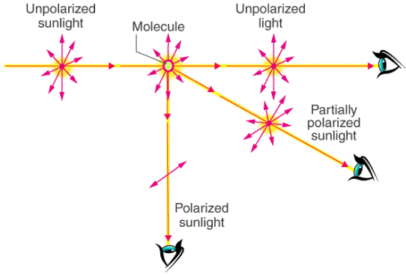

Why is polarization of light important?
Polarization is an important property of light that affects even those optical systems (Optical microscopy, Optical spectroscopy). The polarization of light affects the focus of laser beams, influences the cut-off wavelengths of filters, and can be important to prevent unwanted back reflections. Material science (Photography, sunglasses, 3D movies).

