University of Mosul
College of Science
Department of Physics
Third Stage
Lecture Five

Physical Optics
2024-2025
Lecture Five
Preparation
Dr. Marwa Thamer Al-Shammaa

External and Internal Reflection
When light is reflected on the surface separating two physical media, the phenomenon of reflection can be classified into two states, according the amount of the relative refractive index ($n=\frac{n_{2}}{n_{1}}$).
These two cases are:
- First case: External Reflection: This happens when it is $(n>1)$, that is, when the light falls from the medium of the lowest light density to the medium of the highest light density (for example, "when light falls from the air towards the water). Here, the amplitude of the electric fields is given in terms of the equations in the case of real theta values.
$$r_{s}=\frac{\cos{θ-\sqrt{n^{2}-\sin^{2}θ}}}{\cos{θ+ \sqrt{n^{2}-\sin^{2}θ}}}$$

$$r_{p}=\frac{-n^{2} cos{θ+\sqrt{n^{2}-\sin^{2}θ}}}{n^{2} cos{θ+\sqrt{n^{2}-\sin^{2}θ}}}$$

- Second case: Internal Reflection: This happens when it is $(n<1)$, that is, when light falls from the medium with the highest light density to the medium with the lowest light density (from glass to the air). Using Snell's law, we find that the theta values at which this reversal occur must fulfill the following condition ($θ≥ \sin^{-1}{ n}$)
There is a special value for the theta angle of incidence (($θ$), which corresponds to the angle of refraction in the light medium (90º), and this is called the critical angle ($θ_{crit.}$) and is equal to the magnitude (${θ_{crit.}=sin}^{-1}{ n}$). For example, when light falls from a glass medium into the air, we find that the critical angle is (${θ_{crit.}=sin}^{-1}{\frac{1}{1.5}={41}^{°} }$).

Total Internal Reflection
If the theta value is greater than the critical value, Then the ratio ($\frac{E^{'}}{E}$) becomes a complex number, by reference to the equations:
$$r_{s}=\frac{\cos{θ-\sqrt{n^{2}-\sin^{2}θ}}}{\cos{θ+ \sqrt{n^{2}-\sin^{2}θ}}}$$
$$r_{p}=\frac{-n^{2} cos{θ+\sqrt{n^{2}-\sin^{2}θ}}}{n^{2} cos{θ+\sqrt{n^{2}-\sin^{2}θ}}}$$

we find that the quantity under the square root sign is negative for the values theta. That fulfill the condition (${θ>sin}^{-1}{ n}$), in this range of theta values the values of the reflection coefficients are as follows:
$$r_{s}=\frac{\cos{θ-i\sqrt{{\sin^{2}θ-n}^{2}}}}{\cos{θ+ i\sqrt{\sin^{2}θ-n^{2}}}}$$
$$r_{p}=\frac{-n^{2} cos{θ+i\sqrt{\sin^{2}θ-n^{2}}}}{n^{2} cos{θ+i\sqrt{{\sin^{2}θ-n}^{2}}}}$$
This reflection is known as a total internal reflection, and it is a condition for it (${θ>sin}^{-1}{ n}$) to occur, in this case, it is the magnitude of the reflectivity is 1 (unity) or R = 1…. Prove this.

Optical Fibers
A practical application of the phenomenon of total internal reflection is the process of transmitting the light ray through what is known as an optical fiber.
The optical fiber consists of a cylindrical tube called the core of the fiber, which is made of a transparent material (plastic or glass) to prevent the absorption of light energy during the transmission of light (wave) through it.
This cylinder is completely coated with a layer of an insulating material called the cladding layer. The diameter of the optical fiber is usually about a few microns. In order for the light to remain trapped inside the core of the fiber, the refractive index of the core material $(n_{1})$ must be greater than the refractive index of the cladding layer material ${(n}_{2})$, and the light must fall on the surface separating the core and the cladding at an angle greater than the critical angle. This condition requires that the light enter the fiber’s aperture at a specific angle called the acceptance angle. Half the angle of the cone head is equal to the light rays emitted from the source $(2α)$whose base is the window of this fiber.
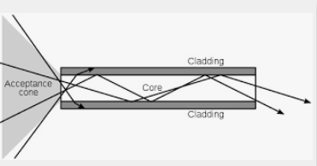
n₂
n₁

To find an angle ($α$) , we apply Snell's law twice.
First, at the surface separating between the air and the material core of the fiber, where we find that:
$$1× sin α= n_{1} cosϕ_{1} =n_{1} \sqrt{1-\sin^{2}ϕ_{1}}$$
Second, at the surface separating between the core and cladding layer material in the case of the critical angle, i.e.
$$n_{1} sin ϕ_{1} =n_{2} sin 90$$
$$sin ϕ_{1}=\frac{n_{2}}{n_{1}}$$
$$sin α=\sqrt{n_{1}^{2}-n_{2}^{2}} → α=\sin^{-1}{\sqrt{n_{1}^{2}-n_{2}^{2}}}$$
Called the magnitude $\sqrt{n_{1}^{2}-n_{2}^{2}}$ ( Numerical Aperture NA).
Example:
If the refractive index of the fiber core material and the cladding are equal (1.55,1.53) respectively. Find the angle of acceptance of the light rays for this fiber, and then find the numerical aperture for it.

$$α=\sin^{-1}{\sqrt{{(1.55)}^{2}-{(1.53)}^{2}}}=14.37 °$$
$$NA=\sqrt{{(1.55)}^{2}-{(1.53)}^{2}}=0.248$$

Brewster Angle
By referring to the equation that gives the ratio between the electric field amplitudes of the reflected wave and the incident in the case of polarization of the magnetic transverse wave (TM)
$$r_{p}=\frac{-n^{2} cos{θ+\sqrt{n^{2}-\sin^{2}θ}}}{n^{2} cos{θ+\sqrt{n^{2}-\sin^{2}θ}}}$$
we find that the reflection coefficient ($r_{p}$) is equal to zero if the following condition is fulfilled:
$$-n^{2} cos{θ=\sqrt{n^{2}-\sin^{2}θ}}$$
By solving this equation, we determine that:
$$θ= \tan^{-1}{n}$$
This angle that satisfies this condition is called the Brewster angle. For example, in the case of the external reflection of light (from air to glass), the magnitude of the Brewster angle is as follows:
$$θ_{Brewster}= \tan^{-1}\left(1.5\right)=57°$$
In the case of internal reflection (from glass to air), this angle is as follows:
$$θ_{Brewster}= \tan^{-1}\left(\frac{1}{1.5}\right)=33°$$

The magnitude of the Brewster angle varies with the wavelength of the incident ray, due to the phenomenon of chromatic dispersion in the glass medium.
When an unpolarized ray of light falls on a separating surface at an angle equal to that of Brewster, the reflected ray is Linearly polarized, so that the electric field vector of the reflected wave is transverse with the plane of incidence, and the transmitting ray is Partly polarized. In practice, this technique (peristaltic angle reflection) can be used to obtain polarized light, but The intensity of this reflected light is weak (if it falls from the air into the glass, only 15% of the light intensity is reflected), which makes this technique ineffective compared to other techniques. by using a bundle of thin glass plates, say seven or eight, the intensity of the reflected beam may be increased to about 40 percent of incident light. This light is all linearly polarized, with the direction of vibration parallel to the glass surfaces$V=\frac{m}{n+\left(\frac{2n}{1-n^{2}}\right)}$
V = The degree of polarization strength
m = Number of panels.
Q1: Find the Brewster angle of the external reflection in the water, the refractive index of the water is equal 1.33?
Q2: Find the Brewster angle of the internal reflection in the water, the refractive index of the water is equal 1.33?

The Evanescent wave in Total Reflection
In the case of total internal reflection, it can theoretically be said that the incident electromagnetic wave on the separating surface (from when light falls from the medium with the highest light density to the medium with the lowest light density) is fully reflected, if the angle of incidence is greater than the critical angle. But in practice, there is still an electric field present behind the boundary or separating medium, this wave in the lowest density medium is called the evanescent wave (vanishing wave).
This can be demonstrated mathematically as follows:
Assume that the electric field vector of the transmitted wave in the lowest medium (behind the separating surface) is as follows:

$E_{trans.}={E''}_{ }exp{i(\overset{⃑}{k''}.\overset{⃑}{r}- ωt)}$… transmitted wave ( refracted wave).
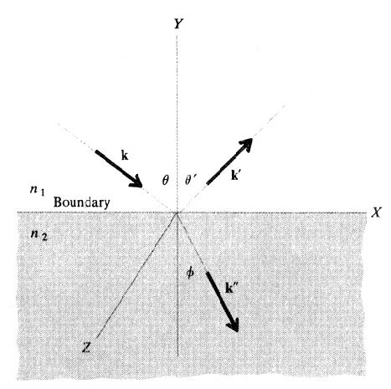
Represent reflection and refraction in the Cartesian plane.

${E''}_{ }$ : constant electric field vector amplitude.
$k''$: propagation coefficient
$\overset{⃑}{r}$ : position vector
$ω:$angular frequency
$t$: time
Now splitting this $\left(k^{''}\right)$ into components which is $({k''}_{x}$) and $({k^{''}}_{y})$ and we are ignoring the $({k^{''}}_{z})$ term because $({k^{''}}_{z})$ is coming out of this plane and this does not affect anything that is happening on this plane so we ignore it so we get the relation:
$$E_{trans.}=E^{''}exp{i({k^{''}}_{x}x + {k^{''}}_{y}y)- ωt)}$$
$${k^{''}}_{x}= k^{''}\sin{∅}$$
${k^{''}}_{y}= k^{''}\cos{∅}$
$$E_{trans.}= E^{''}exp{i(k^{''}x sin{∅} + k^{''}y cos{∅})- ωt)}$$

$\cos{ϕ=\sqrt{1- \frac{\sin^{2}{θ }}{n^{2}} }}$= $i\sqrt{\frac{\sin^{2}{θ }}{n^{2}}-1 }$
$n=\frac{\sin{θ}}{\sin{ϕ}}$, $\sin^{2}ϕ= \frac{\sin^{2}{θ}}{n^{2}}$
$${1-cos}^{2}ϕ= \frac{\sin^{2}{θ}}{n^{2}} \overset{⇒}{} \cos^{2}ϕ= 1-\frac{\sin^{2}{θ}}{n^{2}}$$
$$\cos{ϕ=\sqrt{1- \frac{\sin^{2}{θ}}{n^{2}}}}$$

Note that the amount of $\cos{∅}$ is equals an imaginary quantity in the case of total internal reflection. The wave function of the electric field vector in the transmitted wave is as follows:
$$E_{trans.}=E^{''}exp{-α\left|y\right| }\exp{i(k_{1}x - ωt)}$$

$$α= k^{''}\sqrt{\frac{\sin^{2}{θ }}{n^{2}}-1 }$$
$$k_{1}= k^{''}\frac{\sin{θ}}{n}$$
The parameter $\exp{-α\left|y\right|}$ represents the amplitude of the vanishing wave at a depth of y in the light medium, and we note that this amplitude decreases exponentially as the amount of penetration in this medium increases. As for the complex exponential function, it means that this vanishing wave can be described in terms of constant phase surfaces and moving with a phase velocity, and we note that this velocity is greater than the phase velocity of the incident plane wave by an amount equal to $(\frac{1}{\sin{θ}})$.
The evanescent field, or evanescent wave, is an oscillating electric and/or magnetic field that does not propagate as an electromagnetic wave but whose energy is spatially concentrated in the vicinity of the source.
The physical nature of an evanescent wave–an electromagnetic wave traveling parallel to the interface of two material with different refractive indices, but decaying exponentially in amplitude with respect to distance into the medium of lower index of refraction.
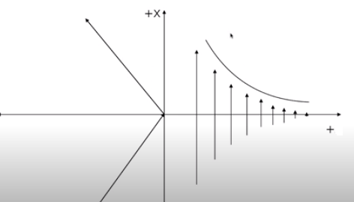

y
n₁
n₂

The evanescent wave in total reflection

