University of Mosul
College of Science
Department of Physics
Third Stage
Lecture Four

Physical Optics
2024-2025
Lecture Four
Preparation
Dr. Marwa Thamer Al-Shammaa

Reflection and Refraction at a Plane Boundary
In this section, we deal with proving the laws of reflection and refraction from the point of view that light represents an electromagnetic wave. Suppose A plane harmonic wave falls on a flat surface separating two different physical media (as in Figure below). When this incident wave reaches this surface, it is split into a reflected wave and a wave penetrates into the second medium (transmitted wave).
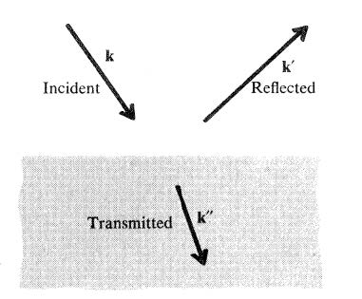
The behavior of a plane wave that falls on a surface separating two media

The space-time dependence of these waves can be expressed in the following forms:
$\exp{i(\overset{⃑}{k}.\overset{⃑}{r}- ωt)}$... incident wave.
$\exp{i(\overset{⃑}{k'}.\overset{⃑}{r}- ωt)}$… reflected wave.
$\exp{i(\overset{⃑}{k''}.\overset{⃑}{r}- ωt)}$… transmitted wave ( refracted wave).
So that there is a constant relationship for all points on the surface between the two medians and for all values (t), all of these exponential functions must be equal, and since the time factor is the same, so this leads to the following:
$k.r=k^{'}.r=k^{''}.r$ ….. (1)
This means that the propagation vectors of these three waves $(k, k^{'}, k'')$ lie in one plane (coplanar). This is known in light as the first law of reflection [The incident ray, the reflected ray and the column on the reflecting surface from the point of incidence are all in one plane perpendicular to the reflecting surface].
Suppose that the incidence point on the separating surface represents the point of origin of the Cartesian axes (oxyz) and the separating surface is represented by the plane (xz), such that it ($k$) lies in the plane (xy) this is called the plane of incidence as shown in figure blew.
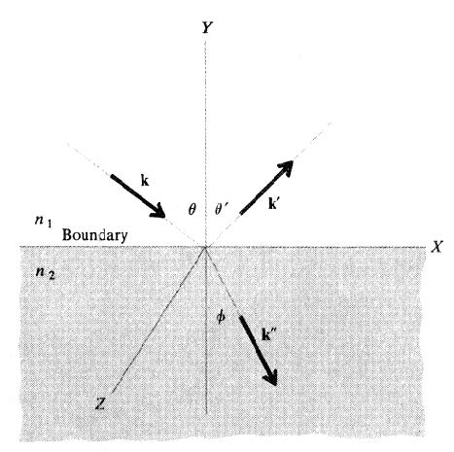
Represent reflection and refraction in the Cartesian plane.

Suppose the angles between the perpendicular to the separating surface (y-axis) and the propagation vectors of these waves are (θ, θ′, ϕ) and since the projections of propagation vectors at the separating surface in the direction of (x-axis) are equal. So the equation (1) becomes as follows:
$k\sin{θ}=k^{'}\sin{θ'}=k^{''}\sin{ϕ}$ ….. (2)
Since the incident wave is in the same medium as the reflected wave ($k=k'$) so that:
$θ=θ'$
[This is known as the second law of reflection in light].
The ratio between the two magnitudes of the propagation vectors of the transmitted wave and the incident wave, we obtain the following:
$$\frac{k''}{k}=\frac{w/{u''}}{w/u}=\frac{c/{u''}}{c/u}=\frac{n_{2}}{n_{1}}=n$$
$$n= Relative refractive index$$
Using the second part of equation (2), we get the following:
$\frac{k''}{k}=\frac{\sin{θ}}{\sin{ϕ}}=$ $\frac{n_{2}}{n_{1}}=n$
This relationship is known as Snell's Law.

Amplitudes of Reflected and Refracted Waves
Suppose that (E) the amplitude of the electric field of the incident wave is on the surface separating the two medium in the previous section. E′, E′′ The amplitude of the electric field of the reflected and the refracted wave, respectively.
We find that the amplitude of the magnetic field for these waves is as follows:
$H=\frac{1}{μ ω}k× E$ ... incident
$H'=\frac{1}{μ ω}k'× E'$ ... reflected
$H''=\frac{1}{μ ω}k''× E''$ … refracted
Practically, there are two states of polarization for the incident wave, namely:
- Transverse polarization electrically and symbolized by it TE- Polarization, Where the electric field vector in the incident wave is parallel to the plane of the separating surface (or perpendicular to the plane of incidence).
- Transverse polarization magnetically and symbolized by it TM- Polarization, Where the magnetic field vector in the incident wave is parallel to the plane of the separating surface (or perpendicular to the plane of incidence).

Figure below shows the directions of the electric and magnetic fields in the two states of the polarization of the incident wave and the change of these directions at the surface separating the two mediums, in the reflected wave and transmitted wave.
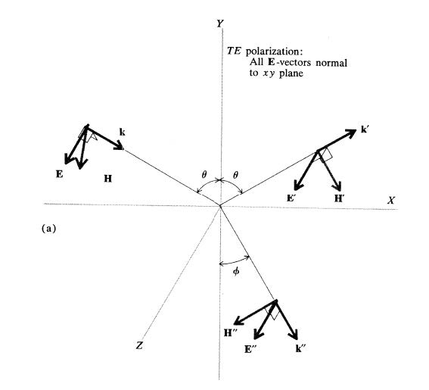
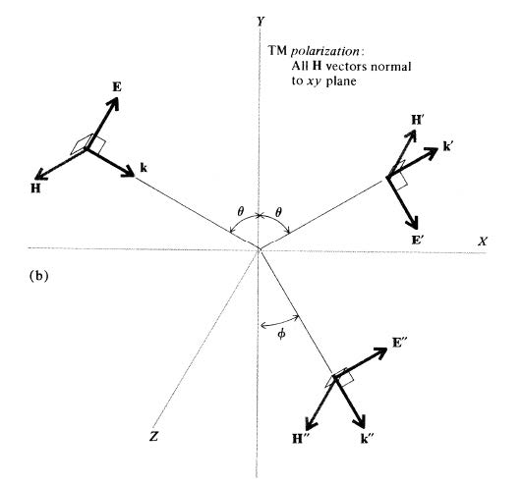
Wave vectors for the two states of polarization
(a)Transverse electrically (b) Transverse Magnetically

Suppose that (xz) is the plane of the separating surface, (y-axis) is perpendicular to this surface. Accordingly, (xy) is plane of the incident. When applying boundary conditions on electric and magnetic fields, which is that tangential compounds of an electric field are continuous at the surface separating the two medium. Therefore, in the case of an electrically transverse wave, we find that:
TE- Polarization
$$E+E^{'}=E''$$
$$-H\cos{θ}+H^{'}\cos{θ}={-H}^{''}\cos{ϕ}$$
$$-k E\cos{θ}+k^{'}E'\cos{θ}={- k''E}^{''}\cos{ϕ}$$
In the case of a magnetically transverse wave, they are tangential compounds of an magnetic field are continuous.
TM- Polarization
$$H-H^{'}=H''$$
$$k E-k^{'}E^{'}=k^{'}'E^{''}$$
$$E\cos{θ}+E'\cos{θ}=E^{''}\cos{ϕ}$$
To find the reflection coefficients, suppose that an electrically or magnetic transverse wave falls on a surface separating two physical mediums. The ratio between the electric field amplitudes of the reflected wave and the incident is called the reflection coefficient.
$r_{s}={\left[\frac{E^{'}}{E}\right]}_{TE}$ … reflection coefficient of the electrically transverse wave .
$r_{p}={\left[\frac{E^{'}}{E}\right]}_{TM}$ ... reflection coefficient of the magnetically transverse wave.
$t_{s}={\left[\frac{E^{''}}{E}\right]}_{TE}$… transition coefficient of the electrically transverse wave .
$t_{p}={\left[\frac{E^{''}}{E}\right]}_{TM}$… transition coefficient of the magnetically transverse wave .

These coefficients can also be expressed in terms of angles of incidence and refraction as follows:
$r_{s}=\frac{\cos{θ-n\cos{ϕ}}}{\cos{θ+n\cos{ϕ}}}$…(3)
$r_{p}=\frac{-n cos{θ+\cos{ϕ}}}{n cos{θ+\cos{ϕ}}}$ …(4)
Where $n=\frac{n_{2}}{n_{1}}$
A special case if the incident is vertical:
$$r_{s}=r_{p}= \frac{1-n}{1+n}$$
Whether the sign of these quantities is negative or positive depends on (n) whether they are greater than one or less than one. A negative value means that the phase of the reflected wave changes (180 degrees) relative to the incident wave. [A wave of light traveling in the air and reflected off a glass surface will have a phase change of 180 degrees].
Fresnel Equations
Using Snell's law [$n=\frac{\sin{θ}}{\sin{ϕ}}$] , The two equations ($r_{s},r_{p}$) can become as follows:
$$r_{s}=-\frac{\sin{(θ-ϕ)}}{\sin{(θ+ϕ)}}$$
$$t_{s}=\frac{2 cos θ sin{ϕ}}{\sin{(θ+ϕ)}}$$
$$r_{p}=- \frac{\tan{(θ-ϕ)}}{\tan{(θ+ϕ)}}$$
$$t_{p}=\frac{2 cos θ sin{ϕ}}{\sin{(θ+ϕ)} \cos{(θ-ϕ)}}$$
The above equations are called Fresnel’s equations

Equations (3,4) can also be converted into other mathematical forms, by using Snell's law to remove the variable ($ϕ$) (angle of refraction) from those equations. These pictures are as follows:
$$r_{s}=\frac{\cos{θ-\sqrt{n^{2}-\sin^{2}θ}}}{\cos{θ+ \sqrt{n^{2}-\sin^{2}θ}}}$$
$r_{p}=\frac{-n^{2} cos{θ+\sqrt{n^{2}-\sin^{2}θ}}}{n^{2} cos{θ+\sqrt{n^{2}-\sin^{2}θ}}}$
$n=\frac{\sin{θ}}{\sin{ϕ}}$, $\sin^{2}ϕ= \frac{\sin^{2}{θ}}{n^{2}}$
$${1-cos}^{2}ϕ= \frac{\sin^{2}{θ}}{n^{2}} \overset{⇒}{} \cos^{2}ϕ= 1-\frac{\sin^{2}{θ}}{n^{2}}$$
$$\cos{ϕ=\sqrt{1- \frac{\sin^{2}{θ}}{n^{2}}}}$$

Reflectivity
It is defined as that reflected part of the incident light energy and symbolized by symbol ($R_{s }, R_{p}$) the polarization $TE, TM$ respectively.
Since the energy is directly proportional to the square of the field amplitude, we get:
$$R_{s }={\left|r_{s }\right|}^{2}= {\left|\frac{E'}{E}\right|}_{TE}^{2}$$
$$R_{p }={\left|r_{p }\right|}^{2}= {\left|\frac{E'}{E}\right|}_{TM}^{2}$$
A special case if the incident is vertical:
$R_{s }=R_{p }={\left[\frac{n-1}{n+1}\right]}^{2}$
Ex 1: Find the reflectivity of a light wave as it falls vertically from the air on a
glass separator surface?
$$n=\frac{n_{2}}{n_{1}}=\frac{1.5}{1}=1.5$$
$$R_{s }=R_{p }={\left[\frac{n-1}{n+1}\right]}^{2}$$
$$R_{s }=R_{p }={\left[\frac{1.5-1}{1.5+1}\right]}^{2}=0.04=4\%$$

This means that the intensity of the reflected wave is equal to 4% of the intensity of the wave transmitted to the glass medium.

