University of Mosul
College of Science
Department of Physics
Third Stage
Lecture Seven

Physical Optics
2024-2025
Lecture Seven
Preparation
Dr. Marwa Thamer Al-Shammaa

$$y= \frac{n λ x}{h} ;n=0,∓1,∓2, ……. Bright fringe$$
$$y=\left(n+\frac{1}{2}\right)\frac{ λ x}{h} ;n=0,∓1,∓2, ….. Dark fringe$$

Phase: The argument of sine or cosine in the expression for displacement of wave is defined as the phase.
$$E=E_{ }\exp{i\left(k. r- ωt+ϕ\right)}$$
Phase difference: The difference between the phases of two waves at a point is called phase difference.
$$E_{(1)}=E_{1 }exp i(k_{1}. r- ωt+ϕ_{1})$$
$$E_{(2)}=E_{2 }exp i\left(k_{2}. r- ωt+ϕ_{2}\right)$$
$$(ϕ_{1}-ϕ_{2}) ……. phase difference$$
Path difference: The difference in path lengths of two waves meeting at a point is called path difference.
Path difference = $\frac{λ}{2π} {(ϕ}_{1}-ϕ_{2})$
Time difference: The time difference between the waves meeting at a point.
Time difference = $\frac{T}{2π} {(ϕ}_{1}-ϕ_{2})$

Types of interference:
Contractive interference | Destructive interference
When the two waves meets a point with same phase (i.e. maximum light). | When the two waves meets a point with opposite phase (i.e. minimum light).
The path difference = $n λ$ | The path difference = $(n+\frac{1}{2}) λ$
The phase difference between the waves at the point of observation = 0º or $2n π$ n=0,1,2…. | The phase difference between the waves at the point of observation = 180º or $(2n+1) π$ n=0,1,2….
All fringes are of same width $ẞ= \frac{ λ x}{h}$ | All fringes are of same width $ẞ= \frac{ λ x}{h}$
All fringes are of same intensity. | All fringes are of same intensity.
Position of nth maxima  $$y_{n(Bright)}= \frac{ n λ x}{h}$$ | Position of nth minima  $$y_{n(Dark)}=(n+\frac{1}{2}) \frac{ λ x}{h}$$

- The central fringe is always bright.
- If the slit widths are unequal, the minima will not be complete dark. For every large width uniform illumination occurs.
- If one slit is illuminated with red light and the other slit is illuminated with blue light, does interference occur and why?

Alternative ways to see interference patterns:
After Young's experiment, several experimental designs were developed to obtain interference patterns. These devices are considered to be Young's experiment simulators to get two coherence sources, so that the original source is one of the two sources, while the other source is the imaginary image of the first source, which is formed by reflection or refraction.

Some objected Young’s Experiment result and said that: “the bright fringes
were probably due to some complicated modification of the light by the
edges of the slits and not interference” Fresnel did new experiments to prove
that they were interference. S is the real source, and the other S′s are virtual.

- Lloyd’s Mirror:
Where the first ray falls from the source directly to the screen, while another ray from the same source falls on the mirror and this ray is reflected to reach the screen, forming an imaginary image of the real source. These two rays, coming from the real source and the imaginary source, overlap on the screen at the point. Let us obtain the interference pattern, as in the case of Yung's experiment. The mathematical treatment to determine the locations of the maximum intensity is as in Young’s experiment, but in this case the change in the phase of the second reflected ray (π) (from air to the separation surface) and its amount must be taken into account.
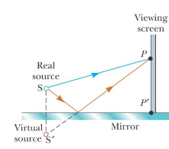

Diagram of Lloyd’s Mirror experiment.

The central point (P′) is dark because of the phase difference (π) (path difference $\frac{λ }{2}$) of the reflecting wave.
Interference Pattern from the Lloyd’s Mirror An interference pattern is formed The positions of the dark and bright fringes are reversed relative to pattern of two real sources this is because there is a 180° phase change produced by the reflection.
$$y_{n(Bright)}=(n+\frac{1}{2}) \frac{ λ x}{h}$$

$$y_{n(Dark)}= \frac{ n λ x}{h}$$
$$ẞ= \frac{ λ x}{h}$$
- Fresnel’s Mirrors:
Here, Fresnel used two mirrors. Light from a slit S is reflected (not refracted) from two plane mirrors slightly inclined to each other. The mirrors produce two virtual images of S.
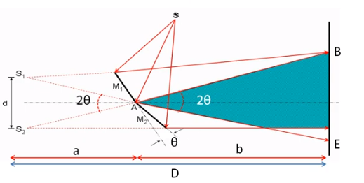

Diagram of Fresnel’s Mirrors experiment.

$$y_{n(Bright)}= \frac{ n λ D}{d}= \frac{ n λ(a+b) }{2θa}$$

- The Fresnel biprism
It consists of two identical prisms that have a small head angle and their common base. The prism refracts the light coming from the slit to form two
virtual images sources .
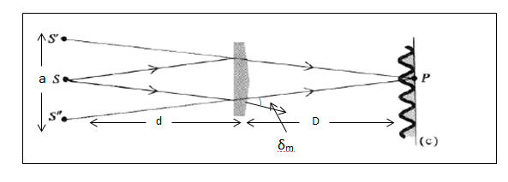

Diagram of Fresnel biprism experiment.

Since the head angle is small, the smallest deflection angle (δ_{m}) can be expressed by the relationship (δ_{m}= θ (n-1) ) where (θ) is the head angle and (n) is the refractive index of the prism.

$$y_{n(Bright)}= \frac{ n λ (d+D)}{a}= \frac{ n λ(d+D) }{2d δ_{m}}=\frac{ n λ(d+D) }{2d θ(n-1)}$$

Q1/ In Lloyd’s Mirror the source and its image is (20 cm) from the left side of mirror, the length of the mirror is (30 cm), the screen is in the contact with right edge of the mirror. Find the distance from the central minima to the 1st maxima on the screen, where the virtual length between the source of the mirror s=is (0.2 cm) and λ=720nm.

