University of Mosul
College of Science
Department of Physics
Third Stage
Lecture Six

Physical Optics
2024-2025
Lecture Six
Preparation
Dr. Marwa Thamer Al-Shammaa

Coherence and Interference:
In this chapter, we will discuss the principles of interference between waves propagating in the medium, and we will study practical experiments and devices that depend on it in her work on the phenomenon of interference. We also explain the concept of coherence between waves and the types of this coherence.
The Principle of Linear Superposition:
The theory of optical interference is based on the principle of linear superposition of electromagnetic fields. The rule of linear superposition states the following:
The generated electric field of several different electric fields that meet at a point in space is equal to the vector sum of these fields. (When two or more waves are present simultaneously at the same place, the resultant disturbance is the sum of the disturbances from the individual waves). It is expressed mathematically as follows:
$$E=E_{(1)}+ E_{\left(2\right)}+E_{\left(3\right)}+… …(1)$$
$E$ : represent the resultant electric field vector.
$E_{(1)},E_{(2)},E_{(3)}$: represent the superimposed electric fields vectors.
This principle also applies in the case of magnetic fields.
Let us consider two linear harmonic waves and linearly polarized, having the same frequency, where the electric field vector for each of them is expressed by the following relationship:
$E_{(1)}=E_{1 }exp i(k_{1}. r- ωt+ϕ_{1})$
$$E_{(2)}=E_{2 }exp i\left(k_{2}. r- ωt+ϕ_{2}\right) …(2)$$
If the phase difference between these two waves is a constant, or
$$ϕ_{1}-ϕ_{2}=constant$$

We say that the sources of these two waves are in state mutually coherent, in this section, we will present an analysis of this type of mutually coherent.
As explained in a previous section, the irradiance is proportional to the square of the wave amplitude of the electric field at a point in the medium. Accordingly, the rule of superposition of the two waves (equation 2) gives a irradiance function as follows:
$$I={\left|E\right|}^{2}=E.E^{*}= {(E}_{\left(1\right)}+ E_{\left(2\right)}).(E_{\left(1\right)}^{*}+E_{\left(2\right)}^{*})$$
$={\left|E_{1}\right|}^{2}+{\left|E_{2}\right|}^{2}+2E_{1}.E_{2}\cos{θ}$
$${ =I}_{1}+I_{2}+ 2E_{1}.E_{2}\cos{θ …(3)}$$
Whereas:
$θ= k_{1}. r-k_{2}. r+ϕ_{1}-ϕ_{2 } …(4)$
In equation (3) the term $(2E_{1}.E_{2}\cos{θ})$ know the interference term, This limit indicates that the amount of intensity may be less or greater than the amount ($I_{1}{+I}_{2}$), and this difference depends on a value ($θ$), and since this value depends on the vector of the location of the point ($r$), it results in periodic spatial changes in the amount of radiative intensity obtained. Accordingly, these changes appear in the form of the called fringes interfering (the result of the union of two mutually coherent light beams as explained later).
But if the two sources of the waves are mutually incoherent, meaning that the amount of the phase difference ($ϕ_{1}-ϕ_{2}$) changes randomly with time, then no interference pattern is seen. That is, no interference occurs if non-polarized light sources are used. Also, no interference pattern is seen if the polarization of the two sources is perpendicular, i.e. ($E_{1}.E_{2}^{*}=0$).
Coherence source: The sources of light which emits continuous light waves of the same frequency, same wavelength and in same phase or having a constant phase difference are called coherence source.
Interference phenomena: When two waves of exactly same frequency (coming from two coherent sources) travels in medium, in the same direction simultaneously then due to their superposition, at some points intensity of light is maximum while at some other points intensity is minimum. This phenomenon is called interference of light.
Young Experiment:
In 1882, the scientist Thomas Young conducted the first experiment to obtain an interference pattern, where he used a light source placed behind a barrier with a pinhole in order to obtain a point source that emits a spherical wave to propagate behind this barrier and then this wave falls on a barrier with two narrow slits, namely S₁ and S₂. These two slits become sources of coherence waves, according to Huygens' theory because they are located on the same front of the spherical wave. A screen is placed behind this barrier and at a distance from its, so that the light waves overlap at the points located in the plane of the screen, and this results in the interference pattern on the image of the two narrow slits on this screen. Meaning, if these two slits are rectangular in shape, the interference pattern will be in the form of light and dark bands, respectively, and they are called interference fringes.
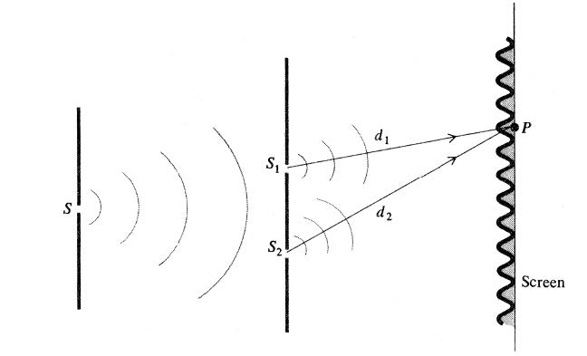
Geometric arrangement of Yung's experiment

Huygens Principle: named after the Dutch physicist Christian Huygens, is a hypothesis that allows the explanation of physical phenomena associated with the propagation of waves, especially light ones, and is formulated as follows: “Each point of the wave front acts as a source and center for a new wave, and the following behavior of the wave front is determined by summing the small waves emanating from the points of the front. wave in the previous moment.

Mathematical analysis of the results of the Young's experiment:
Suppose that the two waves from the two sources S₁ , S₂ overlap at the point (P) on the screen. Suppose this point is far from the two sources d₁,d₂. And therefore, the phase difference between the two interfering waves is as follows:
Referring to the equation (3), we find that the resulting intensity of the superposition of the two waves is great if the following condition is met:
$$k\left(d_{2}-d_{1}\right)=∓2nπ …(5)$$
where (n) the integer, as $(k=\frac{2π}{λ})$, the equation (5) becomes:
$$\left|d_{2}-d_{1}\right|=n λ …(6)$$
Physically, at any point on the screen, there is a maximum intensity (bright fringe) and this interference is called constructive interference, and a condition for obtaining this type of interference is that the geometric path difference between that point and the two sources is equal to an integer number of wavelengths. This condition can be expressed in terms of the geometric variables given in the experiment as follows:

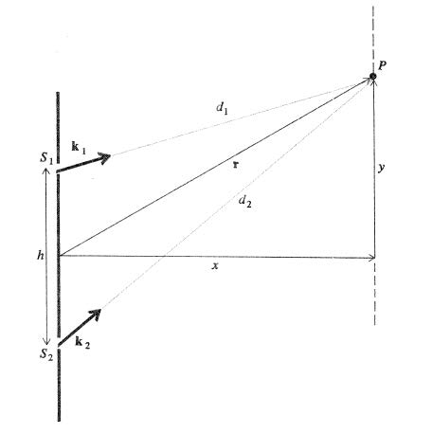
Geometric parameters in Young's experiment.

suppose that (h = the distance between the two slits), (x= the distance between the screen and the two slits), (y= the vertical distance of point P from the central horizontal axis). Using the Pythagorean theorem, we transform equation (6) into the following form:
$${\left[x^{2}+{\left(y+\frac{h}{2}\right)}^{2}\right]}^{1/2}- {\left[x^{2}+{\left(y-\frac{h}{2}\right)}^{2}\right]}^{1/2}=nλ …(7)$$
assuming that $x≫y,h$ , equation (7) can be simplified by using the following approximation:
$${\left[x^{2}+{\left(y+\frac{h}{2}\right)}^{2}\right]}^{1/2}=x{\left[1+{\left(\frac{y+h/2}{x}\right)}^{2}\right]}^{1/2}=x \left[1+\frac{1}{2}{\left(\frac{y+h/2}{x}\right)}^{2}+…\right]$$
Similarly, we find that
$${\left[x^{2}+{\left(y-\frac{h}{2}\right)}^{2}\right]}^{1/2}=x{\left[1+{\left(\frac{y-h/2}{x}\right)}^{2}\right]}^{1/2}=x \left[1+\frac{1}{2}{\left(\frac{y-h/2}{x}\right)}^{2}+…\right]$$
Therefore, equation (7) leads to the following:
$$\frac{yh}{x}=nλ …(8)$$
This indicates that the sites of maximum intensity (bright fringes) are at the following screen points:

$$y= \frac{n λ x}{h} ;n=0,∓1,∓2, …….$$
$$y=0, ∓\frac{ λ x}{h} ,∓\frac{2 λ x}{h} ,……..$$
Notice: n=0 represents the arrangement of the central fringe, n= $∓1$ represents the arrangement of the first bright fringe above and below the central fringe, and so on .....

Q1: Light passes through a barrier with two narrow slits (Young experiment), the distance between them 0.88 mm, an interference pattern is seen on a screen that is distance from this barrier 1.6m and it was also found that the second bright fringe is a distance 2.5 mm from the central line. Find the wavelength of the light used in the experiment?

