University of Mosul
College of Science
Department of Physics
Third Stage
Lecture Ten

Physical Optics
2024-2025
Lecture Ten
Preparation
Dr. Marwa Thamer Al-Shammaa

Plane Harmonic Waves. Phase Velocity
If we use orthogonal coordinates and analyze the wave equations to their components, we will notice that both components ($\overset{⃑}{E}), (\overset{⃑}{H})$ fulfill the following general wave equation:
$$∇^{2}E=\frac{1}{c^{2}}\frac{∂^{2}\overset{⃑}{E}}{{∂t}^{2}}$$
$$\frac{∂^{2} U}{∂x^{2}}+\frac{∂^{2} U}{∂y^{2}}+\frac{∂^{2} U}{∂z^{2}}=\frac{1}{c^{2}}\frac{∂^{2}U}{{∂t}^{2}}$$
The quantity (U) in the equation can represent any component of the two fields: $E_{x}, E_{y}, E_{z}, H_{x},H_{y},H_{z}$.
Waves in one Dimension:
In special case where the spatial change of the quantity (U) is in the direction of a given coordinate. example, toward (Z) axis. In this case, the quantity ${(∇}^{2})$is written as ($\frac{∂^{2} }{∂z^{2}}$) and the equation becomes:
$$\frac{∂^{2}U}{∂z^{2}}=\frac{1}{c^{2}}\frac{∂^{2}U}{{∂t}^{2}}$$
It can be proved that the following equation is a solution to the equation of the above wave :
$U\left(z,t\right)= U_{0 }\cos{(kz}-ωt)$
Provided that the fixed ratio ($ω, k)$ is equal to the fixed quantity (u).
$ω=2π f$, $k= \frac{2 π}{λ}$
This solution is known a plane harmonic wave.
Figure below represents the function$U\left(z,t\right)$ relationship with the distance toward the axis (z). We notice that at a certain time (t) the curve appears as a specific cosine function, and at another moment ($t+∆t$) we notice that the curve as a whole had crawled towards an axis (z) with a distance ($∆z$) where:
$$∆z=u ∆t$$
$∆z$: It is the distance of any two points with the same phase ($p and \grave{p }$, and for this reason it is called phase velocity (phase velocity) $u=\frac{ω}{k}$.
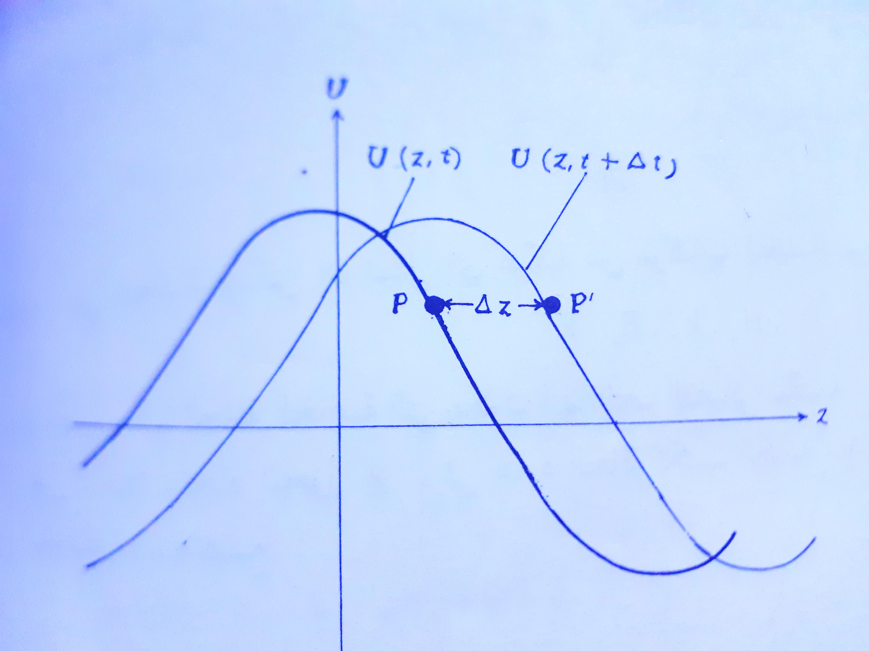

Wave in Three Dimension
We return to the wave equation in three dimensions
$$\frac{∂^{2} U}{∂x^{2}}+\frac{∂^{2} U}{∂y^{2}}+\frac{∂^{2} U}{∂z^{2}}=\frac{1}{c^{2}}\frac{∂^{2}U}{{∂t}^{2}}$$
The solution equation that satisfies the equation of the above wave is:
$U\left(r,t\right)= U_{0 }\cos{(}\overset{⃑}{k}. \overset{⃑}{r}-ωt)$
Where ($\overset{⃑}{r}$) the spatial vector is equal:
$\overset{⃑}{r}=\overset{⃑}{i} x+\overset{⃑}{j} y+\overset{⃑}{k} z$
$$\overset{⃑}{k} :wave vector or propagation vector$$
$$\overset{⃑}{k}= \overset{⃑}{i} k+\overset{⃑}{j} k+\overset{⃑}{k} k$$
Do not forget that the magnitude of the wave vector $\left|\overset{⃑}{k}\right|$ is equal to the wave number k , i.e., that:
$$\left|\overset{⃑}{k}\right|=k= \sqrt{k_{x}^{2}+k_{y}^{2}+k_{z}^{2}}$$
$$\overset{⃑}{k}. \overset{⃑}{r}-ωt=\left(k_{x}x+k_{y}y+k_{z}z\right)-ωt=const.$$
This means that the directions of cosine of fixed-phase planes are proportional to the components of the wave vector $\overset{⃑}{k}$ and are perpendicular to the planes.
$\overset{⃑}{k}$ is propagation vector.
$u=\frac{ω}{k}= \frac{ω}{\sqrt{k_{x}^{2} + k_{y}^{2} +{ k}_{z}^{2}}}$
Group Velocity:
If the simple waves that make up a group are moving at the same speed, then the group will move at the same speed and keep its shape unchanged. But if the velocity changes with the wavelength, then the shape of the shape will change.
We suppose two waves that have the same amplitude ${(U}_{0 })$ but differ in wavelength $λ$ and $λ'$ respectively. That is, their frequency is different, and so is the wave number. Assume that the first wave is its frequency $(ω+∆ω)$and wave number $(k+∆k)$, and the second wave has its frequency $(ω-∆ω)$and wave number $\left(k-∆k\right)$ and go towards (z).
The two waves can be written as follows:
$$U= {U_{0 }e}^{i\left[\left(k+∆k\right)z-\left(ω+∆ω\right)t\right]}+{U_{0 }e}^{i\left[\left(k-∆k\right)z-\left(ω-∆ω\right)t\right]}$$
$$U= {U_{0 }e}^{i(k_{z}-wt)}\left[e^{i\left(∆k_{z}-∆ωt\right)}+ e^{-i\left(∆k_{z}-∆ωt\right)}\right]$$
$$U= e^{i(k_{z}-wt)}. 2 U_{0 }cos(∆k_{z}-∆ωt)$$
$$U= 2 U_{0 }e^{i(k_{z}-wt)}cos\left(∆k_{z}-∆ωt\right)$$
This equation can be interpreted as a simple single wave equation has an amplitude twice the original amplitude and travels at a phase velocity $(u_{p})$ ($2 U_{0 }e^{i(k_{z}-wt)}$), with a modulation envelope $\left(cos\left(∆k_{z}-∆ωt\right)\right)$and travels at a group velocity $(u_{g})$.
$$u_{g}=\frac{∆ω}{∆k}$$
Or differentially $$u_{g}=\frac{dω}{dk}$$
Ex:1/ Express the wave function in one dimension of harmonic waves in terms of a pair of variables:
- In terms of wavelength and frequency ($λ, f$).
$U\left(z,t\right)= U_{0 }\cos{(kz}-ωt)$
$U\left(z,t\right)= U_{0 }\cos{(\frac{2 π}{λ}}z-2 π ft)$
$$U\left(z,t\right)= U_{0 }\cos{2 π( \frac{z}{λ}}- ft)$$
Ex:2 Helium-Neon laser emits light with a wavelength in a vacuum ($λ_{0}=633 nm$). Find the numerical value of the wave number (k) of this light in vacum and in water with a refractive index (n=1.33).
The wave number (k) in vacum
$k= \frac{2 π}{λ}=\frac{2×3.14}{633 nm}$ =0.00992 ($nm$)⁻¹
The wave number (k) in water
$$u=\frac{ω}{k}→ k=\frac{ω}{u}$$
$n=\frac{c}{u}→ u=\frac{c}{n}$ , $ω=2π f$
$$k=\frac{2π f}{\frac{c}{n}}=\frac{2π fn}{c}$$
$$c=λf$$
$$k=\frac{2π fn}{λf}= \frac{2π n}{λ}$$
$k=\frac{2×3.14×1.33}{633 nm}$ =0.013 ($nm$)⁻¹
Ex:3 Derive the following equation:
$u_{g}=u-$ $λ$ $\frac{du}{dλ}$
$u_{g}=\frac{dω}{dk}$ , $u=\frac{ω}{k}$ , $ω=uk$
$$u_{g}=\frac{d(uk)}{dk}$$
$u_{g}=u+k \frac{du}{dk}$ , $k=\frac{2 π}{λ}$= $2 π λ^{-1}$

$$dk=-2 π λ^{-2} dλ=\frac{-2 π dλ}{λ^{2}}$$
$$u_{g}=u+\frac{2 π}{λ} \frac{du}{\frac{-2 π dλ}{λ^{2}}}$$
$u_{g}=u-λ \frac{du}{dλ}$

Ex:4 It is found that the refractive index of some ideal materials is inversely proportional to the wavelength in a vacuum $n =\frac{A}{λ_{0}}$. Prove that the group velocity at a specified wavelength is half the phase velocity. $u_{g}=\frac{u}{2}$
The solution
$$\frac{1}{u_{g}}= \frac{1}{u}- \frac{λ_{0}}{c} \frac{dn}{dλ_{0}}$$
$$\frac{1}{u_{g}}= \frac{1}{u}- \frac{λ_{0}}{c} \frac{d}{dλ_{0}}(\frac{A}{λ_{0}})$$
$$\frac{1}{u_{g}}= \frac{1}{u}- \frac{λ_{0}}{c} (\frac{-A}{λ_{0}^{2}})$$
$$\frac{1}{u_{g}}= \frac{1}{u}+ \frac{A}{c λ_{0} }$$
$$\frac{1}{u_{g}}= \frac{1}{u}+ \frac{n}{c }$$
$$\frac{1}{u_{g}}= \frac{1}{u}+ \frac{1}{u }= \frac{2}{u }$$
$u_{g}=\frac{u}{2}$

Q 2/ Express the wave function in one dimension of harmonic waves in terms of a pair of variables:
- In terms of wavelength and time frequency ($λ, T$).
- In terms of phase velocity and angular frequency ($u, ω$).
- In terms of wavelength and phase velocity ($λ, u$).
Q3: Derive the following equation:
$$\frac{1}{u_{g}}= \frac{1}{u}- \frac{λ_{0}}{c} \frac{dn}{dλ_{0}}$$

Q4:The change of refractive index with wavelength in transparent materials such as glass can be given by relationship (Cauchy equation) $n =A+Bλ_{0}^{-2}$. As the (A,B) are constants and wavelength in a vacuum $λ_{0}$. Find the group velocity at $λ_{0}=500 nm$ and for a specific type of glass it has (A=1.5, B = 3$×{10}^{4} {\left(nm\right)}^{2}$) .

