Lab3:
Centrifuge
A centrifuge is a device used to separate components of a mixture on the basis of their size, density, the viscosity of the medium, and the rotor speed.
Principle 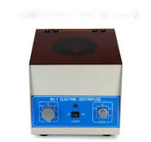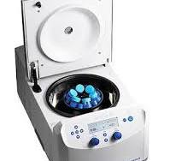
- In a solution, particles whose density is higher than that of the solvent sink (sediment), and particles that are lighter than it floats to the top .
• The greater the difference in density, the faster they move
• If there is no difference in density (isopycnic conditions), the particles stay steady
• A centrifuge is a piece of equipment that puts an object in rotation around a fixed axis (spins it in a circle), applying a potentially strong force perpendicular to the axis of spin (outward)
• The centrifuge works using the sedimentation principle, where the centripetal acceleration causes denser substances and particles to move outward in the radial direction
• At the same time, objects that are less dense are displaced and move to the centerCentrifuge
• The centrifuge is commonly used in laboratories for the separation of biological molecules from a crude extract.
• In a centrifuge, the sample is kept in a rotor that is rotated about a fixed point (axis), resulting in strong force perpendicular to the axis
Parts of a Centrifuge Centrifuge consist of:
- operation time control (timer)
- rotation speed control (in some centrifuges)
- temperature control (in refrigerated centrifuges)
- vibration control (safety mechanism) and brake system.
- Refrigeration system (in refrigerated centrifuges).
- Vacuum system ).
- Base.
- . Cover.
- Casing.
- Electric motor.
- Rotor to hold tubes Drive shaft
- Drive shaft
.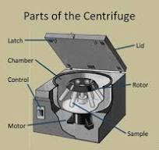
Applications of Centrifugation
• To separate two miscible substances
• To analyze the hydrodynamic properties of macromolecules
• Purification of mammalian cells
• Fractionation of subcellular organelles (including membranes/membrane fractions) Fractionation of membrane vesicles • Separating chalk powder from water
• Removing fat from milk to produce skimmed milk
• Separating particles from an air-flow using cyclonic separation
• The clarification and stabilization of wine
• Separation of urine components and blood components in forensic and research laboratoriesAids in the separation of proteins using purification techniques such as salting out, e.g. ammonium sulfate precipitation. .
