Modified RF magnetron sputtering Technique

A sputtering technique was used to deposit the required materials with various thicknesses on desired substrates. The sputtering machine (Nordiko Limited) as shown in Fig. 4.11a is first warmed up for 30 min in advance. After loading samples into the vacuum chamber, the machine is pumped down until the required vacuum (<6x10-7 Torr) was reached and each target is cleaned by an argon plasma at 200 W for 20 min. During the sputtering process, the energetic
atoms of argon bombard the target. Then, atoms from the target surface are
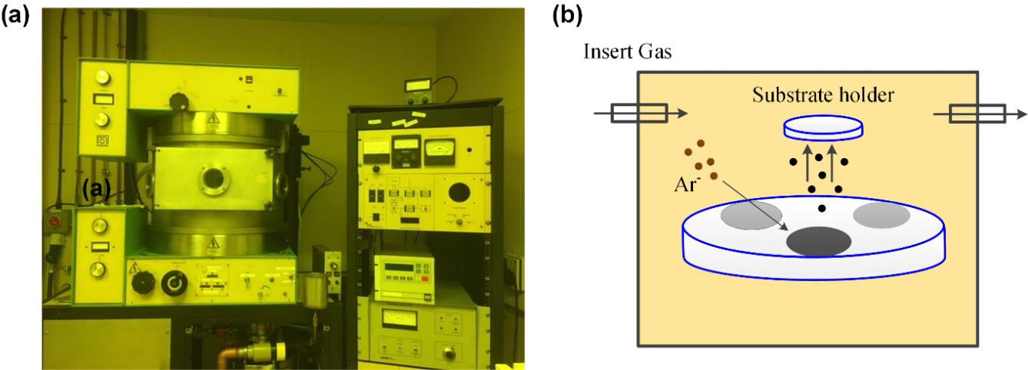

Figure 4-11: (a) Optical image of three targets 8’’ sputtering machine (Nordiko Limited). (b) Schematic of conventional sputtering coating technique.
ejected towards the substrate with energy higher than the binding energy as shown in Fig. 4.11b. During the sputtering process, materials (such as Au, Ag and Cr) are deposited in the same way, where atoms deposits toward a substrate via regular trajectories. However, Au atoms deposit with more random trajectories compared with Ag or Cr atoms [156, 161]. This suggests that Au atoms are more likely to coat the edges of the substrate during sputtering, making the unwanted Au film more difficult to be removed during a lift-off process. This also indicates that the number of Au atoms that reached the substrate is lower than that of others. Thus, sputtered Au atoms have less effect on a graphene surface than others. To secure the properties of graphene and avoid issues that are mentioned in section 3.4.2, a sputtering process for all materials is achieved at a low power of 50 Watt and 4 mTorr argon pressure. Additionally, the substrate is water cooled to avoid thermal damage. To ensure a fast cooling process, a heat sink is placed underneath samples during the sputtering process.

